
CONTRACT REPORT
ARRB Group Ltd
www.arrb.com.au
ACN 004 620 651
ABN 68 004 620 651
- Research and Consulting
- Systems

Updating crashes involving ACT vehicles and controllers in NSW: 2006 to 2010

Project No: 005822
by Victoria Pyta, Tariro Makwasha and Will Hore-Lacy

for NRMA-ACT Road Safety Trust

Updating crashes involving ACT vehicles and controllers in NSW: 2006 to 2010 |  |  |  |   ARRB Group Ltd  ABN 68 004 620 651  Victoria  500 Burwood Highway  Vermont South VIC 3133  Australia  P: +61 3 9881 1555  F: +61 3 9887 8104  info@arrb.com.au  Western Australia  191 Carr Place  Leederville WA 6007  Australia  P: +61 8 9227 3000  F: +61 8 9227 3030  arrb.wa@arrb.com.au  New South Wales  2-14 Mountain St  Ultimo NSW 2007  Australia  P: +61 2 9282 4444  F: +61 2 9280 4430  arrb.nsw@arrb.com.au  Queensland  123 Sandgate Road  Albion QLD 4010  Australia  P: +61 7 3260 3500  F: +61 7 3862 4699  arrb.qld@arrb.com.au  South Australia  Level 5, City Central,  Suite 507, 147 Pirie Street  Adelaide SA 5000  Australia  P: +61 8 7200 2659  F: +61 8 8223 7406  arrb.sa@arrb.com.au  International offices:  Xiamen, People’s Republic of China
for NRMA-ACT Road Safety Trust
 |  | Reviewed
 | Project Leader
 |  | Victoria Pyta
 | Quality Manager
 |  | Peter Cairney
005822
September 2013

Summary


Although the Report is believed to be correct at the time of publication, ARRB Group Ltd, to the extent lawful, excludes all liability for loss (whether arising under contract, tort, statute or otherwise) arising from the contents of the Report or from its use. Where such liability cannot be excluded, it is reduced to the full extent lawful. Without limiting the foregoing, people should apply their own skill and judgement when using the information contained in the Report.
Background
The ACT has the lowest annual road fatalities per 100,000 population among all Australian states and territories. However, two previous studies by ARRB for the NRMA-ACT Road Safety Trust covering the period 1992 to 1998 and 1999 to 2003 have found that residents of the ACT are equally likely to be involved in a fatal crash in NSW as they are in the ACT.
Approximately 20% of travel by ACT drivers occurs in NSW and the population of the ACT and the surrounding region has been growing at a rate of 1.5 to 2.1% per annum (1.5 times the average rate for NSW). All other things being equal, this increase in population would be expected to result in an increase in crashes in the region.
There have been large-scale changes to the NSW road system in the last 10 years, including large infrastructure projects and enforcement programs. These changes would be expected to lead to improvements in road safety.
The ACT Road Safety Strategy 2011–20 identifies reducing ‘fatalities and casualties involving ACT drivers travelling interstate’ as a key target. Given the proportion of travel by ACT drivers in NSW, the higher than average increase in population in the region and the significant efforts of road safety stakeholders, it is time to re-assess the situation.
A current understanding of the volume, nature and frequency of crashes involving ACT controllers in NSW can provide policy guidance and enable practitioners to better address the problem. It can also give some insight into the effectiveness of the current road safety program.

Method
Crashes involving ACT drivers and riders in NSW between 2006 and 2010 were identified from NSW crash data. If the crash record indicated that the crash-involved person was licensed in the ACT or that their vehicle was registered in the ACT, they were included in the analyses. This was the method employed in the previous studies in the series.
Cross-tabulations and some graphs of the key variables were prepared, as well as maps of crash locations and types across NSW. These results were presented to a workshop of regional stakeholders. Finally, a time series analysis comparing crash rates for ACT drivers with those from NSW was performed on 20 years of fatal crash data and 14 years of injury crash data.

Key results
As was the case in the previous two studies, ACT controllers were almost as likely to be involved in fatal crashes in NSW as in the ACT. They were also involved in a substantial number of injury crashes in NSW compared to ACT (although fewer than within the ACT).
The fatal crash rate of ACT controllers in NSW remains high. The rate per 100,000 population has been fairly static for the last 20 years and the injury rate is reducing but the NSW injury crash rate is reducing twice as fast. Fatal crashes involving ACT controllers are three to five times more likely to occur in NSW than in the ACT on the basis of vehicle kilometres travelled.
The majority of crashes occurred in or en route to Metro Sydney, in the LGAs immediately adjacent to the ACT, or en route to the coast and in the coastal areas. Together, crashes in these areas accounted for 66% of all crashes involving an ACT controller in NSW, giving road safety stakeholders a good focus for targeting crashes. However, this leaves a substantial remainder of 34% of crashes spread across an extensive and sparsely travelled network.
The spatial analysis identified that the majority of crashes involving ACT controllers occurred within 200 km of the ACT. They included a substantial pattern of crashes on routes that were not major highways but which clearly have crash problems. These routes included popular recreational routes through the Snowy Mountains and between Canberra and the east coast, routes on which motorcycle crashes were more common. Crashes on unsealed roads within 100 km of the ACT borders also featured more heavily than expected.
Crash severity was not evenly distributed. Crashes were more severe, on average, outside of the urban environments of Metro Sydney and Queanbeyan. ACT controllers were over-represented in single-vehicle crashes, fatigue and speeding-related fatal crashes on major routes across NSW, particularly on weekends and during holiday periods.
Despite the increase in population, crashes have not increased, and on a population basis, they are slowly declining. There do appear to have been some improvements since the previous reports, including reductions in crashes during public holidays and public school holiday periods, and on certain highways. However, there is still a need to maintain pressure on drivers to comply with speed limits and manage their trip to avoid fatigue.
The ACT Government works collaboratively with representatives from NSW Police, NSW Roads and Maritime Services and local governments to address crash problems in the region. The NRMA-ACT Road Safety Trust and the local chapter of the Australasian College of Road Safety are also active in promoting the development and dissemination of road safety information and the promotion of best practice in the region.
A number of recommendations are made to address the issues identified in this report. The successful adoption of the recommendations will rely on strong working relationships across borders and between departments.
Project Team
Victoria Pyta was the leader for this project. She designed the project, conducted the workshop and the time series analysis.
Tariro Makwasha was responsible for data preparation, and conducted the majority of the crash data analyses.
Will Hore-Lacy worked with Arc-GIS to produce the maps presented in this report.
Dr Peter Cairney was the quality manager. Peter reviewed and provided input to the project design and the report.
ACKNOWLEDGEMENTS
The authors gratefully acknowledge:
- NRMA-ACT Road Safety Trust for funding this project via their Grant Program
- NSW Centre for Road Safety (Transport for NSW) for providing crash data for this project
- the assistance of Linda Cooke (NRMA-ACT Road Safety Trust) and Gary McDonald (ACT Government) in organising the project workshop and providing valuable guidance and feedback throughout the project
- local representatives of ACT Police, ACT Government, NRMA–ACT Road Safety Trust and NRMA Motoring Services, regional NSW Roads and Maritime Services, local government, and the ACT chapter of the Australasian College of Road Safety who took the time to attend the project workshop and offered relevant information and valuable insights.
Disclaimer
This work has been prepared exclusively by ARRB and is not endorsed or guaranteed by the Trust.

Contents

1 Introduction 1
2 Method 3
2.1 Definition of an ACT controller 3
2.2 Data 3
2.2.1 Crashes 3
2.2.2 Travel exposure 3
2.2.3 Population 3
2.3 Analysis 3
2.4 Study routes and local government authorities 3
2.1 Workshop 7
3 General crash Statistics and state comparisons 8
3.1 General crash and casualty profile 8
3.2 Comparison of ACT fatalities with other states and territories 9
3.3 Comparison of ACT and NSW crashes involving ACT controllers 9
3.4 Crash trends 10
3.5 Crash rates 11
3.5.1 Crashes per 100,000 population 11
3.5.2 Crashes per million vehicle kilometre travelled 12
3.6 Spatial distribution of crashes 13
3.7 Spatial distribution of crashes – new LGA borders 16
4 Crash characteristics 18
4.1 Day of crash 18
4.2 Weekend crashes 20
4.3 Time of crash 23
4.4 Natural lighting and night-time crashes 25
4.5 Holiday crashes 26
4.6 Single and multiple-vehicle crashes 28
4.7 Crash types 29
5 Vehicle characteristics 33
5.1 Vehicle types 33
5.2 Vehicle occupancy 35
6 Controller characteristics 36
6.1 Age of controller 38
6.2 Age and gender 39
7 Factors contributing to crashes 41
7.1 Fatigue 41
7.2 Speed 42
7.3 Alcohol 43
7.4 Restraint use 45
8 Historical context 46
8.1 Comparison of current study with past studies 46
8.2 Crash Rate Comparisons 51
8.3 Time series analysis 52
8.3.1 Model selection and fit diagnostics 53
8.3.2 Results 54
9 Workshop Findings and summary statistics 57
9.1 Crashes on unsealed roads 57
9.2 Cycling and motorcycling in the region 57
9.3 Unexpected crash reductions in Sydney and Liverpool 57
9.4 Differences in licensing between ACT and NSW 58
9.5 Demerit points 58
9.6 Young drivers 58
9.7 Sources of background and contextual information 58
9.8 Potential impact of the Kings Highway Route Safety Review 59
9.9 Summary statistics for particular groups 59
10 Discussion 63
10.1 Overall crash numbers and rates 63
10.2 Monitoring and benchmarking 64
10.3 Geographical location 64
10.3.1 Locations where the majority of crashes occur 64
10.3.2 Crash severity patterns 64
10.3.3 Crashes dispersed over a wider network 65
10.3.4 Crashes close to the ACT 65
10.4 Distribution of crashes in time 65
10.5 Crash types and characteristics 65
10.6 Road characteristics 66
10.7 Vehicle characteristics 66
10.8 Controller characteristics 66
10.9 Young drivers 66
10.10 Young driver crashes in Queanbeyan City 67
10.11 Illegal and high-risk behaviours 67
10.12 Differential impact of road safety campaigns 67
10.13 The national demerit point scheme 67
10.14 Strong collaboration 68
10.15 Study limitations 68
11 Conclusions 69
12 Recommendations 71
References . 73
Appendix A Maps 75
Appendix B Holidays 95
Appendix C data 97
Appendix D Workshop Notes 100
Appendix E NSW DCA codes 104
Appendix F Time Series Analysis Diagnostics 105

TABLES
Table 2.1: Routes and LGAs analysed 4
Table 3.1: ACT controller-involved crashes in NSW compared to crashes within the ACT (2006–2010) 9
Table 3.2: Annual fatality and fatal crash rates by jurisdiction 11
Table 3.3: Fatal crashes per million VKT involving ACT controllers in ACT and NSW 12
Table 3.4: The 10 NSW LGAs where ACT controllers were most frequently involved in crashes 2006 – 2010 13
Table 3.5: Spatial distribution of crashes in NSW involving ACT controllers by route 2006–2010 14
Table 3.6: Spatial distribution of crashes in NSW involving ACT controllers by study LGAs 2006–2010 14
Table 4.1: Total crashes involving ACT controllers in NSW by day of week and time of day (2006 to 2010) 19
Table 4.2: Weekend versus weekday crashes in NSW involving ACT controllers by route 20
Table 4.3: Weekend versus weekday crashes in NSW involving ACT controllers by study LGAs (between 2006 and 2010) 21
Table 4.4: Crashes in NSW involving ACT controllers by natural lighting and crash severity 25
Table 4.5: Holiday periods in the ACT 26
Table 4.6: Holiday crashes in NSW involving ACT controllers by crash severity 26
Table 4.7: Holiday crashes in NSW involving ACT controllers 27
Table 4.8: Holiday crashes in NSW involving ACT controllers by route 27
Table 4.9: Holiday crashes in NSW involving ACT controllers by study LGAs 28
Table 4.10: Crashes in NSW involving ACT controllers by single unit and multiple units including pedestrians 28
Table 4.11: Crashes in NSW involving ACT controllers by number of traffic units and route 29
Table 4.12: Crashes in NSW involving ACT controllers by number of traffic units and study LGAs 29
Table 4.13: Crashes in NSW involving ACT controllers by crash type and severity 30
Table 4.14: Crashes in NSW involving ACT controllers by crash type and route 31
Table 4.15: Crashes in NSW involving ACT controllers by crash type and LGAs 32
Table 5.1: Distribution of vehicle types with ACT controller involved in crashes across routes in NSW 34
Table 5.2: Distribution of vehicle types with ACT controller involved in crashes across study LGAs in NSW 35
Table 5.3: Vehicles involved in crashes involving an ACT controller in NSW by vehicle occupancy 35
Table 6.1: ACT controllers involved in crashes in NSW by gender and route 37
Table 6.2: ACT controllers involved in crashes in NSW by gender and study LGA 37
Table 6.3: ACT controllers involved in crashes in NSW by age and crash severity 38
Table 6.4: ACT controllers involved in crashes in NSW by age group and route 38
Table 6.5: ACT controllers involved in crashes in NSW by age group and study LGA 39
Table 6.6: ACT controllers involved in crashes in NSW by gender and age group 39
Table 6.7: ACT controllers involved in crashes in NSW by age, gender and crash severity 40
Table 7.1: ACT controllers involved in fatigue-related crashes in NSW by study route 41
Table 7.2: ACT controllers involved in fatigue related crashes in NSW by study LGA 42
Table 7.3: ACT controllers involved in speed-related crashes in NSW by study route 43
Table 7.4: ACT controllers involved in speed-related crashes in NSW by study LGA 43
Table 7.5: ACT controllers involved in crashes in NSW by BAC and severity 44
Table 7.6: ACT controllers involved in crashes in NSW by BAC 44
Table 7.7: ACT controllers involved in crashes in NSW by severity and high alcohol times 45
Table 7.8: ACT controllers involved in crashes in NSW by restraint use and vehicle type 45
Table 8.1: Comparison of fatal and injury crashes involving ACT controllers in NSW (average annual crashes and 95% confidence intervals) 46
Table 8.2: Comparison of times and routes for crashes involving ACT controllers in NSW 46
Table 8.3: Comparison of crash types and vehicle attributes for crashes involving ACT controllers in NSW 47
Table 8.4: Comparison of demographic characteristics of controllers in crashes involving ACT controllers in NSW 47
Table 8.5: Comparison of crash contributing factors in crashes involving ACT controllers in NSW 48
Table 8.6: Comparison of crashes in NSW involving ACT controllers by LGAs with highest crash occurrence (top 10 LGAs) 49
Table 8.7: Comparison of crashes involving ACT controllers in NSW by study route and study times 50
Table 8.8: Comparison of fatal crash rates per 100 million VKT 51
Table 8.9: Model selection statistics 54
Table 8.10: Parameter estimates and 95% confidence intervals 54
Table 9.1: High risk crash routes for crashes in NSW involving ACT controllers 60
Table 9.2: ACT controllers involved in crashes in NSW on high risk routes 61
Table 9.3: ACT controllers involved in crashes in NSW on high risk routes by 62

FIGURES
Map 1: Map of NSW and the ACT highlighting the routes of interest 5
Map 2: Map of the ACT highlighting the neighbouring NSW LGAs of interest (old boundaries top and new boundaries bottom) 6
Figure 3.1: Percentage of crashes in NSW involving ACT controllers by crash severity 2006–2010 8
Figure 3.2: Average annual road fatalities (2006–2010) 9
Figure 3.3: Crashes in NSW involving ACT controllers 1992–2011 10
Figure 3.4: Trends in fatal crash rates in NSW and the ACT (2006–2010) 12
Figure 3.5: Casualty crashes involving an ACT controller by LGA (2001–2011) – using new LGA structure 16
Figure 3.6: Three-year moving average of casualty crashes involving an ACT controller in NSW (top five LGAs – new LGA structure; 2001–2011) 17
Figure 3.7: Three-year moving average of casualty crashes involving an ACT controller in NSW (next five LGAs – new LGA structure; 2001–2011) 17
Figure 4.1: Five-year average crash totals in NSW involving ACT controllers by day of week 2006–2010 18
Figure 4.2: Crashes in NSW involving ACT controllers by weekday and weekend by year 22
Figure 4.3: Percentage of crashes in NSW involving ACT controllers by time of crash and location 23
Figure 4.4: Percentage of crashes in NSW involving ACT controllers by time of crash for top five study LGAs 24
Figure 5.1: Vehicles with ACT controller involved in crashes in NSW by severity and vehicle type 33
Figure 6.1: ACT controllers involved in crashes in NSW by gender and crash severity 36
Figure 8.1: Fatal crashes involving ACT and non-ACT controllers in NSW between 1992 and 2011 52
Figure 8.2: Injury crashes involving ACT and non-ACT controllers in NSW between 1992 and 2011 53
Figure 8.3: Fatal crashes involving an ACT controller in NSW (per 100,000 ACT population, 1992–2011) 55
Figure 8.4: Fatal crashes involving a non-ACT controller in NSW (per 100,000 NSW population, 1992–2011) 55
Figure 8.5: Injury crashes involving an ACT controller in NSW (per 100,000 ACT population, 1998–2011) 56
Figure 8.6: Injury crashes involving a non-ACT controller in NSW (per 100,000 NSW population, 1998–2011) 56

Introduction
The ACT records the lowest rates of fatalities per head of population, vehicles registered and distance travelled of all Australian states and territories, and has done so for many years. This high safety record is taken, in most cases, as an indication of the ACT’s high quality road network.
Crash statistics typically refer to crashes occurring within the boundaries of a specific jurisdiction. These statistics do not differentiate crashes by driver or vehicle origins. Because the ACT is a small, predominantly urban region set within the NSW borders, many residents make frequent use of the NSW road network. Consequently, crashes involving ACT controllers or vehicles are likely to occur outside the ACT boundaries. An understanding of the nature and frequency of these crashes can provide policy guidance and enable practitioners to better address the problem.
Between 2006 and 2010, population growth within the ACT was 1.5% to 2.1% per annum (ABS 2012b). This rate was consistently greater than the national average, approximately 1.5 times the rate in NSW, and similar to the LGAs on the north and north-east borders of the ACT. This increase in population would be expected to lead to an increase in crashes and/or a change in the pattern, hence the need for a review of the statistics.
ARRB has previously undertaken three studies for the NRMA-ACT Road Safety Trust (the Trust) on crashes in NSW involving ACT controllers, comprising:
- Cairney and Gunatillake (2000) analysed the crash patterns for ACT controllers and vehicles in NSW from 1992 to 1998.
- The follow-up study (Imberger et al. 2005) provided an update on these crashes for the period 1999 to 2003.
- To place ACT controller crashes in NSW into the context of the travel patterns of ACT controllers, Pyta (2007) examined the amount of travel by ACT controllers in NSW and compared the crash rates for ACT controllers within NSW to their crash rates within the ACT.
These previous studies revealed that the number of fatal crashes and fatalities involving ACT controllers and vehicles in NSW was similar to the ACT. The numbers involved in injury crashes were also high but less than those within the ACT. The ACT has the highest percentage of distance travelled interstate of all Australian states and territories. The studies also recorded higher injury and fatal crash rates per vehicle kilometre travelled for ACT vehicles in NSW compared to ACT vehicles in the ACT and NSW vehicles in NSW (Pyta 2007).
Some explanations that were put forward for the higher risk to ACT controllers in NSW reflect expectations about the types of trips that ACT controllers take in NSW, including the likelihood that ACT controllers:
- may have longer average trip durations in NSW, making them more prone to fatigue than when travelling within the ACT
- may spend a higher proportion of their journey on high speed and/or lower standard roads, increasing the likelihood that crashes that occur will be more severe
- may be unfamiliar and less prepared for the challenges of the rural NSW road network and the urban Sydney environment.
The ACT road safety strategy: Towards Vision Zero – Improving Safety in the ACT identifies reducing ‘fatalities and casualties involving ACT drivers travelling interstate’ as a key target. Given the proportion of travel by ACT drivers in NSW, the higher than average increase in population in the region and the significant efforts of road safety stakeholders, it is time to re-assess the situation.
The current report provides an update on the nature, frequency and location of crashes in NSW involving ACT controllers from 2006 to 2010. Specifically, this study aims to:
- highlight the features of crashes on the main routes and in Local Government Authorities (LGAs) surrounding the ACT
- compare crash statistics for crashes involving ACT controllers in NSW from 1992 to 1998 and from 1999 to 2005 with those from 2006 to 2010
- provide comments on the changes in crash patterns and the road safety interventions conducted by the ACT road safety partners
- recommend further countermeasures targeted at reducing the incidence and severity of crashes.

Method

Definition of an ACT controller
In order to capture all drivers and riders who were ACT residents, it was decided to count both ACT licence holders and drivers as ACT registered vehicles. ACT controllers were therefore defined as drivers or motorcycle riders who held an ACT licence or whose vehicle was registered in the ACT. This was the definition used in earlier reports and allows statistics from the current report to be compared with previous reports. Commonwealth-registered vehicles were not counted as ACT registered vehicles in the analysis.

Data

Crashes
NSW crash data was obtained from the NSW Centre for Road Safety (Transport for NSW) covering the period 2000 to 2011. ACT crash data was obtained from a publication (Territory and Municipal Services 2012). To allow for comparability with previous research, and to make the most of the vehicle exposure data available, the data reported in the analyses for the majority of this report covers the five-year period 2006–2010.
Historical crash data was obtained from previous studies (Cairney & Gunatillake 2000; Imberger, Styles & Cairney 2005) and publications (Federal Office of Road Safety 1998; Roads and Traffic Authority [RTA] 1999; RTA 2000a; RTA 2000b; RTA 2001).

Travel exposure
Vehicle use data was obtained from the Australian Bureau of Statistics (ABS 2012c) Survey of Motor Vehicle Use and covers 2006, 2007 and 2010 (Appendix C Table C 4). The data included the number of ACT registered vehicles and estimated kilometres travelled within ACT and NSW for 2006, 2007 and 2010.

Population
Population data was also obtained from the ABS (2012a, 2012b). National and jurisdictional crash data in Section 3.2 was obtained from the Australian Road Deaths Database (Bureau of Infrastructure, Transport and Regional Economics 2013). School holidays data for the ACT over the period 2001 to 2011 was obtained from the ACT Education and Training Directorate (email correspondence).

Analysis
Crashes involving ACT controllers from 2006–2010 were analysed using IBM’s Statistical Package for Social Sciences (SPSS) version 21 and Microsoft Excel 2010.
Latitude and longitude fields in the NSW crash data were used for geocoding crashes using the GIS package ArcMap version 9.0. Each point on the map indicates a crash or casualty as identified by the symbol used.

Study routes and local government authorities
The analysis focused on crash and controller characteristics, crash cause factors and the spatial distribution of crashes. Metro Sydney and the major routes connecting the ACT to major NSW towns and tourist areas were the main focus for the spatial distribution of crashes. The study also focused on NSW local government authorities (LGAs) surrounding the ACT. The study routes and LGAs are outlined in Table 2.1.
Table 2.1: Routes and LGAs analysed
Route | Between
Metro Sydney | N/A
Hume Highway | Ashfield to Albury
Kings Highway | Queanbeyan to Bateman's Bay
Federal Highway | Goulburn to Sutton
Barton Highway | Canberra to Yass
Monaro Highway | ACT border near Canberra to Victorian border near Rockton
Princes Highway | Sydney to Victoria border
Pacific Highway | Nth Sydney to Tweed Heads
Local government authority (LGA)
Queanbeyan City | East Border, adjacent to Canberra
Yarrowlumla* | East Border (on route to coast)
Eurobodalla | < 100 km East (coast)
Yass | North-West Border
Mulwaree | < 100 km North-East (on route to Sydney)
Tallaganda* | < 100 km/h East (on route to coast)
Shoalhaven City | > 100 km/h East (coast)
Wingecarribee | > 100 km/h North-East (on route to Sydney)
Cooma-Monaro | South Border (on route to mountains)
* Yarrowlumla and Tallaganda were amalgamated in 2004 to form the Palerang LGA (along with small parts of other neighbouring LGAs).

The study routes are highlighted in Map 1. Crashes that occurred on highlighted routes within the Metro Sydney region were identified as Metro Sydney and excluded from being counted among the study routes in order to avoid double counting. The study routes were identified using the route number and street of crash fields in the crash data while the LGAs were identified using the LGA number. The Metro Sydney area was identified using the ‘urbanisation’ field in the NSW crash data.
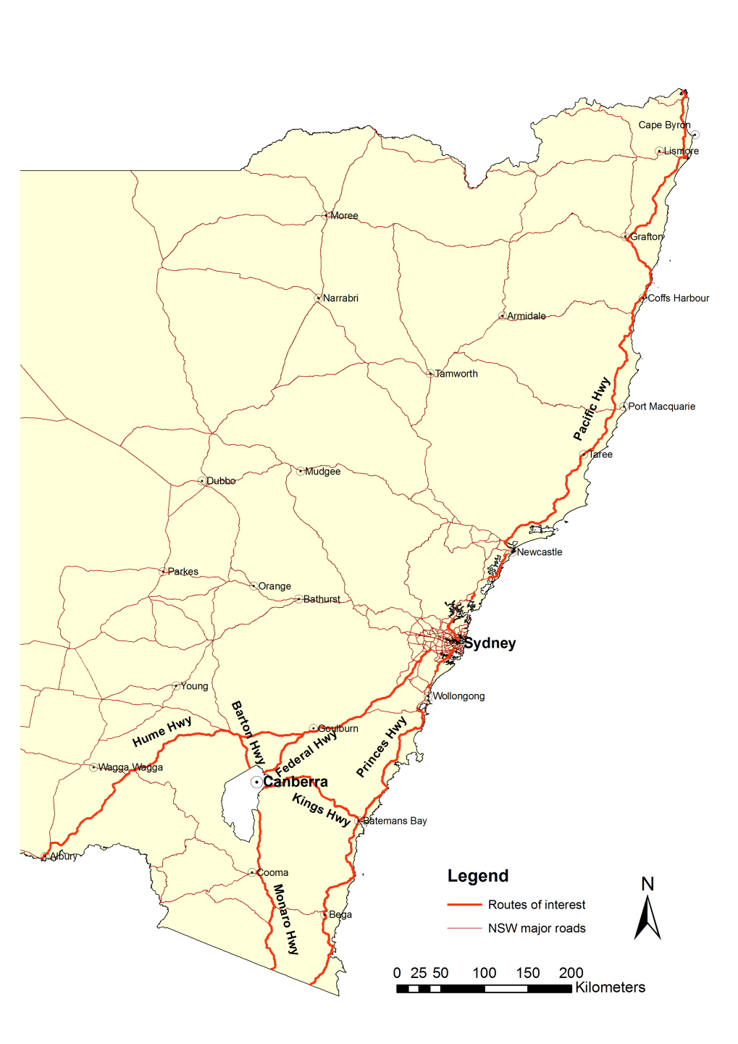
Kilometres
Map 1: Map of NSW and the ACT highlighting the routes of interest

In 2004, there were significant changes to LGA boundaries in NSW. Map 2 shows the old and new LGA boundaries around the ACT. The boundary changes are not reflected in this research as the NSW crash data did not reflect the boundary changes and because retaining the old boundaries made comparisons with past studies possible.
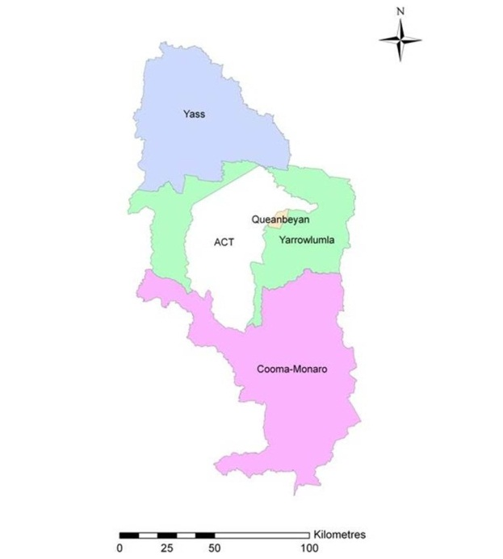
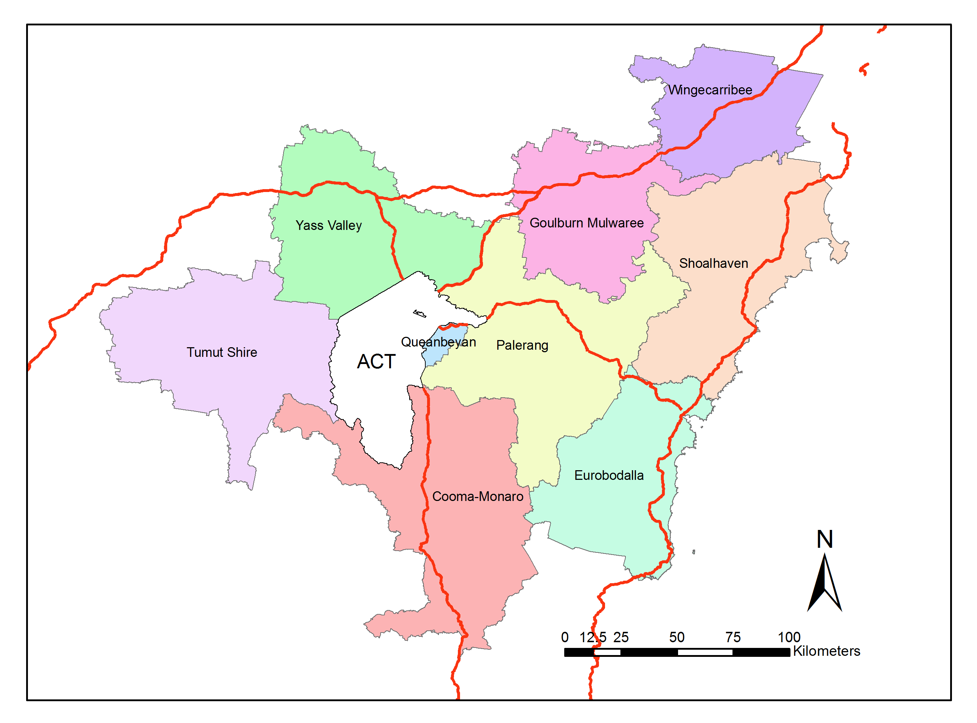
Kilometres
Monaro Highway
Princes Highway
Kings Highway
Barton Highway
Hume Highway
Federal Highway
Map 2: Map of the ACT highlighting the neighbouring NSW LGAs of interest
(old boundaries top and new boundaries bottom)

Workshop
A workshop was undertaken in January 2013 as part of this study. Preliminary findings were presented with the objective of disseminating the information and obtaining insights from the regional perspective into possible contributory factors behind the observed crash patterns. Attendees and their affiliations are listed in Appendix D, which also contains the notes from the meeting.

General crash Statistics and state comparisons

General crash and casualty profile
On average, 1,461 people per year were killed on Australian roads between 2006 and 2010. The average number of people killed over the same period in NSW road crashes was 433, and in ACT 14.
This study analysed crashes involving ACT controllers in NSW from 2006 to 2010. There were 218,893 crashes in NSW over this period, 2,927 of which involved ACT controllers. Of the 2,927 crashes, 55 were fatal crashes, 1,188 were injury crashes and 1,684 were non-casualty (tow-away) crashes.
Fatal crashes constituted 2%, injury crashes 41% and non-casualty crashes 58% of all crashes involving ACT controllers in NSW (Figure 3.1).

Figure 3.1: Percentage of crashes in NSW involving ACT controllers by crash severity 2006–2010

Comparison of ACT fatalities with other states and territories
Figure 3.2 shows average annual fatalities for Australian states and territories from 2006 to 2010. The ACT recorded the lowest average annual fatalities in Australia (14.4) while NSW recorded the highest (432.6). The number of fatalities in the ACT was slightly higher than the average number of fatalities involving ACT controllers in NSW (12.4).

Source: Adapted from Australian Road Deaths Database.
Figure 3.2: Average annual road fatalities (2006–2010)

Comparison of ACT and NSW crashes involving ACT controllers
Table 3.1 outlines the number of fatal and injury crashes within the ACT compared to crashes involving ACT controllers in NSW. The data shows more fatal crashes in the ACT compared to crashes involving ACT controllers in NSW. There were more injury crashes in the ACT than ACT controller crashes in NSW. There are no clear trends in the fatal crashes in the ACT or NSW. There are also no clear trends in injury crashes in NSW, but injury crashes in the ACT increased substantially from 376 in 2006 to 643 in 2010.
Table 3.1: ACT controller-involved crashes in NSW compared to crashes within the ACT (2006–2010)
Year of crash | Fatal crashes |  | Injury crashes
Year of crash | Within ACT | Involving ACT controllers in NSW | Within ACT | Involving ACT controllers in NSW
2006 | 12 | 13 | 376 | 245
2007 | 14 | 11 | 501 | 219
2008 | 14 | 6 | 358 | 254
2009 | 11 | 11 | 519 | 223
2010 | 16 | 14 | 643 | 247
Total | 67 | 55 | 2,397 | 1,188

Crash trends
Figure 3.3 outlines crashes involving ACT controllers by crash severity from 1992 to 2011. The number of all casualty crashes fluctuated throughout the study period. Fatal and injury crashes followed a similar pattern. Fatal crashes reduced from 22 in 1992 to 9 in 2011, but the large fluctuations year on year mean that it is difficult to ascertain whether this is a reliable indication of a downward trend. Injury crashes on the other hand fell from 306 in 1992 to 249 in 2011. There was an extended period of reductions in injury crashes from 1992 to 1997 followed by an increase between 1998 and 2002, and then a slow decrease between 2003 and 2011 (refer to Appendix C, Table C 1 for detailed data).

Figure 3.3: Crashes in NSW involving ACT controllers 1992–2011

Crash rates

Crashes per 100,000 population
In order to calculate crash rates per 100,000 population, for all Australian states and territories as well as ACT controller crashes in NSW, jurisdictional population data was obtained from the ABS (Appendix C Table C 3) and jurisdictional crash and casualty data was obtained from the Australian Road Deaths Database (Appendix C Table C 2).
Taking exposure into consideration (per 100,000 population) the annual average road fatality rate for Australia was 7.0. NSW and ACT both outperformed the national average, with road fatality rates of 6.2 for NSW and 4.2 for the ACT (Table 3.2). However, after taking into account fatalities and fatal crashes occurring in NSW, the fatal crash and fatality rates of ACT controllers overall are similar to the rates for NSW.
Table 3.2: Annual fatality and fatal crash rates by jurisdiction
State/territory | 2006 | 2007 | 2008 | 2009 | 2010 | Annual Average
Fatalities per 100,000 population
Victoria | 6.6 | 6.4 | 5.7 | 5.2 | 5.3 | 5.8
Queensland | 8.2 | 8.6 | 7.6 | 7.3 | 5.6 | 7.5
South Australia | 7.5 | 7.8 | 6.2 | 7.2 | 7.3 | 7.2
Western Australia | 9.7 | 11.2 | 9.4 | 8.3 | 8.6 | 9.4
Tasmania | 11.2 | 9.1 | 7.8 | 12.4 | 6.2 | 9.4
Northern Territory | 21.4 | 27.0 | 34.1 | 13.1 | 21.7 | 23.3
New South Wales (NSW) | 7.3 | 6.3 | 5.4 | 6.3 | 5.7 | 6.2
NSW excluding ACT in NSW | 7.1 | 6.1 | 5.3 | 6.1 | 5.4 | 6.0
Australian Capital Territory (ACT) | 3.9 | 4.1 | 4.1 | 3.3 | 5.4 | 4.2
*ACT fatalities in NSW | 3.9 | 4.1 | 1.7 | 3.6 | 5.1 | 3.7
Australia | 7.7 | 7.6 | 6.7 | 6.7 | 6.2 | 7.0
Fatal crashes per 100,000 population
Victoria | 6.0 | 5.6 | 5.2 | 4.8 | 4.8 | 5.3
Queensland | 7.7 | 8.1 | 6.8 | 6.6 | 5.3 | 6.9
South Australia | 6.6 | 6.8 | 5.4 | 6.3 | 6.5 | 6.3
Western Australia | 8.8 | 10.2 | 8.5 | 7.7 | 7.8 | 8.6
Tasmania | 8.8 | 7.9 | 7.4 | 10.2 | 5.8 | 8.0
Northern Territory | 19.5 | 21.9 | 30.5 | 13.1 | 20.3 | 21.0
New South Wales (NSW) | 6.6 | 5.9 | 5.1 | 5.6 | 5.1 | 5.6
NSW excluding ACT in NSW | 6.4 | 5.7 | 5.0 | 5.5 | 4.9 | 5.5
Australian Capital Territory (ACT) | 3.6 | 4.1 | 4.1 | 3.1 | 4.5 | 3.9
*ACT in NSW | 3.9 | 3.2 | 1.7 | 3.1 | 4.0 | 3.2
Australia | 7.0 | 6.9 | 6.1 | 6.0 | 5.6 | 6.3
Crash rate per 100,000 ACT population.
Source: Adapted from Australian Road Deaths Database.
The ACT fatal crash rate was lower than the NSW rate from 2006 to 2010. The annual fatal crash rates in the ACT increased from 3.6 per 100,000 ACT population in 2006 to 4.1 per 100,000 ACT population in 2007 and 2008 before falling to 3.1 in 2009. There was an increase in the fatal crash rate to 4.5 in 2010 as indicated in Figure 3.4.
Comparing the fatal crash rates for ACT controller crashes in NSW with NSW rates showed initial reductions from 2006 to 2008. Annual fatal crash rates for crashes in NSW involving ACT controllers fell from 3.9 per 100,000 ACT population in 2006 to 1.7 in 2008 and increased to 4.0 in 2010. At the same time, the fatal crash rates in NSW fell from 6.6 to 5.1 per 100,000 NSW population over the same period.

Figure 3.4: Trends in fatal crash rates in NSW and the ACT (2006–2010)

Crashes per million vehicle kilometre travelled
Table 3.3 presents the fatal crash rates per million vehicle kilometres travelled (VKT) by ACT registered vehicles in NSW. The ACT fatal crash rate per million VKT within the ACT was lower than for ACT controllers in NSW. The data indicates that ACT controllers were three to five times more likely to be involved in fatal crashes in NSW than in the ACT.
Table 3.3: Fatal crashes per million VKT involving ACT controllers in ACT and NSW
Year | ACT km (000) | ACT in NSW km (000) | ACT fatal crashes | ACT fatal crashes in NSW | *ACT fatal crashes per 1,000,000 VKT | *ACT fatal crashes in NSW per 1,000,000 VKT | Ratio ACT fatal crash rate in  NSW : ACT
2006 | 2437 | 506 | 12 | 13 | 4.92 | 25.69 | 5.22
2007 | 2569 | 496 | 14 | 11 | 5.45 | 22.18 | 4.07
2010 | 2644 | 746 | 16 | 14 | 6.05 | 18.77 | 3.10
Crash rate per million ACT VKT.

Spatial distribution of crashes
Table 3.4 shows the distribution of crashes among the 10 NSW LGAs where ACT controllers were most frequently involved in crashes. All the LGAs are within 100 km of the ACT border except Shoalhaven City and Wingecarribee (Map 2). Crashes involving ACT controllers in these 10 LGAs constituted 46% (1,356) of total crashes involving ACT controllers in NSW and include the 9 LGAs that have been analysed in this series of studies. Gunning is the only LGA appearing in this group that is not one of the study LGAs.
Table 3.4: The 10 NSW LGAs where ACT controllers were most frequently involved in crashes 2006 – 2010
LGA | Proximity to ACT | Number of crashes | (%) of crashes
Queanbeyan City | East Border, adjacent to Canberra | 313 | 11
Yarrowlumla* | East Border (on route to coast) | 204 | 7
Eurobodalla | < 100 km East (coast) | 194 | 7
Yass | North-West Border | 131 | 5
Mulwaree | < 100 km North-East (on route to Sydney) | 106 | 4
Tallaganda* | < 100 km/h East (on route to coast) | 104 | 4
Shoalhaven City | > 100 km/h East (coast) | 98 | 3
Wingecarribee | > 100 km/h North-East (on route to Sydney) | 85 | 3
Cooma-Monaro | South Border (on route to mountains) | 64 | 2
Gunning** | < 100 km North (on the old Hume Highway) | 57 | 2
Total |  | 1,356 | 46%
* Yarrowlumla and Tallaganda were amalgamated in 2004 to form the Palerang LGA (along with small parts of other neighbouring LGAs).
** Gunning is now part of Upper-Lachlan.
Crashes in the Sydney Metro area constituted just over a quarter of all crashes involving ACT controllers. These crashes were different to those on the major highways, in that they were more likely to be injury or non-casualty crashes. The Hume Highway and Kings Highway each accounted for 13% of fatal crashes, but only 8% and 7% of total crashes (Table 3.5). Metro Sydney excluded, injury crashes followed a similar pattern to fatal crashes.
Table 3.5: Spatial distribution of crashes in NSW involving ACT controllers by route 2006–2010
Route | Fatal crashes |  | Injury crashes |  | Non-casualty (tow-away) crashes |  | Total crashes
Route | n | (%) | n | (%) | n | (%) | n | (%)
Metro Sydney | 3 | 6 | 297 | 25 | 480 | 29 | 780 | 27
Hume Highway | 7 | 13 | 79 | 7 | 134 | 8 | 220 | 8
Kings Highway | 7 | 13 | 83 | 7 | 103 | 6 | 193 | 7
Princes Highway | 3 | 6 | 50 | 4 | 51 | 3 | 104 | 4
Federal Highway | 1 | 2 | 31 | 3 | 42 | 3 | 74 | 3
Pacific Highway | 3 | 6 | 22 | 2 | 36 | 2 | 61 | 2
Barton Highway | 5 | 9 | 18 | 2 | 36 | 2 | 59 | 2
Monaro Highway | 2 | 4 | 15 | 1 | 28 | 2 | 45 | 2
Subtotal | 31 | 56 | 595 | 50 | 910 | 54 | 1,536 | 53
Other | 24 | 44 | 593 | 50 | 774 | 46 | 1,391 | 47
Total | 55 | 100 | 1,188 | 100 | 1,684 | 100 | 2,927 | 100

Table 3.6 further highlights the spatial distribution of crash types by the study LGAs (pre-2004 borders). Queanbeyan City, Yarrowlumla and Eurobodalla had the most crashes of the study LGAs. Eurobodalla and Yass had the most fatal crashes (9%) while Queanbeyan had the most injury (11%) and non-casualty (11%) crashes.
Table 3.6: Spatial distribution of crashes in NSW involving ACT controllers by study LGAs 2006–2010
LGA | Fatal crashes |  | Injury crashes |  | Non-casualty (tow-away) crashes |  | Total crashes
LGA | n | (%) | n | (%) | n | (%) | n | (%)
Queanbeyan City | 0 | 0 | 135 | 11 | 178 | 11 | 313 | 11
Yarrowlumla | 4 | 7 | 94 | 8 | 106 | 6 | 204 | 7
Eurobodalla | 5 | 9 | 83 | 7 | 106 | 6 | 194 | 7
Yass | 5 | 9 | 47 | 4 | 79 | 5 | 131 | 5
Tallaganda | 4 | 7 | 43 | 4 | 57 | 3 | 104 | 4
Shoalhaven City | 0 | 0 | 44 | 4 | 54 | 3 | 98 | 3
Wingecarribee | 2 | 4 | 27 | 2 | 56 | 3 | 85 | 3
Cooma-Monaro | 2 | 4 | 21 | 2 | 41 | 2 | 64 | 2
Goulburn City | 0 | 0 | 7 | 1 | 17 | 1 | 24 | 1
Subtotal | 24 | 40 | 501 | 42 | 694 | 41 | 1,217 | 42
Other | 31 | 60 | 687 | 58 | 990 | 59 | 1,710 | 58
Total | 55 | 100 | 1,188 | 100 | 1,684 | 100 | 2,927 | 100

The spatial distribution of crashes is further highlighted in Map 3.

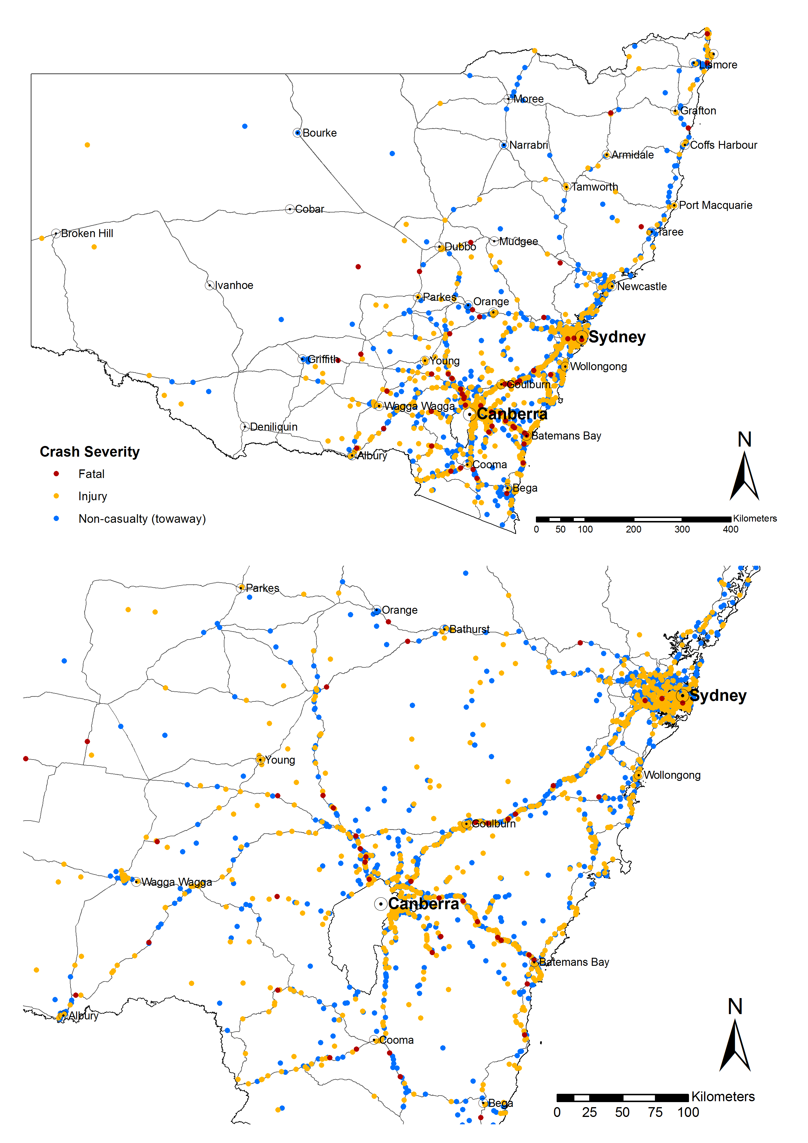
Map 3: Crashes in NSW involving ACT controllers

Spatial distribution of crashes – new LGA borders
The tables in Section 3.6 and the rest of the report refer to the pre-2004 NSW LGA border structure. This is to allow continuity of reporting and make comparisons possible across the series of reports. The graphs in this section disaggregate crashes according to the current LGA boundaries.
Figure 3.5 shows the distribution of casualty (fatal and injury) crashes under the new LGA structure. The first five LGAs are clustered on the ACT’s northern and eastern borders (Queanbeyan, Palerang, Eurobodalla, Yass Valley and Goulburn Mulwaree). Together, these LGAs account for nearly 40% of crashes involving an ACT controller in NSW.

Figure 3.5: Casualty crashes involving an ACT controller by LGA (2001–2011) – using new LGA structure

Figure 3.6 depicts the three-year moving average of casualty crashes in the top five LGAs from Figure 3.5. The annual counts are small and vulnerable to random fluctuations. A three-year moving average period was used to smooth some of the random fluctuation from the data to allow trends to become more visible. The casualty crash numbers in Queanbeyan were relatively static over the 11-year period, but may be on a downward trend in Palerang and Eurobodalla.

Each data point in this graph represents the average of count of crashes from the year prior, the year itself and the year after. Hence, although the x-axis shows the years 2002 to 2009, the data covers the period 2001 to 2011.
Figure 3.6: Three-year moving average of casualty crashes involving an ACT controller in NSW
(top five LGAs – new LGA structure; 2001–2011)
Figure 3.7 shows a largely consistent reduction in casualty crashes involving an ACT controller in the Sydney and Liverpool LGAs over the 11-year period 2001 to 2011.

Figure 3.7: Three-year moving average of casualty crashes involving an ACT controller in NSW
(next five LGAs – new LGA structure; 2001–2011)

Crash characteristics

Day of crash
An analysis of crash patterns by day of the week was undertaken. Figure 4.1 shows that crashes were more common around weekends with an annual average of 102 crashes on Fridays, 115 on Saturdays and 91 on Sundays. Tuesdays and Wednesdays had the lowest number of crashes, with an annual average of 67 each. Crashes increased from Thursdays through to Saturdays before falling from Sundays to Wednesdays.

Figure 4.1: Five-year average crash totals in NSW involving ACT controllers by day of week 2006–2010

On most days of the week, crashes were most likely to occur between midday and 5:59 pm and least likely to occur in the between midnight and 5:59 am. The higher number of crashes on Fridays and Saturdays correspond with substantial increases in crashes occurring during the 6 pm to 11:59 pm time period on Fridays and the midday to 5:59 and 6 pm to 11:59 pm time periods on Saturdays. The number of crashes occurring in the early hours of the morning (between midnight and 5:59 am) is twice as high on Saturday and Sunday compared with weekdays.
Table 4.1: Total crashes involving ACT controllers in NSW by day of week and time of day (2006 to 2010)

Weekend crashes
Weekend crashes refer to crashes that occurred on Saturdays and Sundays. Table 4.2 shows the number and percentage of weekday and weekend crashes in NSW involving ACT controllers on the study routes. The spatial distribution of these crashes is illustrated in Appendix A, Map A 1. Weekend crashes were particularly over-represented on the Federal, Kings, Barton and Hume Highways (50%, 47%, 42% and 40% on those routes respectively).
Table 4.2: Weekend versus weekday crashes in NSW involving ACT controllers by route
Route | Weekday |  | Weekend |  | Total
Route | n | (%) | n | (%) | n | (%)
Metro Sydney | 548 | 70 | 232 | 30 | 780 | 100
Hume Highway | 133 | 61 | 87 | 40 | 220 | 100
Kings Highway | 102 | 53 | 91 | 47 | 193 | 100
Princes Highway | 66 | 64 | 38 | 37 | 104 | 100
Federal Highway | 37 | 50 | 37 | 50 | 74 | 100
Pacific Highway | 47 | 77 | 14 | 23 | 61 | 100
Barton Highway | 34 | 58 | 25 | 42 | 59 | 100
Monaro Highway | 30 | 67 | 15 | 33 | 45 | 100
Other | 901 | 65 | 490 | 35 | 1391 | 100
Total | 1,898 | 65 | 1,029 | 35 | 2,927 | 100
Table 4.3 shows weekday and weekend crashes in NSW involving ACT controllers by study LGAs. The proportion of crashes in Queanbeyan City was lower than average, suggesting work-related travel, whereas the higher proportions of weekend crashes in the other LGAs suggest leisure-related travel. Weekend crashes were over-represented in Eurobodalla, Tallaganda and Yass (55%, 48% and 44% of crashes in those LGAs respectively).
Table 4.3: Weekend versus weekday crashes in NSW involving ACT controllers by study LGAs (between 2006 and 2010)
LGA | Weekday |  | Weekend |  | Total crashes
LGA | n | (%) | n | (%) | n | (%)
Queanbeyan City | 242 | 77 | 71 | 23 | 313 | 100
Yarrowlumla | 126 | 62 | 78 | 38 | 204 | 100
Eurobodalla | 87 | 45 | 107 | 55 | 194 | 100
Yass | 74 | 57 | 57 | 44 | 131 | 100
Tallaganda | 54 | 52 | 50 | 48 | 104 | 100
Shoalhaven City | 62 | 63 | 36 | 37 | 98 | 100
Wingecarribee | 56 | 66 | 29 | 34 | 85 | 100
Cooma-Monaro | 40 | 63 | 24 | 38 | 64 | 100
Goulburn City | 16 | 67 | 8 | 33 | 24 | 100
Other | 1,141 | 67 | 569 | 33 | 1,710 | 100
Total | 1,898 | 65 | 1,029 | 35 | 2,927 | 100
Note: Percentages refer to proportion of all crashes between 2006 and 2010 involving ACT controllers in the specified LGAs.
Figure 4.2 shows fluctuations in year on year crashes between 2006 and 2010. Weekend crashes fell from 225 in 2006 to 182 in 2008 before increasing slightly to 194 in 2009 and 220 in 2010. Weekday crashes decreased from 371 in 3006 to 368 in 2007, increasing to 402 in 2008, falling to 362 in 2009 and increasing to 395 in 2010. Annual average weekday crashes were 378 while weekend crashes were 206 over the five years.

Figure 4.2: Crashes in NSW involving ACT controllers by weekday and weekend by year

Time of crash
Figure 4.3 shows the percentage of crashes in NSW involving ACT controllers for each hour of the day for Metro Sydney region, the study routes and the rest of NSW.
In general, crashes are least frequent very early in the morning (between midnight and 4:59 am); they increase in frequency over the course of the day and peak in the afternoon before declining into the evening. The specific time of the peak differs slightly between the groups, with crashes on the study routes peaking earliest at 2:00–2:59 pm, and crashes in Metro Sydney peaking the latest at 5:00–5:59.
During early morning, between midnight and 6:59 am, crashes were most likely to occur on the study routes. During evening, between 5:00 pm and 8:59 pm, crashes were most likely to occur in the Metro Sydney region.

Figure 4.3: Percentage of crashes in NSW involving ACT controllers by time of crash and location

Figure 4.4 shows the percentage of crashes involving ACT controllers by three-hourly periods for the five study LGAs experiencing the most crashes involving ACT controllers. There were gradual increases in the percentage of crashes from 5:00 am to 5:59 pm for locations outside the study LGAs. The data for the study LGAs suggested a similar pattern as the locations outside the study LGAs. However, there were a small number of crashes in Tallaganda and Yass as reflected by the fluctuations in the percentage of crashes.
For Queanbeyan City, the percentage of crashes increased from 6:00 am to 8:59 am with further increases from 10:00 am to 6:59 pm, decreasing after. The peak for Queanbeyan City occurred between 5:00 pm and 5:59 pm.
Eurobodalla had a different crash pattern from the other LGAs. The percentage of crashes showed a sharp increase between 8:30 am and 9:59 am, dropping between 9:59 am and 11:59 am before reaching the peak of 11% between 12:00 pm and 12:59 pm and falling for the rest of the day.

Figure 4.4: Percentage of crashes in NSW involving ACT controllers by time of crash for top five study LGAs

Natural lighting and night-time crashes
Table 4.4 presents crashes in NSW involving ACT controllers by crash severity and natural light conditions. Appendix A shows the spatial distribution of these crashes.
The highest percentage of crashes occurred in daylight, with 58% of fatal crashes, 70% of injury crashes and 64% of non-casualty crashes occurring in these conditions. Around 25% of all crashes occurred during darkness, including 31% of fatal crashes, 22% of injury crashes and 27% of non-casualty crashes.
Dusk and dawn times constituted a small proportion of crashes (6% and 3%), but still a substantial proportion relative to the short duration of the dusk and dawn periods of the day. Dawn and dusk collectively comprise approximately 25 to 30 minutes per day in the ACT (depending on the time of year), equating to roughly 2% each (and 4% combined) of a 24 hour period. Thus, it is estimated that crashes are 1.5 as likely to occur at dawn and 3.0 as likely at dusk compared with other times of day. Traffic volumes are likely to explain some of the increased rate of crash involvement, particularly at dusk. Traffic volumes are likely to be higher at dusk than dawn, because dusk occurs during typical peak evening travel times for all of winter, and much of spring and autumn. People may also do more travel for sport, social and recreational activities in the evenings than mornings.
Table 4.4: Crashes in NSW involving ACT controllers by natural lighting and crash severity
Natural lighting | Fatal | Injury | Non-casualty (tow-away) | Total
Daylight | 58% | 70% | 64% | 67%
Darkness | 31% | 22% | 27% | 25%
Dusk | 6% | 5% | 6% | 6%
Dawn | 6% | 2% | 3% | 3%
Total | 100% | 100% | 100% | 100%

Holiday crashes
This section examines the distribution of crashes over public and school holiday periods. The holiday periods are summarised in Table 4.5. The school holiday periods (Appendix B) were obtained from the ACT Education and Training Directorate. Holiday crashes in this report refer to both public holiday periods and the school holidays. The spatial distribution of holiday crashes is outlined in Appendix A, Map A 4.
Table 4.5: Holiday periods in the ACT
Holiday | Dates | Period
New Year's Day | 1 January | 1-3 days
Australia Day | 26 January | 1-3 days
Canberra Day | March | 1-3 days
Easter | Variable (March/April) | 4 days
Anzac Day | 25 April | 1-3 days
Queen's Birthday | June | 3 days
Bank Holiday | August | 3 days
Family and Community Day* | Variable (September/October)
Labour Day | October | 3 days
Christmas | 24 December-31 December | 7-8 days
School holidays** | January | 30-32 days
 | April | 12-13 days
 | July | 16 days
 | Late September/Early October | 12-21 days
 | 18-29 December to 31 December | 11-14 days
Total holidays (including school holidays) |  | 105 days (min)
 |  | 130 days (max)
 |  | 118 days (average)
First Tuesday of November until 2009, changed to first Monday of the September/October school holidays.
** School holidays include Christmas, New Year’s Day, Easter, Family and Community Day, and Labour Day holidays.
Table 4.6 shows the number of holiday crashes in NSW involving ACT controllers (728). The highest proportion of crashes were non-casualty crashes (57%) while fatal crashes constituted about 2% of all holiday crashes.
Table 4.6: Holiday crashes in NSW involving ACT controllers by crash severity
Severity | Holiday crashes
Severity | n | (%)
Fatal | 13 | 2
Injury | 298 | 41
Non-casualty (tow-away) | 417 | 57
Total holiday crashes | 728 | 100
Table 4.7 illustrates that 25% of crashes involving ACT controllers in NSW occurred over public and school holiday periods. The highest proportion of holiday crashes occurred over school holidays (75%) followed by the Christmas and Easter holiday periods (3% and 2% respectively). Less than 1% of crashes occurred over Canberra Day and the Queen’s Birthday holidays (0.5% and 0.3% respectively).
Table 4.7: Holiday crashes in NSW involving ACT controllers
Holiday | Total crashes (2006-2010) | Average annual crashes | % of holiday crashes (728) | % of total crashes (2927)
*School holidays | 544 | 108.8 | 75 | 19
New Year's Day | 9 | 2.3 | 1 | 0
Australia Day | 7 | 2.3 | 1 | 0
Canberra Day | 4 | 1.3 | 1 | 0
Easter | 49 | 9.8 | 7 | 2
Anzac Day | 9 | 2.3 | 1 | 0
Queen's Birthday | 2 | 1.0 | 0 | 0
Bank Holiday | 10 | 2.0 | 1 | 0
Labour Day | 8 | 2.0 | 1 | 0
Family and Community Day | 9 | 1.8 | 1 | 0
Christmas | 77 | 15.4 | 11 | 3
Total | 728 | 66.2 | 100 | 25
School holidays exclude public holidays.
Table 4.8 outlines the distribution of holiday crashes by major routes and severity. Thirteen of the 728 were fatal crashes (2%), 298 were injury crashes (41%) while the majority were non-casualty crashes (57%).
Table 4.8: Holiday crashes in NSW involving ACT controllers by route
Route | Fatal |  | Injury |  | Non-casualty (tow-away) |  | Total crashes
Route | n | (%) | n | (%) | n | (%) | n | (%)
Metro Sydney | 1 | 8 | 65 | 22 | 113 | 27 | 179 | 25
Hume Highway | 1 | 8 | 26 | 9 | 32 | 8 | 59 | 8
Kings Highway | 2 | 15 | 18 | 6 | 37 | 9 | 57 | 8
Princes Highway | 0 | 0 | 18 | 6 | 16 | 4 | 34 | 5
Pacific Highway | 0 | 0 | 7 | 2 | 13 | 3 | 20 | 3
Federal Highway | 0 | 0 | 8 | 3 | 8 | 2 | 16 | 2
Monaro Highway | 1 | 8 | 2 | 1 | 10 | 2 | 13 | 2
Barton Highway | 0 | 0 | 4 | 1 | 8 | 2 | 12 | 2
Other | 8 | 62 | 150 | 50 | 180 | 43 | 338 | 46
Total holiday crashes | 13 | 100 | 298 | 100 | 417 | 100 | 728 | 100
The distribution of holiday crashes across the study LGAs is outlined in Table 4.9. There were 69 in Eurobodalla (9%) followed by Queanbeyan City (8%) and Yarrowlumla (6%) and Yass (5%). Injury crashes were most common in Eurobodalla (9%), Queanbeyan City (7%), Yarrowlumla (6%), Yass (5%) and Shoalhaven (6%).
Table 4.9: Holiday crashes in NSW involving ACT controllers by study LGAs
LGA | Fatal |  | Injury |  | Non-casualty (tow-away) |  | Total crashes
LGA | n | (%) | n | (%) | n | (%) | n | (%)
Eurobodalla | 0 | 0 | 28 | 9 | 41 | 10 | 69 | 10
Queanbeyan City | 0 | 0 | 22 | 7 | 34 | 8 | 56 | 8
Yarrowlumla | 1 | 8 | 19 | 6 | 21 | 5 | 41 | 6
Yass | 0 | 0 | 16 | 5 | 21 | 5 | 37 | 5
Shoalhaven City | 0 | 0 | 17 | 6 | 18 | 4 | 35 | 5
Tallaganda | 1 | 8 | 8 | 3 | 21 | 5 | 30 | 4
Cooma-Monaro | 1 | 8 | 5 | 2 | 13 | 3 | 19 | 3
Wingecarribee | 0 | 0 | 5 | 2 | 13 | 3 | 18 | 3
Goulburn City | 0 | 0 | 3 | 1 | 5 | 1 | 8 | 1
Other | 10 | 76 | 175 | 59 | 230 | 56 | 415 | 55
Total holiday crashes | 13 | 100 | 298 | 100 | 417 | 100 | 728 | 100

Single and multiple-vehicle crashes
Table 4.10 shows that 77% of NSW crashes involving ACT controllers involved multiple vehicles, 39% involved single vehicles (refer to Appendix A, Map A 6 for spatial distribution). Single-vehicle crashes included run-off-road and on-path crashes while multiple-vehicle crashes included rear-end, side-swipe, intersection and head-on crashes.
Table 4.10: Crashes in NSW involving ACT controllers by single unit and multiple units including pedestrians
Number of vehicles involved | n | (%)
Multiple | 1,148 | 39
Single | 1,775 | 61
Total | 2,923 | 100
Table 4.11 and Table 4.12 show the number of vehicles involved in crashes involving an ACT controller by route and study LGAs. As would be expected, crashes in the Metro Sydney region were much more likely to involve multiple vehicles or a pedestrian than crashes on the study routes. Fifty-seven per cent of single-vehicle crashes occurred on routes other than the study routes.
Multiple-vehicle crashes accounted for 92% of crashes in the Metro Sydney region, 77% on the Pacific Highway and 68% on the Princes Highway. The highest proportions of single vehicle crashes occurred on the Kings, Monaro and Federal Highways (69% of crashes on these roads), followed by the Barton Highway (66%) and the Hume Highway (62%).

Table 4.11: Crashes in NSW involving ACT controllers by number of traffic units and route
Route | Single | Multiple | Row % |  | Column %
Route | Single | Multiple | Single | Multiple | Single | Multiple
Metro Sydney | 59 | 720 | 8 | 92 | 5 | 44
Hume Highway | 136 | 84 | 62 | 38 | 12 | 5
Kings Highway | 134 | 59 | 69 | 31 | 12 | 3
Princes Highway | 33 | 71 | 32 | 68 | 3 | 4
Federal Highway | 51 | 23 | 69 | 31 | 4 | 1
Pacific Highway | 14 | 47 | 23 | 77 | 1 | 3
Barton Highway | 39 | 20 | 66 | 34 | 3 | 1
Monaro Highway | 31 | 14 | 69 | 31 | 3 | 1
Other | 651 | 737 | 47 | 53 | 57 | 39
Total | 1148 | 1775 | 39 | 61 | 100 | 100
Table 4.12 shows that among the study LGAs, the largest proportion of multiple vehicle crashes occurred in Queanbeyan City (15%). The largest proportion of single-vehicle crashes occurred in Yarrowlumla (12%), Eurobodalla (9%) and Yass (8%). Multiple-vehicle crashes accounted for 85% of crashes in Queanbeyan City, 71% for Goulburn City and 59% for Shoalhaven City. Single-vehicle crashes accounted for 74% of crashes in Tallaganda, 72% in Yass and 69% in Cooma-Monaro.
Table 4.12: Crashes in NSW involving ACT controllers by number of traffic units and study LGAs
LGA | Single | Multiple | Row % |  | Column %
LGA | Single | Multiple | Single | Multiple | Single | Multiple
Queanbeyan City | 48 | 264 | 15 | 85 | 4 | 15
Eurobodalla | 103 | 91 | 53 | 47 | 9 | 5
Yarrowlumla | 138 | 66 | 68 | 32 | 12 | 4
Shoalhaven City | 40 | 58 | 41 | 59 | 3 | 3
Yass | 94 | 37 | 72 | 28 | 8 | 2
Tallaganda | 77 | 27 | 74 | 26 | 7 | 2
Wingecarribee | 54 | 31 | 64 | 36 | 5 | 2
Cooma-Monaro | 44 | 20 | 69 | 31 | 4 | 1
Goulburn City | 7 | 17 | 29 | 71 | 1 | 1
Other | 543 | 1,164 | 32 | 68 | 47 | 66
Total | 1,148 | 1,775 | 39 | 61 | 39 | 61

Crash types
The different DCAs (definitions for classifying accidents) were grouped using the DCA codes for NSW (Appendix E). Table 4.13 shows the number and proportion of crashes in NSW involving ACT controllers by crash type and severity.
Vehicles travelling in the same direction accounted for 30% of all crashes, and vehicles from opposing directions accounted for 13%. However, the severity levels of these crashes were not distributed in the same proportions. Crashes involving vehicles from opposing directions represented 35% of fatal crashes and 13% of injury crashes, while vehicles from the same direction represented only 4% of fatal crashes but 30% of injury crashes.
The ‘vehicles travelling in the same direction’ crash type refers to crashes in which both vehicles had been travelling in the same direction prior to the manoeuvre that caused the crash. These crashes include rear-end and side-swipe crashes. The ‘vehicles from opposing directions’ crash type refers to crashes in which both vehicles had been facing each other prior to the manoeuvre that caused the crash. These include head-on crashes and turning crashes.
Off-path on-straight crashes accounted for 20%, and off-path on-curve 18% (38% in total). Off-path crashes are single-vehicle crashes in which the vehicle leaves the road. On rural roads, these are the most typical crash types, and this pattern is clearly visible in Appendix A, Map A 7. Off-path crashes represented 48% of fatal crashes and 40% of injury crashes.
Pedestrian crashes represented only 1% of total crashes involving an ACT controller, but 9% of fatal crashes and 3% of injury crashes. All pedestrian crashes resulted in an injury or fatality.
Table 4.13: Crashes in NSW involving ACT controllers by crash type and severity
Crash type | Fatal |  | Injury |  | Non-casualty (tow-away) |  | Total
Crash type | n | (%) | n | (%) | n | (%) | n | (%)
Vehicles from same direction | 2 | 4 | 352 | 30 | 515 | 31 | 869 | 30
Off path on curve | 11 | 20 | 249 | 21 | 334 | 20 | 594 | 20
Off path on straight | 13 | 24 | 228 | 19 | 294 | 18 | 535 | 18
Vehicles from opposing directions | 19 | 35 | 156 | 13 | 195 | 12 | 370 | 13
Intersection vehicles from adjacent approaches | 3 | 5 | 96 | 8 | 157 | 9 | 256 | 9
On path | 0 | 0 | 34 | 3 | 123 | 7 | 157 | 5
Manoeuvring | 0 | 0 | 28 | 2 | 50 | 3 | 78 | 3
Pedestrian | 5 | 9 | 30 | 3 | 0 | 0 | 35 | 1
Overtaking | 2 | 4 | 12 | 1 | 9 | 1 | 23 | 1
Passenger & miscellaneous | 0 | 0 | 3 | 0 | 3 | 0 | 6 | 0
Total | 55 | 100 | 1,188 | 100 | 1,680 | 100 | 2,923 | 100
The distribution of crash types across the major routes in NSW is outlined in Table 4.14. In the Metro Sydney area, 53% of crashes involved vehicles from the same direction. This was also the most frequently occurring crash type on the Pacific Highway (52%) and the Princes Highway (35%).
Opposing direction crashes were over-represented on the Kings and Princes Highways (17% of crashes on those routes).
Off-path on-straight crashes were over-represented on the Hume Highway (38%), the Barton Highway (34%), the Federal Highway (32%) and the Monaro Highway (29%). Off-path on-curve crashes were over-represented on the Kings Highway (44%) and the Federal Highway (28%).
On-path crashes were over-represented on the Monaro Highway (27%) and the Barton Highway (20%). This crash type involves a vehicle striking a fixed or temporary object (including parked or broken-down vehicles, roadworks, animals and permanent obstructions).
Table 4.14: Crashes in NSW involving ACT controllers by crash type and route
Route | Vehicles from one direction | Off path on curve | Off path on straight | Vehicles from opposing directions | Intersection vehicles from adjacent approaches | On path | Manoeuvring | Pedestrian on foot or in toy/pram | Overtaking | Passenger & miscellaneous | Total
Metro Sydney | 413 | 24 | 79 | 128 | 76 | 12 | 30 | 13 | 0 | 4 | 779
Hume Highway | 58 | 43 | 84 | 6 | 7 | 18 | 2 | 2 | 0 | 0 | 220
Kings Highway | 23 | 85 | 30 | 32 | 1 | 19 | 1 | 0 | 2 | 0 | 193
Princes Highway | 36 | 20 | 14 | 18 | 9 | 5 | 1 | 1 | 0 | 0 | 104
Federal Highway | 12 | 21 | 24 | 1 | 5 | 9 | 2 | 0 | 0 | 0 | 74
Pacific Highway | 32 | 11 | 4 | 7 | 2 | 3 | 1 | 1 | 0 | 0 | 61
Barton Highway | 10 | 9 | 20 | 5 | 1 | 12 | 0 | 1 | 1 | 0 | 59
Monaro Highway | 6 | 7 | 13 | 4 | 0 | 12 | 0 | 1 | 1 | 1 | 45
Other | 279 | 374 | 267 | 169 | 155 | 67 | 41 | 16 | 19 | 1 | 1388
Total | 869 | 594 | 535 | 370 | 256 | 157 | 78 | 35 | 23 | 6 | 2923
Metro Sydney | 53% | 3% | 10% | 16% | 10% | 2% | 4% | 2% | 0% | 1% | 100%
Hume Highway | 26% | 20% | 38% | 3% | 3% | 8% | 1% | 1% | 0% | 0% | 100%
Kings Highway | 12% | 44% | 16% | 17% | 1% | 10% | 1% | 0% | 1% | 0% | 100%
Princes Highway | 35% | 19% | 13% | 17% | 9% | 5% | 1% | 1% | 0% | 0% | 100%
Federal Highway | 16% | 28% | 32% | 1% | 7% | 12% | 3% | 0% | 0% | 0% | 100%
Pacific Highway | 52% | 18% | 7% | 11% | 3% | 5% | 2% | 2% | 0% | 0% | 100%
Barton Highway | 17% | 15% | 34% | 8% | 2% | 20% | 0% | 2% | 2% | 0% | 100%
Monaro Highway | 13% | 16% | 29% | 9% | 0% | 27% | 0% | 2% | 2% | 2% | 100%
Other | 20% | 27% | 19% | 12% | 11% | 5% | 3% | 1% | 1% | 0% | 100%
Total | 30% | 20% | 18% | 13% | 9% | 5% | 3% | 1% | 1% | 0% | 100%

Table 4.15 shows the distribution of crash types across the study LGAs. The majority of crashes in Queanbeyan City involved vehicles from the same direction (34%), followed by intersection crashes involving vehicles from adjacent approaches (24%).
Eurobodalla experienced the largest percentage of crashes involving vehicles from the opposite direction (23%).
Wingecarribee was over-represented in off-path on-straight crashes (46%), followed by Yass (33%). Eurobodalla was over-represented in off-path on-curve crashes (45%), followed by Cooma-Monaro (36%), Tallaganda (36%) and Yarrowlumla (35%).
Six of the ten crashes in the study LGAs that involved a pedestrian occurred in Queanbeyan.
Table 4.15: Crashes in NSW involving ACT controllers by crash type and LGAs
LGA | Vehicles from one direction | Off path on curve | Off path on straight | Vehicles from opposing directions | Intersection vehicles from adjecent approaches | On path | Manoeuvring | Pedestrian on foot or in toy/pram | Overtaking | Passenger & miscellaneous | Total
Queanbeyan City | 105 | 19 | 41 | 42 | 74 | 7 | 16 | 6 | 1 | 1 | 312
Yarrowlumla | 29 | 71 | 46 | 21 | 9 | 24 | 2 | 0 | 2 | 0 | 204
Eurobodalla | 25 | 87 | 17 | 45 | 10 | 3 | 4 | 2 | 1 | 0 | 194
Yass | 16 | 35 | 43 | 6 | 6 | 20 | 2 | 1 | 2 | 0 | 131
Tallaganda | 13 | 37 | 27 | 9 | 0 | 15 | 2 | 0 | 1 | 0 | 104
Shoalhaven City | 27 | 24 | 18 | 14 | 6 | 5 | 3 | 0 | 1 | 0 | 98
Wingecarribee | 18 | 15 | 39 | 5 | 3 | 4 | 1 | 0 | 0 | 0 | 85
Cooma-Monaro | 9 | 23 | 16 | 7 | 1 | 6 | 0 | 1 | 0 | 1 | 64
Goulburn City | 5 | 1 | 6 | 2 | 7 | 2 | 1 | 0 | 0 | 0 | 24
Other | 622 | 282 | 282 | 219 | 140 | 71 | 47 | 25 | 15 | 4 | 1707
Total | 869 | 594 | 535 | 370 | 256 | 157 | 78 | 35 | 23 | 6 | 2923
Queanbeyan City | 34% | 6% | 13% | 13% | 24% | 2% | 5% | 2% | 0% | 0% | 100%
Yarrowlumla | 14% | 35% | 23% | 10% | 4% | 12% | 1% | 0% | 1% | 0% | 100%
Eurobodalla | 13% | 45% | 9% | 23% | 5% | 2% | 2% | 1% | 1% | 0% | 100%
Yass | 12% | 27% | 33% | 5% | 5% | 15% | 2% | 1% | 2% | 0% | 100%
Tallaganda | 13% | 36% | 26% | 9% | 0% | 14% | 2% | 0% | 1% | 0% | 100%
Shoalhaven City | 28% | 24% | 18% | 14% | 6% | 5% | 3% | 0% | 1% | 0% | 100%
Wingecarribee | 21% | 18% | 46% | 6% | 4% | 5% | 1% | 0% | 0% | 0% | 100%
Cooma-Monaro | 14% | 36% | 25% | 11% | 2% | 9% | 0% | 2% | 0% | 2% | 100%
Goulburn City | 21% | 4% | 25% | 8% | 29% | 8% | 4% | 0% | 0% | 0% | 100%
Other | 36% | 17% | 17% | 13% | 8% | 4% | 3% | 1% | 1% | 0% | 100%
Total | 30% | 20% | 18% | 13% | 9% | 5% | 3% | 1% | 1% | 0% | 100%

Vehicle characteristics

Vehicle types
Analysis of crash severity by vehicle type indicated that 80% of vehicles involved in crashes involving an ACT controller were cars, 13% trucks, 4% motorcycles, 1% pedestrians and less than 1% buses (Figure 5.1, Map A 5, Map A 15 and Map A 17).
Of the crash-involved cars, 1% were involved in fatal crashes, 39% in injury crashes and 60% in non-casualty crashes. Among crash-involved trucks, 4% were involved in fatal crashes, 42% in injury crashes and 54% in non-casualty crashes.
Eighty-two per cent of crash-involved motorcycles were involved in injury crashes, and 5% were involved in fatal crashes. They were more than twice as likely to be involved in an injury crash compared with cars (82% versus 38%), and five times as likely to be involved in a fatal crash (5% compared with 1%).
Pedestrians were about as likely as motorcycles to be involved in an injury crash (83%), but their risk of being involved in a fatal crash was higher again, at 17 times the risk for cars (17% versus 1%).

Note: Truck includes articulated trucks, heavy rigid trucks and light trucks.
Figure 5.1: Vehicles with ACT controller involved in crashes in NSW by severity and vehicle type
Table 5.1 shows the distribution of vehicle types in crashes involving ACT controllers on the study routes. Cars were the predominant vehicle type, accounting for between 78% and 84% of involved vehicles depending on study route.
The route where cars represented the largest proportion of vehicles involved in crashes was the Kings Highway (84%), and the route where they were the smallest proportion was the Pacific Highway (75%).
Among the study routes, motorcycles were proportionately most likely to be involved in crashes on the Kings Highway (6% of vehicles involved in crashes on this route). The route where trucks were proportionately most likely to be involved in crashes was the Pacific Highway (21%), followed by the Barton and Monaro Highways (16%).
Table 5.1: Distribution of vehicle types with ACT controller involved in crashes across routes in NSW
Route | Car |  | Motorcycle |  | Truck |  | Bus |  | Other |  | Pedestrian |  | Total
Route | n | (%) | n | (%) | n | (%) | n | (%) | n | (%) | n | (%) | n | (%)
Metro Sydney Region | 1533 | 82 | 37 | 2 | 205 | 11 | 9 | 1 | 65 | 4 | 16 | 1 | 1865 | 100%
Hume Highway | 273 | 83 | 2 | 1 | 47 | 14 | 0 | 0 | 4 | 1 | 2 | 1 | 328 | 100%
Kings Highway | 225 | 84 | 17 | 6 | 24 | 9 | 1 | 0 | 0 | 0 | 1 | 0 | 268 | 100%
Princes Highway | 165 | 82 | 5 | 3 | 24 | 12 | 1 | 1 | 5 | 3 | 1 | 1 | 201 | 100%
Pacific Highway | 95 | 75 | 1 | 1 | 26 | 21 | 2 | 2 | 1 | 1 | 1 | 1 | 126 | 100%
Federal Highway | 83 | 82 | 2 | 2 | 14 | 14 | 0 | 0 | 2 | 2 | 0 | 0 | 101 | 100%
Barton Highway | 69 | 83 | 0 | 0 | 13 | 16 | 0 | 0 | 0 | 0 | 1 | 1 | 83 | 100%
Monaro Highway | 49 | 79 | 2 | 3 | 10 | 16 | 0 | 0 | 0 | 0 | 1 | 2 | 62 | 100%
Other | 1762 | 78 | 120 | 5 | 328 | 15 | 7 | 0 | 29 | 1 | 19 | 1 | 2265 | 100%
Total | 4254 | 80 | 186 | 4 | 691 | 13 | 20 | 0 | 106 | 2 | 42 | 1 | 5299 | 100%
The distribution of vehicle types involved in crashes by study LGAs is outlined in Table 5.2. The patterns are similar to those on the study routes. Cooma-Monaro experienced the highest proportion of trucks involved in crashes (20% of vehicles) while Tallaganda had the highest proportion of motorcycles involved in crashes (8% of vehicles). Motorcycle-involved crashes represented a higher proportion of crashes involving ACT controllers in LGAs bordering the ACT.
Table 5.2: Distribution of vehicle types with ACT controller involved in crashes across study LGAs in NSW
LGA | Car |  | Motorcycle |  | Truck |  | Bus |  | Other |  | Pedestrian |  | Total
LGA | n | (%) | n | (%) | n | (%) | n | (%) | n | (%) | n | (%) | n | (%)
Queanbeyan City | 493 | 79 | 15 | 2 | 92 | 15 | 3 | 1 | 11 | 2 | 7 | 1 | 621 | 100
Eurobodalla | 258 | 84 | 17 | 6 | 25 | 8 | 1 | 0 | 3 | 1 | 3 | 1 | 307 | 100
Yarrowlumla | 214 | 76 | 17 | 6 | 46 | 16 | 1 | 0 | 3 | 1 | 0 | 0 | 281 | 100
Yass | 140 | 82 | 8 | 5 | 21 | 12 | 0 | 0 | 1 | 1 | 1 | 1 | 171 | 100
Shoalhaven City | 143 | 84 | 8 | 5 | 17 | 10 | 1 | 1 | 2 | 1 | 0 | 0 | 171 | 100
Tallaganda | 116 | 82 | 11 | 8 | 13 | 9 | 1 | 1 | 0 | 0 | 0 | 0 | 141 | 100
Wingecarribee | 107 | 85 | 3 | 2 | 14 | 11 | 0 | 0 | 2 | 2 | 0 | 0 | 126 | 100
Cooma-Monaro | 65 | 75 | 4 | 5 | 17 | 20 | 0 | 0 | 0 | 0 | 1 | 1 | 87 | 100
Goulburn City | 36 | 88 | 0 | 0 | 5 | 12 | 0 | 0 | 0 | 0 | 0 | 0 | 41 | 100
Other | 2682 | 80 | 103 | 3 | 441 | 13 | 13 | 0 | 84 | 3 | 30 | 1 | 3353 | 100
Total | 4254 | 80 | 186 | 4 | 691 | 13 | 20 | 0 | 106 | 2 | 42 | 1 | 5299 | 100

Vehicle occupancy
Table 5.3 shows vehicle occupants per vehicle involved in ACT controller crashes (Refer to Appendix A, Map A 8 for plot of these crashes). Sixty per cent of vehicles had one occupant and 35% had multiple occupants. Most of the multi-occupant vehicles involved in the crashes had two occupants (not shown).
Table 5.3: Vehicles involved in crashes involving an ACT controller in NSW by vehicle occupancy
Year | No occupant* |  | Single occupant |  | Multi-occupant |  | Unknown |  | Total
Year | n | (%) | n | (%) | n | (%) | n | (%) | n | (%)
2006 | 46 | 4 | 657 | 61 | 353 | 33 | 22 | 2 | 1078 | 100
2007 | 37 | 3 | 638 | 60 | 380 | 36 | 14 | 1 | 1069 | 100
2008 | 30 | 3 | 615 | 59 | 381 | 37 | 11 | 1 | 1037 | 100
2009 | 26 | 3 | 606 | 60 | 359 | 35 | 23 | 2 | 1014 | 100
2010 | 48 | 4 | 651 | 59 | 386 | 35 | 16 | 1 | 1101 | 100
Total | 187 | 4 | 3167 | 60 | 1859 | 35 | 86 | 2 | 5299 | 100
* Vehicles with no occupant include parked vehicles, and vehicles that are stationary after a crash or breakdown, and ‘run-away’ parked vehicles.

Controller characteristics
The data outlined in this section relates to ACT controllers only. There were 2927 ACT controllers involved in crashes in NSW from 2006 to 2010. Of these, 947 (32%) were female, 1896 (65%) were male and 84 (3%) were of unknown gender (refer to Appendix A, Map A 9 for spatial distribution of these crashes). Two per cent of the controllers were involved in fatal crashes, 41% in injury crashes and 57% in non-casualty crashes.
Figure 6.1 shows the percentage of ACT male and female controllers involved in crashes in NSW by injury severity. Male controllers were more than twice as likely to be involved in a fatal crash compared with female controllers (71% versus 29%).

Figure 6.1: ACT controllers involved in crashes in NSW by gender and crash severity
Table 6.1 illustrates the distribution of ACT controllers involved in crashes in NSW by gender. Males represented between 63% and 73% of ACT controllers involved in crashes across the routes. Males were particularly over-represented in crashes on the Pacific, Federal and Hume Highways (73%, 72% and 69% of ACT controllers respectively).
Table 6.1: ACT controllers involved in crashes in NSW by gender and route
Route | Male |  | Female |  | Unknown |  | Total
Route | n | (%) | n | (%) | n | (%) | n | (%)
Metro Sydney Region | 507 | 65 | 246 | 32 | 26 | 3 | 779 | 100
Hume Highway | 151 | 69 | 63 | 29 | 6 | 3 | 220 | 100
Kings Highway | 122 | 63 | 69 | 36 | 2 | 1 | 193 | 100
Princes Highway | 67 | 64 | 36 | 35 | 1 | 1 | 104 | 100
Pacific Highway | 54 | 73 | 18 | 24 | 2 | 3 | 74 | 100
Federal Highway | 44 | 72 | 16 | 26 | 1 | 2 | 61 | 100
Barton Highway | 40 | 68 | 16 | 27 | 3 | 5 | 59 | 100
Monaro Highway | 29 | 64 | 16 | 36 | 0 | 0 | 45 | 100
Other | 882 | 64 | 467 | 34 | 43 | 3 | 1392 | 100
Total | 1896 | 65 | 947 | 32 | 84 | 3 | 2927 | 100
Table 6.2 shows a similar pattern as Table 6.1, with males representing a majority of ACT controllers involved in crashes in all the study LGAs. The highest proportion of crashes involving ACT female controllers was in Goulburn City. This may be an artefact of the relatively small number of crashes involving ACT controllers occurring in this LGA. It may also reflect greater travel within this LGA involving female controllers, perhaps due to a major attractor such as employment or education.
Table 6.2: ACT controllers involved in crashes in NSW by gender and study LGA
LGA | Male |  | Female |  | Unknown |  | Total
LGA | n | (%) | n | (%) | n | (%) | n | (%)
Queanbeyan City | 205 | 66 | 98 | 31 | 9 | 3 | 312 | 100
Yarrowlumla | 128 | 63 | 72 | 35 | 4 | 2 | 204 | 100
Eurobodalla | 118 | 61 | 73 | 38 | 3 | 2 | 194 | 100
Yass | 82 | 63 | 43 | 33 | 6 | 5 | 131 | 100
Tallaganda | 63 | 61 | 39 | 38 | 2 | 2 | 104 | 100
Shoalhaven City | 69 | 70 | 28 | 29 | 1 | 1 | 98 | 100
Wingecarribee | 58 | 68 | 27 | 32 | 0 | 0 | 85 | 100
Cooma-Monaro | 39 | 61 | 24 | 38 | 1 | 2 | 64 | 100
Goulburn City | 13 | 54 | 11 | 46 | 0 | 0 | 24 | 100
Other | 1121 | 66 | 532 | 31 | 58 | 3 | 1711 | 100
Total | 1896 | 65 | 947 | 32 | 84 | 3 | 2927 | 100

Age of controller
Table 6.3 shows the distribution ACT controllers involved in crashes in NSW by age group and crash severity. Thirty-three per cent of crash-involved controllers were 25 years or younger, 28% were 26-39 years, 25% were 40-59 years and 9% were 60 years or older. The remaining 5% were of unknown age. The age group with the highest proportion of controllers involved in fatal and injury crashes was 40 to 59 years (33%). Refer to Appendix A, Map A 10 for the spatial distribution of crash involved controllers by age group.
Table 6.3: ACT controllers involved in crashes in NSW by age and crash severity
Age | ≤25 |  | 26-39 |  | 40-59 |  | 60+ |  | Unknown |  | Total
Age | n | (%) | n | (%) | n | (%) | n | (%) | n | (%) | n | (%)
Fatal | 17 | 31 | 14 | 25 | 18 | 33 | 6 | 11 | 0 | 0 | 55 | 100
Injury | 375 | 32 | 324 | 27 | 326 | 27 | 118 | 10 | 45 | 4 | 1188 | 100
Non-casualty (tow-away) | 585 | 35 | 483 | 29 | 379 | 23 | 133 | 8 | 104 | 6 | 1684 | 100
Total | 977 | 33 | 821 | 28 | 723 | 25 | 257 | 9 | 149 | 5 | 2927 | 100
Table 6.4 and Table 6.5 outline the distribution of ACT controllers involved in NSW crashes by age, route and study LGAs.
The highest proportion of ACT controllers involved in crashes in the Metro Sydney Region were aged up to 39 years (31%). Controllers aged between 26 and 39 years and 40 to 59 years represented a large proportion of ACT controllers involved in crashes on the Hume Highway (30%). Controllers from older age groups were proportionately more involved in crashes on the other study routes (Table 6.4).
Table 6.4: ACT controllers involved in crashes in NSW by age group and route
Route | ≤25 |  | 26-39 |  | 40-59 |  | 60+ |  | Unknown |  | Total
Route | n | (%) | n | (%) | n | (%) | n | (%) | n | (%) | n | (%)
Metro Sydney Region | 241 | 31 | 240 | 31 | 199 | 26 | 56 | 7 | 43 | 6 | 779 | 100
Hume Highway | 58 | 26 | 67 | 30 | 66 | 30 | 18 | 8 | 11 | 5 | 220 | 100
Kings Highway | 77 | 40 | 40 | 21 | 54 | 28 | 18 | 9 | 4 | 2 | 193 | 100
Princes Highway | 41 | 39 | 24 | 23 | 22 | 21 | 14 | 13 | 3 | 3 | 104 | 100
Federal Highway | 23 | 31 | 21 | 28 | 23 | 31 | 4 | 5 | 3 | 4 | 74 | 100
Pacific Highway | 16 | 26 | 16 | 26 | 18 | 30 | 9 | 15 | 2 | 3 | 61 | 100
Barton Highway | 14 | 24 | 22 | 37 | 15 | 25 | 4 | 7 | 4 | 7 | 59 | 100
Monaro Highway | 15 | 33 | 11 | 24 | 16 | 36 | 3 | 7 | 0 | 0 | 45 | 100
Other | 492 | 35 | 380 | 27 | 310 | 22 | 131 | 9 | 79 | 6 | 1392 | 100
Total | 977 | 33 | 821 | 28 | 723 | 25 | 257 | 9 | 149 | 5 | 2927 | 100
Table 6.5 shows the distribution of ACT controllers by age group and study LGAs. The age distribution is similar across most of the LGAs, with the controllers aged 25 years and under constituting the highest number of crashes. Young controllers were over-represented in Queanbeyan (45%) and Shoalhaven City (44%) while older drivers were over-represented in Eurobodalla (15%) and Goulburn City (17%).
Table 6.5: ACT controllers involved in crashes in NSW by age group and study LGA
Route | ≤25 |  | 26-39 |  | 40-59 |  | 60+ |  | Unknown |  | Total
Route | n | (%) | n | (%) | n | (%) | n | (%) | n | (%) | n | (%)
Queanbeyan City | 140 | 45 | 91 | 29 | 38 | 12 | 25 | 8 | 18 | 6 | 312 | 100
Yarrowlumla | 67 | 33 | 56 | 27 | 58 | 28 | 15 | 7 | 8 | 4 | 204 | 100
Eurobodalla | 68 | 35 | 43 | 22 | 47 | 24 | 30 | 15 | 6 | 3 | 194 | 100
Yass | 41 | 31 | 34 | 26 | 35 | 27 | 12 | 9 | 9 | 7 | 131 | 100
Tallaganda | 45 | 43 | 24 | 23 | 21 | 20 | 9 | 9 | 5 | 5 | 104 | 100
Shoalhaven City | 43 | 44 | 22 | 22 | 19 | 19 | 10 | 10 | 4 | 4 | 98 | 100
Wingecarribee | 21 | 25 | 27 | 32 | 30 | 35 | 4 | 5 | 3 | 4 | 85 | 100
Cooma-Monaro | 21 | 33 | 17 | 27 | 20 | 31 | 4 | 6 | 2 | 3 | 64 | 100
Goulburn City | 8 | 33 | 4 | 17 | 7 | 29 | 4 | 17 | 1 | 4 | 24 | 100
Other | 523 | 31 | 503 | 29 | 448 | 26 | 144 | 8 | 93 | 5 | 1711 | 100
Total | 977 | 33 | 821 | 28 | 723 | 25 | 332 | 11 | 149 | 5 | 2927 | 100

Age and gender
The highest proportion of male ACT controllers involved in crashes in NSW were aged 25 years or younger (32%), and a further 29% were between 26 and 39 years of age and 27% between 40 and 59 years of age. The highest proportion of female ACT controllers involved in crashes in NSW were aged 25 years and younger (40%) (Table 6.6).
Table 6.6: ACT controllers involved in crashes in NSW by gender and age group
Gender | ≤25 |  | 26-39 |  | 40-59 |  | 60+ |  | Unknown |  | Total
Gender | n | (%) | n | (%) | n | (%) | n | (%) | n | (%) | n | (%)
Male | 600 | 32 | 542 | 29 | 520 | 27 | 187 | 10 | 47 | 2 | 1896 | 100
Female | 376 | 40 | 279 | 29 | 202 | 21 | 70 | 7 | 20 | 2 | 947 | 100
Unknown | 1 | 1 | 0 | 0 | 1 | 1 | 0 | 0 | 82 | 98 | 84 | 100
Total | 977 | 33 | 821 | 28 | 723 | 25 | 257 | 9 | 149 | 5 | 2927 | 100
Table 6.7 shows the percentage of ACT controllers involved in fatal, injury and non-casualty crashes by age group and gender. The majority of crash-involved controllers aged up to 25 years were involved in non-casualty crashes, with more males than females involved in fatal crashes. Female crash-involved controllers were most likely to be 26 to 39 years of age and males were most likely to be 40 to 59 years. Female controllers aged between 40 and 59 years were over-represented in fatal crashes, while those aged less than 26 years were over-represented in injury and non-casualty crashes. Male controllers aged between 40 and 59 years constituted the highest proportion of controllers involved in fatal and injury crashes.
Table 6.7: ACT controllers involved in crashes in NSW by age, gender and crash severity
Age | Male |  |  | Female |  |  | Unknown |  |  | Total
Age | Fatal | Injury | Non-casualty (tow-away) | Fatal | Injury | Non-casualty (tow-away) | Fatal | Injury | Non-casualty (tow-away) | Fatal | Injury | Non-casualty (tow-away)
Number of crashes
≤25 | 13 | 212 | 375 | 4 | 163 | 209 | 0 | 0 | 1 | 17 | 375 | 585
26-39 | 10 | 212 | 320 | 4 | 112 | 163 | 0 | 0 | 0 | 14 | 324 | 483
40-59 | 11 | 222 | 287 | 7 | 104 | 91 | 0 | 0 | 1 | 18 | 326 | 379
60+ | 5 | 94 | 88 | 1 | 24 | 45 | 0 | 0 | 0 | 6 | 118 | 133
Unknown | 0 | 19 | 28 | 0 | 9 | 11 | 0 | 17 | 65 | 0 | 45 | 104
Total | 39 | 759 | 1098 | 16 | 412 | 519 | 0 | 17 | 67 | 55 | 1188 | 1684
Percentage of crashes
≤25 | 76% | 57% | 64% | 24% | 43% | 36% | 0% | 0% | 0% | 100% | 100% | 100%
26-39 | 71% | 65% | 66% | 29% | 35% | 34% | 0% | 0% | 0% | 100% | 100% | 100%
40-59 | 61% | 68% | 76% | 39% | 32% | 24% | 0% | 0% | 0% | 100% | 100% | 100%
60+ | 83% | 80% | 66% | 17% | 20% | 34% | 0% | 0% | 0% | 100% | 100% | 100%
Unknown | 0% | 42% | 27% | 0% | 20% | 11% | 0% | 38% | 63% | 0% | 100% | 100%
Total | 71% | 64% | 65% | 29% | 35% | 31% | 0% | 1% | 4% | 100% | 100% | 100%

Factors contributing to crashes
This section examines factors contributing to crash involvement, specifically fatigue, alcohol, speeding and restraint use. The information on fatigue, speeding, blood alcohol concentration (BAC) levels and restraint use were included in the NSW crash data as they are reported when a crash occurs. Information on fatigue and speeding is indicative only.
The figures reported in this section relate to ACT controllers involved in crashes in NSW (ACT controllers hereon). The data in Appendix A, relates to crashes. In Map A 19, contributing factors have been combined to simplify the representation of the data. The categories were combined using the following rules: crashes denoted ‘speed and alcohol’ include crashes in which both speed and alcohol were indicated as possible factors, and may also include crashes in which fatigue was indicated; while crashes for which both speed and fatigue were indicated do not include crashes where alcohol was indicated as a possible factor.

Fatigue
Table 7.1 shows that there were 269 ACT controllers involved in crashes in which fatigue was listed as a contributing factor (9%) (refer to Appendix A, Map A 11 for a plot of these crashes). Thirteen per cent of these crashes occurred in the Metro Sydney region and 36% occurred on the study routes. Fifty-one per cent occurred on other roads.
Table 7.1: ACT controllers involved in fatigue-related crashes in NSW by study route
Route | Controller fatigued
Route | Yes |  | No or unknown |  | Not recorded |  | Total
Route | n | (%) | n | (%) | n | (%) | Total
Hume Highway | 27 | 10 | 193 | 7 | 0 | 0 | 220
Kings Highway | 16 | 6 | 177 | 7 | 0 | 0 | 193
Princes Highway | 9 | 3 | 95 | 4 | 0 | 0 | 104
Federal Highway | 19 | 7 | 55 | 2 | 0 | 0 | 74
Pacific Highway | 6 | 2 | 55 | 2 | 0 | 0 | 61
Barton Highway | 12 | 4 | 47 | 2 | 0 | 0 | 59
Monaro Highway | 8 | 3 | 37 | 1 | 0 | 0 | 45
Study routes subtotal | 97 | 36 | 659 | 25 | 0 | 0 | 756
Metro Sydney Region | 36 | 13 | 738 | 28 | 5 | 50 | 779
Other | 136 | 51 | 1251 | 47 | 5 | 50 | 1392
Total | 269 | 100 | 2648 | 100 | 10 | 100 | 2927
Of the 269 ACT controllers involved in crashes in which fatigue was a contributing factor, 57% were involved in crashes outside the study LGAs. The highest levels of involvement in crashes where fatigue was a contributing factor within the study LGAs occurred in Yass (10%), Yarrowlumla (9%) and Queanbeyan City (6%) (Table 7.2).
Table 7.2: ACT controllers involved in fatigue related crashes in NSW by study LGA
LGA | Yes |  | No or unknown |  | Missing |  | Total
LGA | n | (%) | n | (%) | n | (%) | n | (%)
Queanbeyan City | 17 | 6 | 294 | 11 | 1 | 10 | 312 | 11
Yarrowlumla | 25 | 9 | 179 | 7 | 0 | 0 | 204 | 7
Eurobodalla | 12 | 4 | 182 | 7 | 0 | 0 | 194 | 7
Yass | 26 | 10 | 105 | 4 | 0 | 0 | 131 | 4
Tallaganda | 9 | 3 | 95 | 4 | 0 | 0 | 104 | 4
Shoalhaven City | 7 | 3 | 91 | 3 | 0 | 0 | 98 | 3
Wingecarribee | 8 | 3 | 77 | 3 | 0 | 0 | 85 | 3
Cooma-Monaro | 8 | 3 | 56 | 2 | 0 | 0 | 64 | 2
Goulburn City | 3 | 1 | 21 | 1 | 0 | 0 | 24 | 1
Other | 154 | 57 | 1548 | 58 | 9 | 90 | 1711 | 58
Total | 269 | 100 | 2648 | 100 | 10 | 100 | 2927 | 100

Speed
The number of ACT controllers involved in crashes where their speed was thought to be a contributing factor was determined using the controller speeding contributing factor in the NSW crash data. The spatial distribution of speed-related crashes involving ACT controllers is shown in Appendix A, Map A 12.
Table 7.3 shows that speed was a contributing factor for 662 of the 2927 ACT controllers involved in crashes in NSW (23%). The majority of ACT controllers involved in crashes in which their speed was a contributing factor were involved in crashes on roads other than the study routes (61%). On the study routes, controllers for whom speed was identified as a crash contributing factor were most likely to be involved in crashes on the Kings Highway (14% of ACT controllers).
Table 7.3: ACT controllers involved in speed-related crashes in NSW by study route
Route | Yes |  | No or unknown |  | Missing |  | Total
Route | n | (%) | n | (%) | n | (%) | n | (%)
Hume Highway | 42 | 6 | 178 | 8 | 0 | 0 | 220 | 8
Kings Highway | 95 | 14 | 98 | 4 | 0 | 0 | 193 | 7
Princes Highway | 22 | 3 | 82 | 4 | 0 | 0 | 104 | 4
Federal Highway | 23 | 3 | 51 | 2 | 0 | 0 | 74 | 3
Pacific Highway | 12 | 2 | 49 | 2 | 0 | 0 | 61 | 2
Barton Highway | 13 | 2 | 46 | 2 | 0 | 0 | 59 | 2
Monaro Highway | 6 | 1 | 39 | 2 | 0 | 0 | 45 | 2
Study routes subtotal | 213 | 31 | 543 | 24 | 0 | 0 | 756 | 28
Metro Sydney Region | 44 | 7 | 730 | 32 | 5 | 50 | 779 | 27
Other | 405 | 61 | 982 | 44 | 5 | 50 | 1392 | 48
Total | 662 | 100 | 2255 | 100 | 10 | 100 | 2927 | 100
The LGAs with the highest proportion of ACT controllers involved in crashes in which speed was a contributing factor were Eurobodalla (16%) and Yarrowlumla (11%) (Table 7.4).
Table 7.4: ACT controllers involved in speed-related crashes in NSW by study LGA
Route | Yes |  | No or unknown |  | Missing |  | Total
Route | n | (%) | n | (%) | n | (%) | n | (%)
Queanbeyan City | 35 | 5 | 276 | 12 | 1 | 10 | 312 | 11
Yarrowlumla | 70 | 11 | 134 | 6 | 0 | 0 | 204 | 7
Eurobodalla | 103 | 16 | 91 | 4 | 0 | 0 | 194 | 7
Yass | 38 | 6 | 93 | 4 | 0 | 0 | 131 | 4
Tallaganda | 36 | 5 | 68 | 3 | 0 | 0 | 104 | 4
Shoalhaven City | 27 | 4 | 71 | 3 | 0 | 0 | 98 | 3
Wingecarribee | 21 | 3 | 64 | 3 | 0 | 0 | 85 | 3
Cooma-Monaro | 19 | 3 | 45 | 2 | 0 | 0 | 64 | 2
Goulburn City | 4 | 1 | 20 | 1 | 0 | 0 | 24 | 1
Other | 309 | 47 | 1393 | 62 | 9 | 90 | 1711 | 58
Total | 662 | 100 | 2255 | 100 | 10 | 100 | 2927 | 100

Alcohol
The crash data from NSW included the BAC levels of vehicle controllers, including readings for ACT controllers. However, in previous reports, the ACT controller BAC levels were not available. Consequently, high alcohol times were used as an indicator of alcohol involvement in crashes. This report includes both BAC levels and high alcohol times to allow for comparisons with past research. Based on the previous report (Imberger et al. 2005), high alcohol times are classified as:
- weekdays 6 pm to 6 am
- Fridays 4 pm to midnight
- Saturdays midnight to 8 am and 2 pm to midnight
- Sunday midnight to 10 am and 4 pm to midnight.
Table 7.5 shows the number and percentage of ACT controllers involved by alcohol level and crash severity (the spatial distribution of these crashes is outlined in Appendix A, Map A 13).
There were 101 ACT controllers with illegal blood alcohol levels (3% of 2927) while 2084 were within the legal limit (71% of 2927). ACT controllers with illegal blood alcohol levels were 11 times as likely to be involved in a fatal crash compared with ACT controllers with legal blood alcohol levels (11% compared with 1%) and represented 20% of controllers involved in fatal crashes (11/55=20%). They were also 1.2 times more likely to be involved in injury crashes (48% versus 40%).
Table 7.5: ACT controllers involved in crashes in NSW by BAC and severity
Alcohol level | Fatal |  | Injury |  | Non-casualty (tow-away) |  | Total
Alcohol level | n | (%) | n | (%) | n | (%) | n | (%)
Illegal | 11 | 11 | 48 | 48 | 42 | 42 | 101 | 100
Legal | 27 | 1 | 836 | 40 | 1221 | 59 | 2084 | 100
Unknown | 17 | 2 | 298 | 40 | 421 | 57 | 736 | 100
Missing | 0 | 0 | 6 | 100 | 0 | 0 | 6 | 100
Total | 55 | 2 | 1188 | 41 | 1684 | 58 | 2927 | 100
Table 7.6 and Table 7.7 outline the number of crashes involving ACT controllers by blood alcohol level and crash severity during high alcohol times. ACT controllers with illegal blood alcohol were twice as likely to crash during high alcohol times compared with ACT controllers with legal blood alcohol levels (84% compared with 41%). Forty-four per cent of ACT controllers crashed during high alcohol times.
Table 7.6: ACT controllers involved in crashes in NSW by BAC
Alcohol level | High alcohol times |  | Low alcohol times |  | Total
Alcohol level | n | (%) | n | (%) | n | (%)
Illegal | 85 | 84 | 16 | 16 | 101 | 100
Legal | 851 | 41 | 1233 | 59 | 2084 | 100
Unknown | 338 | 46 | 398 | 54 | 736 | 100
Missing | 1 | 17 | 5 | 83 | 6 | 100
Total | 1275 | 44 | 1652 | 56 | 2927 | 100

The majority of ACT controllers involved in crashes during high alcohol times were involved in non-casualty crashes (59%), followed by injury crashes (38%) and fatal (2%), as indicated in Table 7.7. However, fatal crash involvement was four times higher for controllers who crashed during high alcohol hours compared with controllers who crashed during low alcohol hours (9% compared with 2%).
Table 7.7: ACT controllers involved in crashes in NSW by severity and high alcohol times
Alcohol time | Fatal |  | Injury |  | Non-casualty (tow-away) |  | Total
Alcohol time | n | (%) | n | (%) | n | (%) | n | (%)
High | 8 | 9% | 42 | 49% | 35 | 41% | 85 | 100%
Low | 13 | 2% | 327 | 38% | 511 | 60% | 851 | 100%
Unknown | 7 | 2% | 120 | 35% | 212 | 63% | 339 | 100%
Total | 28 | 2% | 489 | 38% | 758 | 59% | 1275 | 100%

Restraint use
Table 7.8 shows the number of ACT controllers by restraint use and vehicle type (also refer to the plot in Appendix A, Map A 14). The majority of controllers wore restraints. Restraint use was highest for car, light truck and heavy vehicle occupants (92%, 94% and 92% respectively). The use of helmets was higher among motorcycle riders (81%) compared to bicycle riders (67%).
Table 7.8: ACT controllers involved in crashes in NSW by restraint use and vehicle type
Vehicle type | Belt worn | Belt not worn | Belt not fitted | Full face helmet worn | No helmet worn | Open face/bicycle helmet | Unknown | **Total | %Restraint or helmet worn | %Restraint or helmet not worn^
Car | 2177 | 10 | 3 | 0 | 0 | 0 | 173 | 2363 | 92% | 1%
Light truck | 216 | 1 | 0 | 0 | 0 | 0 | 12 | 229 | 94% | 0%
Heavy vehicle | 0 | 0 | 0 | 111 | 0 | 16 | 11 | 138 | 92% | 0%
Motorcycle | 112 | 3 | 1 | 0 | 0 | 0 | 22 | 138 | 81% | 3%
Other | 18 | 2 | 1 | 0 | 0 | 0 | 22 | 43 | 42% | 7%
Bus | 8 | 0 | 0 | 0 | 0 | 0 | 2 | 10 | 80% | 0%
Bicycle | 0 | 0 | 0 | 1 | 1 | 3 | 1 | 6 | 67% | 17%
Total | 2531 | 16 | 5 | 112 | 1 | 19 | 243 | 2927* | 91% | 1%
*Includes belt not worn, belt not fitted, no helmet worn, unknown and missing.
** Pedestrians excluded.
^excludes unknown.

Historical context

Comparison of current study with past studies
Table 8.1 shows the results of the present study compared with earlier reports (Cairney and Gunatillake 2000, and Imberger et al. 2005). Compared to Imberger et al. (2005), there was a 6% increase in fatal crashes, a 13% reduction in injury crashes and a 17% reduction in non-casualty crashes. Compared to Cairney and Gunatillake (2000), there was a decrease in fatal crashes of about 19%, a 12% increase in injury crashes and a 34% reduction in non-casualty crashes. The 95% confidence intervals around the percentage changes overlap zero substantially, indicating that none of the changes in annual average fatal or injury crashes were statistically significant.
Table 8.1: Comparison of fatal and injury crashes involving ACT controllers in NSW
(average annual crashes and 95% confidence intervals)
Crash type | 1992–1998^{(*)} | 1999–2003^{(**)} | 2006–2010⁽⁺⁾ | % Change ^{(a)} | 95% CI | % Change ^{(b)} | 95% CI
Fatal | 13.6 | 10.4 | 11.0 | -19% | -73%; +143% | 6% | -68%; +245%
Injury | 271.4 | 274.8 | 237.6 | -12% | -73%; +176% | -14% | -75%; +198%
Non-casualty (tow-away) | 510.1 | 405.4 | 336.8 | -34% | # | -17% | #
*Cairney and Gunatillake (2000), **Imberger et al. (2005), ⁺Current study.
ª Comparing current study to Cairney and Gunatillake (2000), ^{b} Comparing current study to Imberger et al. (2005).
# Unable to calculate confidence intervals for non-casualty crashes due to lack of access to the original yearly counts.
A comparison of crashes by route with both Cairney and Gunatillake (2000) and Imberger et al. (2005) showed no change in the percentage of crashes occurring along the study routes. However, there were increases in the percentage of crashes occurring in the rest of NSW as outlined in Table 8.2. Of note are the reductions in crashes occurring on public holidays and school holidays. There was a 17% reduction in holiday crashes when compared to Cairney and Gunatillake (2000) and a 22% reduction when compared to Imberger et al. (2005).
Table 8.2: Comparison of times and routes for crashes involving ACT controllers in NSW
Crash locations, times and light conditions |  | 1992–1998^{(*)} | 1999–2003^{(**)} | 2006–2010⁽⁺⁾ | % Change (a) | % Change (b)
Location | Metro Sydney | 33% | 31% | 27% | -18% | -13%
Location | Study routes | 26% | 26% | 26% | 0% | 0%
Location | Rest of NSW | 41% | 43% | 48% | 17% | 12%
Day of week | Weekday | 66% | 66% | 65% | -2% | -2%
Day of week | Weekend | 34% | 34% | 35% | 3% | 3%
Holidays | Holiday crashes | 30% | 32% | 25% | -17% | -22%
Holidays | Non-holiday crashes | 70% | 68% | 75% | 7% | 10%
Light condition | Dark | 26% | 25% | 31% | 19% | 24%
Light condition | Daylight | 68% | 69% | 58% | -15% | -16%
*Cairney and Gunatillake (2000), **Imberger et al. (2005), +Current study.
ª Comparing current study to Cairney and Gunatillake (2000), ^{b} Comparing current study to Imberger et al. (2005).
Table 8.3 presents the findings of the current study compared with Cairney and Gunatillake (2000) and Imberger et al. (2005). The percentage of single-vehicle crashes was higher in the current study compared to previous studies. Similarly, the percentage of same-direction crashes was higher in the current study compared to Cairney and Gunatillake (2000) and Imberger et al. (2005).
Table 8.3: Comparison of crash types and vehicle attributes for crashes involving ACT controllers in NSW
 |  | 1992–1998^{(*)} | 1999–2003^{(**)} | 2006–2010⁽⁺⁾ | % Change ^{(a)} | % Change ^{(b)}
Number of vehicles | Single | 36% | 34% | 39% | 8% | 15%
Number of vehicles | Multiple | 64% | 64% | 61% | -5% | -5%
Crash type | Adjacent direction | 14% | 12% | 9% | -36% | -25%
Crash type | Opposite direction | 14% | 13% | 13% | -7% | 0%
Crash type | Same direction | 27% | 27% | 30% | 11% | 11%
Crash type | Manoeuvring | 4% | 4% | 3% | -25% | -25%
Crash type | Overtaking | 2% | 1% | 1% | -50% | 0%
Crash type | On path | 5% | 4% | 5% | 0% | 25%
Crash type | Off path - straight | 16% | 17% | 18% | 13% | 6%
Crash type | Off path - curve | 21% | 20% | 20% | -5% | 0%
Crash type | Pedestrian | 2% | 1% | 1% | -50% | 0%
Vehicle type | Car | 84% | 82% | 81% | -4% | -1%
Vehicle type | Motorcycle | 4% | 5% | 5% | 25% | 0%
Vehicle type | Other | 12% | 13% | 14% | 17% | 8%
Vehicle occupancy | Persons in vehicle | 1.7 | 1.7 | 1.6 | -6% | -6%
*Cairney and Gunatillake (2000), **Imberger et al. (2005), +Current study.
ª Comparing current study to Cairney and Gunatillake (2000), ^{b} Comparing current study to Imberger et al. (2005).
The percentage of female controllers involved in crashes increased by 19% in the current study compared to Cairney and Gunatillake (2000) (Table 8.4).
Table 8.4: Comparison of demographic characteristics of controllers in crashes involving ACT controllers in NSW
 |  | 1992–1998^{(*)} | 1999–2003^{(**)} | 2006–2010⁽⁺⁾ | % Change ^{(a)} | % Change ^{(b)}
Age | Under 25 | 36% | 29% | 33% | -8% | 14%
Age | 26-39 | 32% | 31% | 28% | -13% | -10%
Age | 40-59 | 21% | 27% | 25% | 19% | -7%
Age | 60+ | 6% | 9% | 9% | 50% | 0%
Gender | Male | 70% | 68% | 65% | -7% | -4%
Gender | Female | 27% | 32% | 32% | 19% | 0%
Gender | Unknown | 3% | 0% | 3% | 0% | -
*Cairney and Gunatillake (2000), **Imberger et al. (2005), +Current study.
ª Comparing current study to Cairney and Gunatillake (2000), ^{b} Comparing current study to Imberger et al. (2005).
Further comparisons of the current study with previous studies indicated slight increases in the percentage of crashes involving fatigue and speed as indicated in Table 8.5.
Table 8.5: Comparison of crash contributing factors in crashes involving ACT controllers in NSW
 |  | 1992–1998^{(*)} | 1999–2003^{(**)} | 2006–2010⁽⁺⁾ | % Change^{( a)} | % Change ^{(b)}
Fatigue | Crashes where fatigue was identified as a factor | 7% | 8% | 9% | 29% | 13%
Speeding | Crashes where speeding was identified as a factor | 17% | 20% | 23% | 35% | 15%
Alcohol hours | Crashes in high alcohol hours | 44% | 43% | 44% | 0% | 2%
Restraint use | Restraint use | 90% | 93% | 91% | 1% | -2%
*Cairney and Gunatillake (2000), **Imberger et al. (2005), ⁺Current study.
ª Comparing current study to Cairney and Gunatillake (2000), ^{b} Comparing current study to Imberger et al. (2005).
Table 8.6 shows the LGAs with the highest number of crashes involving ACT controllers. The comparison of past studies with the present study indicates that the highest number of crashes involving ACT controllers or vehicles occurred in Queanbeyan City. The top four LGAs in Cairney and Gunatillake (2000) were similar to the current study.
Table 8.6: Comparison of crashes in NSW involving ACT controllers by LGAs with highest crash occurrence (top 10 LGAs)
Study | LGA | Crashes involving ACT controllers | % of all crashes in NSW involving ACT controllers
1. Cairney and Gunatillake (2000) | 1. Queanbeyan City | 367 | 7
 | 2. Yarrowlumla | 280 | 6
 | 3. Eurobodalla | 256 | 5
 | 4. Yass | 241 | 5
 | 5. Tallaganda | 149 | 3
 | 6. Shoalhaven City | 146 | 3
 | 7. Mulwaree | 142 | 3
 | 8. Liverpool City | 130 | 3
 | 9. Cooma-Monaro | 125 | 3
 | 10. Gunning | 123 | 2
 | TOTAL | 1,959 | 39
2. Imberger et al. (2005) | 1. Queanbeyan City | 295 | 9
 | 2. Eurobodalla | 245 | 7
 | 3. Yarrowlumla | 196 | 6
 | 4. Yass | 148 | 4
 | 5. Mulwaree | 138 | 4
 | 6. Tallaganda | 120 | 4
 | 7. Wingecarribee | 96 | 3
 | 8. Shoalhaven City | 93 | 3
 | 9. Liverpool City | 89 | 3
 | 10. South Sydney City | 88 | 3
 | TOTAL | 1,508 | 44
3. Current study (2013) | 1. Queanbeyan City | 313 | 11
 | 2. Yarrowlumla | 204 | 7
 | 3. Eurobodalla | 194 | 7
 | 4. Yass | 131 | 5
 | 5. Mulwaree | 106 | 4
 | 6. Tallaganda | 104 | 4
 | 7. Shoalhaven City | 98 | 3
 | 8. Wingecarribee | 85 | 3
 | 9. Cooma-Monaro | 64 | 2
 | 10. Gunning | 57 | 2
 | Total | 1,356 | 46
Table 8.7 shows the distribution of ACT controllers involved in crashes along the study routes. In both Cairney and Gunatillake (2000) and Imberger et al. (2005), crashes along the study routes constituted 57% of crashes and 53% in the current study.
Table 8.7: Comparison of crashes involving ACT controllers in NSW by study route and study times
Study* | Region/Route | Fatal crashes |  | Injury crashes |  | Non-casualty crashes |  | TOTAL
Study* | Region/Route | n | (%) | n | (%) | n | (%) | n | (%)
1. | Metro Sydney | 8 | 8 | 556 | 27 | 1,422 | 37 | 1,986 | 33
 | Hume Hwy | 15 | 15 | 148 | 7 | 245 | 6 | 408 | 7
 | King’s Hwy | 7 | 7 | 153 | 8 | 258 | 7 | 418 | 7
 | Federal Hwy | 10 | 10 | 59 | 3 | 90 | 2 | 159 | 3
 | Pacific Hwy | 9 | 9 | 60 | 3 | 78 | 2 | 147 | 2
 | Princes Hwy | 5 | 5 | 69 | 3 | 91 | 2 | 165 | 3
 | Monaro Hwy | 5 | 5 | 40 | 2 | 75 | 2 | 120 | 2
 | Subtotal | 59 | 58 | 1,085 | 53 | 2,259 | 59 | 3,403 | 57
 | Other | 43 | 42 | 949 | 47 | 1,567 | 41 | 2,559 | 43
 | TOTAL | 102 | 100 | 2,034 | 100 | 3,826 | 100 | 5,962 | 100
2. | Metro Sydney | 2 | 4 | 388 | 28 | 685 | 34 | 1075 | 31
 | Hume Hwy | 1 | 2 | 81 | 6 | 160 | 8 | 242 | 7
 | King’s Hwy | 6 | 12 | 124 | 9 | 168 | 8 | 298 | 9
 | Federal Hwy | 5 | 10 | 36 | 3 | 49 | 2 | 90 | 3
 | Pacific Hwy | 4 | 8 | 35 | 3 | 36 | 2 | 75 | 2
 | Princes Hwy | 4 | 8 | 52 | 4 | 52 | 3 | 108 | 3
 | Monaro Hwy | 3 | 6 | 30 | 2 | 38 | 2 | 71 | 2
 | Subtotal | 25 | 48 | 746 | 54 | 1188 | 59 | 1959 | 57
 | Other | 27 | 52 | 628 | 46 | 839 | 41 | 1494 | 43
 | TOTAL | 52 | 100 | 1374 | 100 | 2027 | 100 | 3453 | 100
3. | Metro Sydney | 3 | 6 | 297 | 25 | 480 | 29 | 780 | 27
 | Hume Highway | 7 | 13 | 79 | 7 | 134 | 8 | 220 | 8
 | Kings Highway | 7 | 13 | 83 | 7 | 103 | 6 | 193 | 7
 | Princes Highway | 3 | 6 | 50 | 4 | 51 | 3 | 104 | 4
 | Federal Highway | 1 | 2 | 31 | 3 | 42 | 3 | 74 | 3
 | Pacific Highway | 3 | 6 | 22 | 2 | 36 | 2 | 61 | 2
 | Barton Highway | 5 | 9 | 18 | 2 | 36 | 2 | 59 | 2
 | Monaro Highway | 2 | 4 | 15 | 1 | 28 | 2 | 45 | 2
 | Subtotal | 31 | 56 | 595 | 50 | 910 | 54 | 1,536 | 53
 | Other | 24 | 44 | 593 | 50 | 774 | 46 | 1,391 | 47
 | Total | 55 | 100 | 1,188 | 100 | 1,684 | 100 | 2,927 | 100
* Study 1 = 1992 to 1998; Study 2 = 1999 to 2003; Study 3 = 2006 to 2010

Crash Rate Comparisons
Table 8.8 compares crash rates per 100 million VKT (vehicle kilometres travelled) for crashes in the current study with the previous study Imberger et al. (2005). There was no significant change in the rate of fatal crashes involving ACT controllers in NSW, but there was a statistically significant 12% reduction in the rate of injury crashes (40.8/46.5 = 0.88; 95% confidence interval for the rate ratio = 0.83 to 0.93).
Between 2006 and 2010, ACT controllers were more likely to be involved in fatal and injury crashes in NSW than in the ACT per VKT. These differences were statistically significant:
- 3.6 times more likely to be involved in a fatal crash (95% confidence interval = 2.3 to 4.7)
- 2.2 times more likely to be involved in an injury crash (95% confidence interval = 2.0 to 2.3).
Table 8.8: Comparison of fatal crash rates per 100 million VKT
State/territory of registration by location of travel | Annual average crash rates per  10⁸ vkt (1999-2003) |  |  | Annual average crash rates per 10⁸ vkt (2006-2010)
State/territory of registration by location of travel | Fatal | Injury | All fatal and injury | Fatal | Injury | All fatal and injury
ACT vehicles in ACT | 0.5 | 17.4 | 18.2 | 0.5 | 18.7 | 19.2
ACT vehicles in NSW | 1.8 | 46.5 | 48.2 | 1.9 | 40.8 | 42.6
Rate Ratio | 3.3 | 2.7 | 2.7 | 3.6 | 2.2 | 2.2
95% Conf. Interval | (2.3 to 4.8) | (2.5 to 2.8) | (2.6 to 2.8) | (2.3 to 4.7) | (2.0 to 2.3) | (2.1 to 2.4)

Time series analysis
Time series analysis was conducted to model the rate of change of crashes per 100,000 population in NSW. For ACT controllers, the reference population was the ACT population and for non-ACT controllers, the reference population was the NSW population. The goals of the time series analysis were to determine:
- whether the rate of change in crash risk was equivalent for ACT controllers and non-ACT controllers in NSW
- if the rate of change for ACT controllers was greater than for non-ACT controllers, whether certain significant events such as the commencement of a major advertising program or the upgrade of a freeway explained a significant portion of the change in risk.
For the fatal crash data, the time series analysis covered the years 1992 to 2011. Fatal crashes per 100,000 population are shown in Figure 8.1. A linear downward trend can be observed in the fatal crash rate for non-ACT controllers, and it is possible that a slight downward trend is present for the ACT controllers, but year on year variability in the rates makes this difficult to confirm.
Figure 8.1: Fatal crashes involving ACT and non-ACT controllers in NSW between 1992 and 2011
For the injury crash data, the time series analysis covered the years 1997 to 2011. This was because the available data from 1992 to 1996 included only serious injury crashes whereas the data available for the later years in the time series included all ‘injury’ crashes, and it was not possible to disaggregate data in the later years into serious injury crashes versus other injury.
Injury crashes per 100,000 population are shown in Figure 8.2. An increase in the injury crash rate of non-ACT controllers is observed between 1997 and 2002, followed by a general decrease over the following 10-year period. There is a slow decrease in the crash rate of ACT controllers over the 20 years 1992 to 2011.

Figure 8.2: Injury crashes involving ACT and non-ACT controllers in NSW between 1992 and 2011

Model selection and fit diagnostics
Graphs and tables of diagnostic statistics are shown in Appendix F. Ordinary least squares (OLS) linear regression has a number of assumptions that must be met for the regression model to produce valid and reliable results. These include:
- normal distribution of the dependent variable (crashes per 100,000 population)
- homogeneity and random distribution of residuals around the regression line
- linear relationship between predictors and the dependent variable.
Examination of the normal probability plots showed that the dependent variable (crashes per 100 000 population) was roughly normally distributed (Figure F 1). It also appeared to have a linear relationship with year (Figure F 2). When variance of the residuals was examined separately by crash severity and controller group, homogeneity of variance appeared to hold true (Figure F 3), but when the four strata were combined, the assumption of homogeneity of variance was violated. Therefore, it was necessary to model the crash rate for each stratum separately. This resulted in four regression models being developed to model the crashes per 100 000 population for fatal and injury crashes that did and did not involve an ACT controller.
Year was entered into each model as an explanatory variabllle. Vehicle kilometres travelled was significantly correlated with year and was not available for all years of the analysis, so it was not included in the model.
The Durbin-Watson statistic indicated that there was an issue with autocorrelation of the residuals in the model for injury crashes among non-ACT controllers (Table F 1). An autoregressive error term with lag 1 [AR(1)] was added to this model to address the autocorrelation issue. This resulted in a significant improvement in the amount of variance explained for this model (compare the Adjusted R² values; Table 8.9). The autoregressive error term was not required for any of the other groups, and its inclusion in their respective models was associated with deterioration in the Adjusted R² statistic.
Therefore, for the first three groups, the OLS model was retained and for the fourth group the AR(1) model was retained.
Table 8.9: Model selection statistics
Severity | Controllers | Model type | R² | Adj R²
Fatal | ACT | OLS* | .129 | .081
Fatal | ACT | AR(1) | .129 | .028
Fatal | Non-ACT | OLS* | .939 | .936
Fatal | Non-ACT | AR(1) | .940 | .933
Injury | ACT | OLS* | .825 | .810
Injury | ACT | AR(1) | .828 | .660
Injury | Non-ACT | OLS | .838 | .702
Injury | Non-ACT | AR(1)* | .783 | .753
- OLS = Ordinary least squares regression; AR(1) = Autoregressive error term (lag 1); * = selected model.
- The dependent variable for each model is crashes per 100 000 population within the group under consideration.

Results
The regression coefficient in Table 8.10 can be interpreted as a rate of change. The results show:
- ACT controllers:
- a non-significant and very slight reduction of 0.1 fatal crashes per 100,000 population per year (or 1 crash per 100,000 population every 10 years)
- a significant but small reduction of 2.1 injury crashes per 100,000 population per year (or 21 crashes per 100,000 population every 10 years).
- Non-ACT controllers:
- a significant but very slight reduction of 0.2 fatal crashes per 100,000 population per year (or 2 crashes per 100,000 population every 10 years)
- a significant reduction of 4.1 injury crashes per 100,000 population per year (or 41 crashes per 100,000 population every 10 years).
Table 8.10: Parameter estimates and 95% confidence intervals
Severity | Controllers | Variables | Estimate | 95% CI: Lower | 95% CI: Upper
Fatal | ACT | (Constant) | 133.4 | -33.8 | 300.7
Fatal | ACT | Year | -0.1 | -0.1 | <0.1
Fatal | Non-ACT | (Constant) | 479.1 | 419.8 | 538.5
Fatal | Non-ACT | Year | -0.2 | -0.3 | -0.2
Injury | ACT | (Constant) | 4214.1 | 3015.1 | 5413.0
Injury | ACT | Year | -2.1 | -2.6 | -1.5
Injury | Non-ACT | (Constant) | 8423.6 | 2066.1 | 14781.1
Injury | Non-ACT | AR(1) | .6 | 0.1 | 1.1
Injury | Non-ACT | Year | -4.1 | -7.2 | -0.9
The regression line and its 95% confidence limits are superimposed on graphs of the observed crash rates over the 20-year period (1992 to 2011) in Figure 8.3 to Figure 8.6.
Although there does appear to be a slight reduction in the fatal crash rate for ACT controllers, there are large year on year fluctuations in the crash rate over the 20-year period (Figure 8.3). In contrast, the reduction in the fatal crash rate among non-ACT controllers fits the linear trend line closely (Figure 8.4). The rate reduction among non-ACT controllers is two times the reduction among ACT controllers (-0.2/-0.1).
Figure 8.3: Fatal crashes involving an ACT controller in NSW (per 100,000 ACT population, 1992–2011)
Figure 8.4: Fatal crashes involving a non-ACT controller in NSW (per 100,000 NSW population, 1992–2011)
The injury crash rate reductions are less obviously linear than the fatal crash rate reductions, and although the numbers are much larger (and should be subject to less proportionate variability), there is still a lot of variation present in both Figure 8.5 and Figure 8.6. It appears that injury crash rates have been reducing steadily over the last 10 years, but there is large variation in the 5 to 10 years prior. The injury crash rate reduction for non-ACT controllers is approximately two times the injury crash rate reduction for ACT controllers in NSW (-4.1/-2.1).
Figure 8.5: Injury crashes involving an ACT controller in NSW (per 100,000 ACT population, 1998–2011)
Note: The confidence intervals in this graph apply to the individual data points rather than the regression line.
Figure 8.6: Injury crashes involving a non-ACT controller in NSW (per 100,000 NSW population, 1998–2011)

Workshop Findings and summary statistics
The project workshop on 30 January 2013 was a forum for exploring the preliminary results, generating discussion and getting background information, insights and feedback from local stakeholders. Participants included representatives from ACT Police, ACT Government, NRMA (Trust and Insurance), regional NSW RMS, local government, and the ACT chapter of the Australian College of Road Safety.
The discussion resulted in valuable insights into crash problems involving ACT controllers in NSW from the local perspective. Participants shared inter-disciplinary and inter-agency perspectives on crash causes and interventions.
In particular, the workshop was useful for generating theories about what might be contributing to unexpected changes, clusters and patterns of crashes, as well as ideas about what to look for in the data.

Crashes on unsealed roads
For example, on viewing the map of crashes involving ACT controllers in NSW there were a number of attendees who recognised that some patterns of crashes were tracking along local unsealed roads. As a result, Map A 18 was produced. This map shows that there are a substantial number of crashes on unsealed roads within 100 km of the ACT’s borders. Unlike the issues on major highways, this problem affects all the LGAs bordering the ACT, including Tumut and Cooma-Monaro on the ACT’s south-western border.

Cycling and motorcycling in the region
Cycling and motorcycling are popular activities in the ACT region. There was specific interest in the involvement of ACT cyclists and motorcyclists in crashes in NSW.
Map A 17 shows there were very few cyclist crashes recorded in the crash data, and these were predominantly in Sydney. Motorcycle crashes were more common. There were:
- clusters of crashes in Sydney and Queanbeyan
- crashes scattered along the coast roads in the east
- clusters of crashes on mountain roads, particularly
- Tooma and Snowy Mountain Roads (to the south)
- Captain’s Flat Road and Cooma Road (to the east)
- scattered between Crookwell and Bathurst (to the north).

Unexpected crash reductions in Sydney and Liverpool
Workshop participants were shown Figure 3.7 (Section 3.7). It was suggested that the reductions in annual crashes over the 11-year period depicted might be associated with the opening of major bypasses replacing the need to travel on the Hume Highway via Liverpool to access Sydney or continue on to other locations.
The M5 and M7 bypasses opened in December 2001 and December 2005. This roughly corresponds with the substantial reductions in casualty crashes involving ACT drivers in Sydney and Liverpool LGAs.

Differences in licensing between ACT and NSW
Issues were identified around the different procedures for licencing in ACT compared with NSW. There is a perception that it is easier to get a licence in the ACT than in NSW, and there is anecdotal evidence that some NSW residents in the region are fraudulently obtaining an ACT licence to avoid the rigours of the NSW graduated licensing system.
The graduated licensing systems in many Australian states have been made much more rigorous over the last 5 to 10 years. The requirements in NSW are more stringent than in the ACT:
- The length of time required to hold a learner permit is 12 months (compared with 6 in the ACT).
- NSW learners are required to accrue a minimum 120 hours of driving practice including 20 at night while on the learner permit (no such requirement in the ACT).
- The minimum length of time NSW drivers are required to hold a provisional licence is 3 years, which is the same in the ACT, but ACT provisional licence holders can take the Road Ready Plus course after holding a provisional licence for six months and on successful completion will not be required to display p-plates.
- Successful completion of the Road Ready Plus course also results in an increase in the maximum demerit points allowed from 4 to 8 in a 12 month period.
- There are also differences in towing, mobile phone use and peer passenger restrictions.
Such differences suggest why obtaining an ACT licence would be an attractive prospect to young NSW people in the region.
This may mean that the statistics provided in this report slightly overestimate the involvement of ACT controllers in crashes in NSW, depending on the prevalence of this practice.

Demerit points
The demerit points scheme is a national scheme, and points incurred in other jurisdictions are supposed to be allocated to drivers in their home jurisdiction. However, there was some anecdotal evidence that this process between NSW and the ACT may have some deficiencies that may need to be addressed. It was later clarified that the system was audited in the last year and has been functioning well since early 2012.

Young drivers
There was a perception expressed that young drivers from ACT (or with ACT licences) were disproportionately represented in crashes in NSW (over and above the over-representation of young NSW drivers). It was not within the scope of this project to test this question, but some additional summary statistics have been provided on the incidence of crashes involving young drivers on high risk routes in NSW. Further investigation of the crash patterns of young ACT drivers in NSW would be beneficial, but is outside of the scope of this project.

Sources of background and contextual information
Another local government representative alerted the group to the presence of a road safety community survey commissioned in 2010 by the ACT Government (Micromex 2010). The survey revealed that ACT residents have a high awareness of road safety campaigns. They had good understanding of the risks associated with driving when tired, and good awareness of strategies to prevent driving when fatigued.
Areas where improvement could be made included:
- increasing the community’s understanding of the risks of drink-driving, speeding and using a hand-held mobile telephone while driving, particularly among males
- increasing community perceptions of the likelihood of being caught offending, particularly among males
- communicating safe car messages to younger residents, particularly females.
As with any communication campaign, care should be taken to tailor the media and message to the audience.

Potential impact of the Kings Highway Route Safety Review
The representative from Eurobodalla told the group that 31% of their ratepayers live in the ACT, and that they are predominantly holiday-home owners. The major access route to Eurobodalla is the Kings Highway. The road is an important link between the ACT and the NSW east coast, and it features heavily in the crash involvement of ACT controllers in NSW.
Over the last year, there has been a major review of the safety of the Kings Highway (Transport for NSW 2013). The report was released in March 2013. It found that casualty crashes across NSW have reduced at a rate of 15–20% over the last 12 years, but they have not been reducing on the Kings Highway. The review has resulted in a road safety strategy for the road.
Among other things, the strategy includes the following road safety engineering program:
- targeted road safety engineering improvements (including improvements to road alignment)
- review and upgrades of signage, safety barriers and line marking
- targeted improvements for higher risk locations (particularly improvements in clear zones and overtaking opportunities)
- reassessment of speed limits and speed zones to ensure they are consistent and appropriate.
Road user behaviour and enforcement programs will be targeted at:
- enforcement of speed and compliance with road transport regulations
- management of driver fatigue
- community engagement and education to address speeding, driver fatigue and drink driving.
This comprehensive strategy is expected to have a significant impact on the safety of ACT drivers on the Kings Highway, and this should be monitored.

Summary statistics for particular groups
Following the workshop, further analysis involving identifying high risk routes and the road and controller profiles, i.e. vehicle types (motorcycles, bicycles and heavy vehicles), age and gender , crash cause factors (specifically speed, alcohol and fatigue), holidays, weekend crashes as well as the most common crash type was undertaken. High risk routes were obtained by ranking the number of crashes by routes (route number). High risk routes therefore refer to the five routes with the highest number of crashes involving ACT controllers in NSW.
Table 9.1 shows the high risk routes for crashes involving ACT controllers in NSW. The highest number of crashes occurred on Hume Highway, Princes Highway and Kings Highway respectively.
Table 9.1: High risk crash routes for crashes in NSW involving ACT controllers
Route No. | Road name | LGA | No. crashes
52 (Yass Rd) | YASS RD | Queanbeyan City | 22
52 (Yass Rd) | LANYON DR | Queanbeyan City | 20
52 (Yass Rd) | SUTTON RD | Yarrowlumla | 8
52 (Yass Rd) |  | Yass | 5
52 (Yass Rd) |  | Other | 2
52 (Yass Rd) | GUNDAROO RD | Other | 8
52 (Yass Rd) |  | Yarrowlumla | 2
52 (Yass Rd) |  | Yass | 2
52 (Yass Rd) | GUNNING RD | Other | 2
52 (Yass Rd) | GRABBEN GULLEN RD | Other | 2
52 (Yass Rd) | CORK ST | Other | 1
52 (Yass Rd) | ENDURANCE AVE | Queanbeyan City | 1
Total |  |  | 75
51 (Kings Highway) | KINGS HWY | Eurobodalla | 92
51 (Kings Highway) |  | Tallaganda | 71
51 (Kings Highway) |  | Yarrowlumla | 26
51 (Kings Highway) |  | Queanbeyan City | 4
51 (Kings Highway) | CANBERRA AVE | Queanbeyan City | 35
51 (Kings Highway) | BUNGENDORE ST | Queanbeyan City | 10
51 (Kings Highway) | MONARO ST | Queanbeyan City | 9
51 (Kings Highway) | BUNGENDORE RD | Queanbeyan City | 4
51 (Kings Highway) |  | Yarrowlumla | 1
51 (Kings Highway) | FARRER PL | Queanbeyan City | 3
51 (Kings Highway) | MALBON ST | Yarrowlumla | 3
51 (Kings Highway) | CAPTAINS FLAT RD | Yarrowlumla | 2
51 (Kings Highway) | CRAWFORD ST | Queanbeyan City | 2
51 (Kings Highway) | BUTMAROO ST | Yarrowlumla | 1
51 (Kings Highway) | KENDALL AVE | Queanbeyan City | 1
51 (Kings Highway) | WALLACE ST | Tallaganda | 1
Total |  |  | 265
3 (Federal Highway) | FEDERAL HWY | Other | 46
3 (Federal Highway) |  | Yarrowlumla | 28
3 (Federal Highway) | MACS REEF RD | Yarrowlumla | 2
Total |  |  | 76
2 (Hume Highway) | HUME HWY | Other | 199
2 (Hume Highway) |  | Wingecarribee | 63
2 (Hume Highway) |  | Yass | 13
2 (Hume Highway) |  | Goulburn City | 5
2 (Hume Highway) | LACHLAN VALLEY WAY | Yass | 1
Total |  |  | 281
1 (Princes Highway) | PRINCES HWY | Other | 50
1 (Princes Highway) |  | Shoalhaven City | 38
1 (Princes Highway) |  | Eurobodalla | 37
1 (Princes Highway) | CLEVELAND ST | Other | 1
1 (Princes Highway) | OLD HWY | Eurobodalla | 1
1 (Princes Highway) | PLUNKETT ST | Shoalhaven City | 1
1 (Princes Highway) | ROCKDALE PLAZA DR | Other | 1
Total |  |  | 129
Other roads |  |  | 778
Total |  |  | 1604
Table 9.2 shows the percentage of ACT controllers involved in crashes in NSW on high risk routes by crash severity, percentage of young drivers, and percentage of crashes involving motorcycles, bicycles and heavy vehicles.
The highest percentage of fatal crashes occurred on route 2 (Hume Highway), followed by route 51 (Kings Highway) and route 1 (Princes Highway). A very high percentage of crashes on route 52 (Yass Road) involved young controllers (aged 17-25 years), followed by route 1 (Princes Highway) and route 51 (Kings Highway). The highest percentage of crashes involving motorcycles occurred on route 51 (Kings Highway), but non-study roads experienced an even higher percentage of motorcycle crashes.
Table 9.2: ACT controllers involved in crashes in NSW on high risk routes
Route no. | % Fatal | % Injury | % 17-25 | % Motorcycle | % Bicycle | % Heavy vehicle
52 (Yass Rd) | 0.0 | 41.3 | 44.0 | 5.3 | 0.0 | 1.3
51 (Kings Highway) | 2.6 | 42.3 | 40.0 | 6.4 | 0.0 | 1.1
3 (Federal Highway) | 1.3 | 42.1 | 31.6 | 1.3 | 0.0 | 1.3
2 (Hume Highway) | 3.2 | 37.0 | 26.7 | 1.4 | 0.0 | 7.1
1 (Princes Highway) | 2.3 | 45.7 | 39.5 | 2.3 | 0.0 | 3.1
Other | 1.0 | 42.0 | 34.7 | 6.7 | 0.3 | 2.7
Total | 1.7 | 41.5 | 34.9 | 5.0 | 0.1 | 3.1

Table 9.3 shows the percentage of crashes that were off-path on-curve crashes, holiday, weekend, alcohol related, speed related and fatigue related. On the Kings Highway, run-off-curve crashes constituted 44% of all crashes. Holiday crashes on the high risk roads constituted 7% of all crashes. Route 51 (Kings Highway) and Route 3 (Federal Highway) were over-represented in weekend crashes (41% and 49% of ACT crash involvements on those roads). The highest percentage of fatigue-related crashes occurred on Federal Highway (15%), but fatigue-related crash involvements were also over-represented on the Hume Highway and Princes Highway. The highest percentage of speed-related crashes (including crashes where a mix of speed, alcohol and fatigue was a factor) occurred on Federal Highway, Kings Highway, Hume Highway and Princes Highway. Alcohol contributed to a small proportion of crashes on all routes except Yass Road, which experienced no alcohol-related crashes.
Table 9.3: ACT controllers involved in crashes in NSW on high risk routes by
Route no. | % Off path on curve | % Holiday^{(*)} | % Weekend | % Alcohol⁽⁺⁾ | % Fatigue | % Speed | % Speed and alcohol⁽⁺⁾ | % Speed and fatigue⁻
52 (Yass Rd) | 14.7 | 0.0 | 26.7 | 0.0 | 4.0 | 9.3 | 0.0 | 0.0
51 (Kings Highway) | 33.2 | 9.4 | 40.8 | 0.0 | 1.9 | 26.0 | 1.9 | 1.9
3 (Federal Highway) | 27.6 | 5.3 | 48.7 | 0.0 | 14.5 | 19.7 | 0.0 | 6.6
2 (Hume Highway) | 16.4 | 4.3 | 37.7 | 0.0 | 7.5 | 11.7 | 1.4 | 0.7
1 (Princes Highway) | 15.5 | 13.2 | 35.7 | 0.0 | 5.4 | 10.1 | 3.1 | 1.6
Other | 23.8 | 6.0 | 35.5 | 1.3 | 3.6 | 13.1 | 2.4 | 1.2
Total | 23.1 | 6.5 | 37.0 | 0.6 | 4.7 | 14.9 | 2.0 | 1.4
*Includes school holidays, ⁺Includes fatigue,⁻Excludes alcohol

Discussion
This study examined crashes involving ACT controllers in NSW from 2006 to 2010. The focus was on updating statistics on the frequency, nature and location of ACT controller crashes in NSW and providing a comparison with findings from two previous studies covering the periods 1992 to 1996 (the first study) and 1999 to 2003 (the second study). A time series analysis was also conducted to compare the rate of change of crash risk per 100,000 population for ACT controllers in NSW to other controllers in NSW. A workshop was held to present the results of the analysis to ACT stakeholders and consider ways of addressing key issues. It provided valuable information about the ACT situation, and generated inter-disciplinary and inter-agency perspectives on crash causes and interventions.

Overall crash numbers and rates
Between 2006 and 2010, the total number of fatal crashes in NSW involving ACT controllers was almost equal to the number within the ACT, although the number fluctuated substantially from year to year. This finding was consistent with findings from the two earlier studies. The variability could be attributed to the relatively small number of fatal crashes occurring on an annual basis.
Although annual average fatal crashes have reduced from 13.6 in the first study to 11.0 in the current study, this change was not statistically significant. Nor was there any significant difference in the number of fatal crashes involving ACT controllers per vkt in NSW between the current study and the previous study, and the very small reduction in fatal crashes per ACT population over time was not statistically significant. Time series analysis suggested that the fatal crash rate for ACT controllers was reducing approximately half as fast as the fatal crash rate among other controllers in NSW, but again, this apparent trend was not statistically significant.
There was a reduction in annual average injury crashes involving ACT controllers in NSW, from 271 in the first study to 238 in the current study. Time series analysis confirmed that the rate of involvement of ACT controllers in injury crashes in NSW is reducing at a rate of 2.1 crashes per year (±0.6 crashes) per 100,000 population. Although this trend is promising, the rate is reducing twice as fast among other controllers in NSW, at 4.1 injury crashes per year (±3.2 crashes).
As discussed in the previous reports, it is possible that the high fatal crash involvement rate between ACT controllers and non-ACT controllers in NSW may be accounted for by different types of driving. By necessity, ACT drivers leaving the ACT to travel any distance in NSW must traverse long distances on high speed roads. Crash severity is inexorably linked to speed and prolonged driving correlates with fatigue. These factors may also contribute to the different rate of change in crash risk between ACT and non-ACT controllers in NSW.
Significant reductions in crashes in urban areas have been observed over the last 10 years in other states and territories, but crashes in rural areas have proven more difficult to address. It has been postulated that this is due to factors such as the standard of the road and roadside, travel speeds and distances (Austroads 2010). The rural road network is extensive, and traffic volumes on most rural arterials are low compared with the urban network. This means there is more road network to treat for comparatively fewer road users who benefit from the improvement. Similarly, in policing terms, it is difficult to sustain the perception of a high probability of apprehension on a sparsely travelled network.
Limitations of the time series analysis include changes in reporting practices over time that may result in spurious increases or decreases in crashes. A simple and useful further step would be to include dummy variables representing the commencement dates of major interventions or road improvements into the regression model to determine whether they are associated with a significant improvement in variance explained by the model (and whether they are therefore likely to be associated with a significant improvement in safety).

Monitoring and benchmarking
The Bureau of Infrastructure, Transport and Regional Economics (BITRE) produces annual comparisons of fatal crash statistics by Australian states and territories. However, the ACT is unique in being of small area geographically, and having a predominantly urban environment.
Workshop participants felt that identifying a suitable NSW local government area (LGA) for the ACT to benchmark itself against might make crash rate comparisons more meaningful for this jurisdiction. An appropriate benchmarking LGA (or group of LGAs) could be selected through a process of comparing LGAs in NSW on the basis of population features, remoteness, crash features and road features. LGAs in other jurisdictions could be considered if a suitable LGA could not be found in NSW.

Geographical location

Locations where the majority of crashes occur
The majority of crashes occurred in or en route to Metro Sydney, in the LGAs immediately adjacent to the ACT, en route to the coast and in the coastal areas. Together, crashes in these areas accounted for 66% of all crashes involving an ACT controller in NSW. Key features include:
- Crashes were most frequent in Metro Sydney (27%).
- The two LGAs that the Hume Highway passes through en route to Sydney (Mulwaree and Wingecarribee) together represented a further 7% of crashes.
- The total crashes in the LGAs on the north-east border of the ACT (Queanbeyan, Yarrowlumla and Tallaganda) are almost as many as in Sydney (22% altogether). These LGAs are believed to cater for much ACT travel within their borders, and are also on the most direct route to the east coast.
- The two coastal LGAs (Eurobodalla and Shoalhaven) represented 10% of crashes. Many of these crashes occurred on the highway to the coast (Kings Highway) or the Princes Highway, which runs along the coast.

Crash severity patterns
Crash severities were not evenly distributed. While Metro Sydney represented 27% of total crashes, they represented only 6% of fatal crashes. Similarly, while the small LGA of Queanbeyan constituted 11% of total crashes, it experienced no fatal crashes involving an ACT controller during the study period.
Of the study routes, the Hume Highway (the main route to Sydney) and the Kings Highway (the main route to the coast) represented 8% and 7% of total crashes but 13% each of fatal crashes. This disparity in crash severities is probably due to the urban nature of the driving task in Metro Sydney and Queanbeyan versus long distance high speed driving on the major highways.
Since the earlier two studies, there has been an increase in the percentage of crashes involving ACT controllers occurring in Queanbeyan City, Yarrowlumla and Eurobodalla. Population growth has been higher than average within the ACT and in the LGAs on its eastern and northern borders, and this is likely to make it difficult to maintain downward pressure on crashes in this region.

Crashes dispersed over a wider network
The findings also showed that 54% of fatal crashes occurred outside the study LGAs and Metro Sydney, and 50% occurred on roads other than the study routes. This indicates that while targeting the high crash involvement areas and highways is the most efficient way to address most crashes, once interventions begin to gain ground in these areas there will be an increasing need to consider more general and far-reaching interventions.
The spatial analysis also identified routes that were not major highways but which clearly have crash problems. These routes include popular recreational routes through the Snowy Mountains and between Canberra and the east coast. Motorcycle crashes were more frequent on these routes (see Map A 1 and Map A 17).

Crashes close to the ACT
The maps in Appendix A show that the majority of crashes involving ACT controllers occur within 200 km of the ACT.

Distribution of crashes in time
Weekend crashes were overrepresented on the Federal, Kings, Barton and Hume Highways. The percentage of weekend crashes:
- increased from 37% to 50% on the Federal Highway since the first study
- increased from 37% to 47% on Kings Highway over the same period
- increased from 33% to 40% on the Hume Highway since the second study
- reduced from 43% to 33% on the Monaro Highway since the first study.
The study showed more crashes during the morning and evening peak commute times along the major routes as well as within the study LGAs compared to other times of day. Most crashes occurred during daylight conditions, but there was an increase in the percentage of crashes occurring in dark conditions.
Twenty-five per cent of NSW crashes involving ACT controllers occurred over the holiday periods (including public school holidays). The highest percentage of holiday crashes occurred on other routes outside of the study LGAs and major routes. A comparison of holiday crashes in the current study with previous research showed a reduction in the percentage of holiday crashes from 30% in the first study to 32% in the second study and to 25% in the current study.
This suggests (but cannot confirm) that fatigue campaigns (e.g. messages about setting off refreshed, planning to take regular breaks and take advantage of the ‘driver reviver’ temporary coffee vans in rest stops during major public holiday periods) may have been having some success.

Crash types and characteristics
Sixty-one per cent of the crashes involving ACT controllers in NSW were single-vehicle crashes. Pedestrian crashes were 1% of all crashes, with the largest proportion of these occurring in Queanbeyan City (17%). Pedestrian crashes made up 2% of all crashes involving ACT controllers in NSW in the first study, and 1% in the second study.
Vehicles from same direction crashes were the most common crash type (30% of crashes), owing largely to the large number of same direction crashes in Metro Sydney. The next most common crash types were run-off-road on curve (20%) and on straight (18%). Together, the run-off-road crash types represented 38% of crashes. These crash types occurred most frequently on the Kings Highway and the Federal Highway (60% of crashes on these routes), followed by the Hume Highway (58% of crashes). Vehicles from opposing directions represented 13% of crashes. On path crashes were more likely to occur on the Monaro Highway and the Barton Highway.

Road characteristics
Map A 18 shows there are a substantial number of crashes on roads that are not major highways. These include classified and unclassified roads, including unsealed roads within 100 km of the ACT’s borders. Unlike the issues on major highways, this problem affects all the LGAs bordering the ACT, including Tumut and Cooma-Monaro on the ACT’s south-western border. Resources are available to support local government engineers in managing safety on low-volume and unsealed roads. For example, the Unsealed Roads Manual (Giumarra 2009) includes a chapter on managing road safety and the Austroads report: Road Safety on Local Government Roads (Austroads 2010) gives guidance to state and territory governments on how to support local government in managing road safety from a Safe System perspective.
Local government roads are typically not of the same design standard as state managed roads, and the default 100 km/h speed limit is not always justified. Speed limit reductions on either all or a selection of lower standard roads can result in reductions in speeds and crashes. For example, the reduction of speed limits from 100 km/h to 90 km/h on local sealed and to 80 km/h on gravel roads in Kingborough (Tasmania) has resulted in small overall reductions in mean speeds and crashes (Langford 2011). A similar approach is also being trialled in Mornington Peninsula (Victoria), where local roads featuring high numbers of crashes have been selected to have their speed limits reduced to 80 or 90 km/h depending on road features (Pyta 2012). The results of community surveys from both of these trials have found that speed limit reductions were supported by the affected communities.

Vehicle characteristics
Motorcycles constituted 4% of vehicles involved in ACT controller crashes in NSW. Map A 17 (Appendix A) shows that crashes involving motorcycles were clustered in Sydney and Queanbeyan, and scattered along recreational routes through mountains and along the coast. On the major routes, the highest number of motorcycle crashes occurred along the Kings Highway.
Trucks represented 13% of vehicles involved in the crashes. The highest proportion of crashes involving trucks on the major highways occurred along the Pacific, Barton and Monaro Highways.

Controller characteristics
Male controllers aged between 40 and 59 years of age were over-represented in fatal and injury crashes in NSW. Young female drivers were overrepresented in injury crashes, while females aged between 40 and 59 years made up the highest proportion of females involved in fatal crashes.

Young drivers
There was a perception expressed in the workshop that young drivers from the ACT are disproportionately involved in crashes in NSW (more so than local NSW young drivers). It would be valuable to quantify:
- whether young ACT drivers have a crash rate higher than young drivers from a comparable LGA
- what types of crashes young ACT drivers are involved in over the border.
This would help provide a sound evidence base for countermeasures targeting young ACT drivers when they travel in NSW.
There are different procedures for licensing in ACT compared with NSW (outlined in Section 9.4). There is a perception that it is easier to get a licence in the ACT than in NSW, and there was anecdotal evidence from the workshop that some NSW residents in the region are fraudulently obtaining an ACT licence to avoid the rigours of the NSW graduated licensing system.

Young driver crashes in Queanbeyan City
Young ACT drivers were particularly over-represented in Queanbeyan, and further investigations showed that this was predominantly on a couple of roads connecting Canberra with Queanbeyan (Yass Road, Lanyon Drive and Canberra Avenue).
Further investigation of this issue is warranted to understand what is leading to these crashes. If it is a matter of speed and/or drink driving then enforcement and education campaigns may need to be specially targeted in this location. If there are other factors at play then there is a need to understand what these are before attempting to address them. In-depth crash investigations may assist in identifying the issues.

Illegal and high-risk behaviours
The incidence of crashes in which fatigue and speed were reported as possible contributing factors increased slightly in the most recent study. Crashes during high alcohol hours also increased slightly, though not by as much as fatigue and speed.
In contrast The increases appear to be coming from roads away from
This demonstrates a need to continue to work with drivers to address these issues, and perhaps indicates a need to investigate new approaches. Restraint use increased slightly.
Key features included:
- The highest number of fatigue-related crashes occurred on the Hume Highway followed by Federal and Kings Highways.
- The highest percentage of speed-related crashes occurred along Kings Highway.
- Alcohol-related crashes constituted 3% of all crashes involving ACT controllers in NSW (and 20% of fatal crashes).
Caution should be used in interpreting statistics on fatigue in particular, because it is very difficult for investigators to ascertain whether this was a factor after the crash, and there may be inconsistencies in reporting practices across the state and over time.

Differential impact of road safety campaigns
Results of the study reported to the ACT Government by Micromex suggest that road safety campaigns may not be as effective as hoped with groups who are at greatest risk (particularly young males). This may represent an opportunity for new approaches to be developed for this important target group.

The national demerit point scheme
The demerit point scheme is a national scheme, and points incurred in other jurisdictions are supposed to be allocated to drivers in their home jurisdiction. However, there was some anecdotal evidence from the workshop that this process may have had some deficiencies in the recent past that may need to be addressed. This has implications for the efficacy of enforcement efforts of NSW police on ACT controllers, particularly recidivist offenders who would have been aware that points were not being transferred to their ACT licence. Early last year, this process was reviewed and the system appears to have been working effectively since then.

Strong collaboration
The ACT Government works collaboratively with the representatives from NSW Police, NSW Roads and Maritime Services and local governments to address crash problems in the region. The NRMA-ACT Road Safety Trust and local chapter of the Australasian College of Road Safety are also active in promoting the development and dissemination of road safety information and the adoption of best practice in the region. In this context, strong partnerships can work to produce excellent outcomes, as is hoped will be the case with the Kings Highway Route Safety Review.

Study limitations
- The three studies in this series have found annual averages of between 10 and 14 fatal crashes involving ACT controllers in NSW. In a statistical sense, these are small numbers. Small annual fluctuations in these numbers are observed as large fluctuations as a percentage of the annual average, and make it difficult to ascertain whether trends are reliable.
- Changes in reporting practices and record management over time may result in spurious increases or decreases in crash rates, as seen in the NSW crash data around 1997.
- It is not possible to guarantee the accuracy and consistency of the recording of more subjective crash factors such as fatigue and distraction.
- The current study identifies high-risk routes based on road names and route numbers. This approach works reasonably well for major highways, but crash risk on popular routes on lower classification roads are more difficult to identify due to lack of continuity of route names and numbers. It was identified in this report that a large number of crashes involving ACT drivers are occurring off the main highway network, and a different GIS-based approach may be required to capture and catalogue these in future studies.
- This study provides a broad overview of the involvement of ACT controllers in crashes in NSW, and measures progress in the area-wide effort to improve road safety. Given the broad analysis and wide-ranging types of countermeasures, lack of specific information on commencement and exposure, and small crash numbers, it is difficult to isolate the effect of any individual countermeasure.

Conclusions
- The fatal crash rate of ACT controllers in NSW remains high. The rate per 100,000 population has been fairly static for the last 20 years. The injury crash rate has reduced over the last 14 years, but half as fast as the rate for the NSW population.
- Approximately 20% of travel occurs in NSW and fatal crashes involving ACT controllers are three to five times more likely in NSW than in the ACT on the basis of vehicle kilometres travelled.
- BITRE statistics do not allow for adequate benchmarking of road safety performance in the ACT, due to its small size, largely urban character, and frequent use of the NSW road network by ACT residents.
- Two-thirds of crashes involving ACT controllers in NSW occur in Sydney or on roads between the ACT and Sydney, in neighbouring Queanbeyan, and on roads to or along the east coast.
- The majority of crashes involving ACT controllers occur within an approximate 200 km radius of the ACT.
- The Hume and Kings Highways featured heavily in fatal crashes. However, more than one-third of injury and fatal crashes occurred on roads and in LGAs other than those specifically studied in this and previous reports. Map A 18 (Appendix A) shows that there are a substantial minority of crashes occurring over a more dispersed network of local arterials (some of which are unsealed). As the standard of NSW highways continues to improve, there is an increasing need to consider treatments that are effective on roads other than major highways.
- Crashes on weekends remained over-represented (35%) and probably reflect travel patterns. There was no real change in this figure from the previous two studies (34% in the first and second study). However, crashes on public holidays and during public school holiday periods decreased from 30% and 32% in the previous two studies, to 25% in the current study.
- The reduction in holiday crashes may be a sign that messages about trip planning and fatigue management are having some success for longer trips. However, the small increase in proportion of crashes in which fatigue was thought to be a factor indicates a need to continue to work with drivers on this issue.
- The highest percentage of crashes in which fatigue was considered a contributing factor occurred on the Hume Highway followed by Federal and Kings Highways. However, 13% of fatigue-labelled crashes occurred in Metro Sydney, and 51% on other roads.
- There was also a small increase in the proportion of crashes in which speed was thought to be a factor. These crashes were twice as likely to occur away from the main study routes (61% versus 31% of crashes), indicating a need to address inappropriate speed selection across the wider road network.
- Crash types differed significantly between highways like the Hume Highway (with high traffic volumes and median separation) compared with the Kings Highway (with comparatively low traffic volumes and more challenging road geometry).
- Crashes involving motorcycles were clustered in Sydney and Queanbeyan, and scattered along recreational routes through mountains and along the coast. On the major routes, the highest number of motorcycle crashes occurred along Kings Highway. This suggests two distinct patterns of riding: urban (possibly commuting) and rural recreation.
- Trucks represented 13% of vehicles in crashes involving an ACT controller, and were more frequent on the Pacific, Barton and Monaro Highways.
- Young drivers were over-represented in quite specific locations in Queanbeyan, particularly on roads between Canberra and Queanbeyan. Further investigation is required.
- The workshop identified that in the past, the demerit points transfer system was not operating effectively. It has been reviewed and appears to have been effective since early 2012. During the period when the system was not working effectively, the effectiveness of police enforcement efforts would have been undermined, particularly among high-risk recidivist offenders.
- The workshop raised questions regarding the crash rates of young ACT drivers in NSW compared with NSW young drivers. There are important differences in licensing procedures between the ACT and NSW that could impact on the safety of young ACT drivers. It was outside the scope of this project, but it is an issue worthy of further investigation. The preliminary results show that the strengthened graduated licensing systems in NSW and other states in Australia have been associated with improvements in novice driver safety.
- Overall, there is still a need to work with drivers to eliminate illegal and high-risk behaviours such as speeding, alcohol use and driving when fatigued. The locations where these issues predominate have been identified, and this report provides details that can help road safety stakeholders identify where to focus their efforts.

Recommendations
These recommendations follow on from the discussion of the issues in the previous section.
- A key goal in the ACT Road Safety Strategy 2011 to 2020 is to ‘reduce fatalities and casualties involving ACT drivers travelling interstate’. It is recommended that the next Action Plan specify a specific measurable target, for example that the crash rate reduction of ACT controllers in NSW should come to match the crash rate reduction for the general NSW population.
- As per Section 10.2, explore benchmarking options that take into account the ACT’s unique geographical and population features.
- Investigate options for regular reporting of crashes involving ACT controllers outside the ACT, particularly within the 200 km radius around the ACT.
- A high proportion of crashes occur in Sydney. For trips within Sydney, encourage and facilitate the use of public transport, taking care to address any anxieties and promote the benefits.
- Fatigue-related crashes have not diminished in frequency since the previous studies. This suggests that current and historical campaigns regarding trip planning and rest breaks may need to be strengthened. Efforts should be focused on identifying the underlying issues on routes where problems persist, maintaining existing services and finding new ways to address the problem.
- As standards on major highways improve, crashes on other roads are emerging as a serious problem. There is evidence that speed limit reductions can result in reduced speeds and casualty crashes on lower standard roads. It is recommended that NSW RMS and local governments in the region be encouraged and supported to consider speed limit reductions on roads where a high proportion of crashes are speed related, or the geometry and/or roadside does not support a 100 km/h default rural speed limit.
- There have been no improvements in the number of crashes linked to speeding and little change in drink-driving. It is recommended that stakeholders maintain successful programs, but focus on identifying underlying problems and developing new solutions for these problems which particularly contribute to higher severity crashes.
- Continue to regularly monitor the operational effectiveness of the demerit point transfer scheme to ensure that police enforcement efforts in NSW are not undermined.
- Take note of the findings of the Micromex report which found different levels of impact of road safety advertising between males and females. Males were not as receptive to road safety messages. They also drive more and are involved in more crashes than females. A renewed focus on making road safety messages meaningful to men is recommended.
- The strengthened graduated licensing systems in NSW and other states in Australia have been associated with improvements in novice driver safety. It is understood that the ACT is in the process of reviewing the Road Ready program and potentially its licensing system. It is strongly recommended that it considers adapting more stringent requirements along the lines of the graduated licensing systems in NSW and other jurisdictions across Australia.
- The majority of crashes involving motorcyclists occurred within 100 km of the ACT’s borders, and they either clustered in urban centres or were dispersed on recreational routes through mountainous and coastal areas. These are areas for further investigation. In addition, road safety audits of popular motorcycle routes are recommended on those routes where motorcycle crashes are particularly prevalent.
- Many of these recommendations rely on strong relationships between NSW and ACT governments, local governments, and different agencies within governments. In line with the ACT Road Safety Strategy, the current model of inter-agency and inter-government collaboration and knowledge sharing should continue to be encouraged and strengthened.

References .
Australian Bureau of Statistics 2012b, 3218.0 - Regional Population Growth, Australia, 2011, Commonwealth of Australia, Canberra, <www.abs.gov.au>.
Australian Bureau of Statistics 2012a, 3218.0 – Regional Population Growth, Australia and New Zealand, 1991 to 2001, Commonwealth of Australia, Canberra, <www.abs.gov.au>.
Australian Bureau of Statistics 2012b, 9208.0: Survey of motor vehicle use, Australia, Commonwealth of Australia, Canberra, <www.abs.gov.au>.
Austroads 2010, Road Safety on Local Government Roads: Final Report, Austroads Research Report AP-R359/10, prepared by Blair Turner, Victoria Pyta, Jeremy Woolley and Sarah Zhang, Austroads, Sydney, NSW.
Cairney P and Gunatillake T 2000, Crashes involving ACT vehicles outside the ACT, Report No. RC91091-1, ARRB Transport Research, Vermont South, Victoria.
Bureau of Infrastructure, Transport and Regional Economics 2013, Australian road deaths database viewed 26 March, 2013 <http://www.bitre.gov.au/statistics/safety/fatal_road_crash_database.aspx>.
Department of Justice and Community Safety 2011, Road Safety Strategy 2011-20, ACT Government, Canberra, ACT.
Federal Office of Road Safety 1998, Road injury Australia 1996 statistical summary, Commonwealth of Australia.
Giummarra, G (ed.) 2009, Unsealed Roads Manual: Guidelines to Good Practice, 3rd edition, ARRB Group Ltd, Vermont South, Victoria.
Imberger K, Styles T & Cairney P 2005, Crashes involving ACT vehicles and ACT controllers in NSW 1999-2003, Report No. RC4433-1, ARRB Group Ltd, Vermont South, Victoria.
Langford, J 2011, Kingborough Safer Speeds (KiSS): Evaluation report after 24 months, amended January 2011, <http://www.transport.tas.gov.au/__data/assets/pdf_file/0018/51381/Twenty-four_Month_KiSS_Evaluation.pdf>.
Micromex Research 2010, Road Safety Community Survey, July 2010, prepared for ACT Government, Micromex Research, Tuggerah NSW.
Pyta V 2007, Crash rates of ACT vehicles inside and outside the ACT, report no. RC72615-1, prepared for NRMA-ACT Road Safety Trust, ARRB Group Ltd, Vermont South, Victoria.
Pyta V 2012, Peninsula SaferSpeeds Project: Baseline Study, report no. 004650-1, interim report for Mornington Peninsula Shire, ARRB Group Ltd, Vermont South, Victoria.
Roads and Traffic Authority 1999, Road traffic accidents in New South Wales 1997: statistical statement: year ended 31 December 1997, RTA, Sydney, NSW, viewed March 2013, <http://www.rta.nsw.gov.au/roadsafety/downloads/accident_statistics_dl4.html>.
Roads and Traffic Authority 2000a, Road traffic accidents in New South Wales 1998: statistical statement: year ended 31 December 1998, RTA, Sydney, NSW, viewed March 2013, <http://www.rta.nsw.gov.au/roadsafety/downloads/accident_statistics_dl4.html>.
Roads and Traffic Authority 2000b, Road traffic accidents in New South Wales 1999: statistical statement: year ended 31 December 1999, RTA, Sydney, NSW, viewed March 2013, <http://www.rta.nsw.gov.au/roadsafety/downloads/accident_statistics_dl4.html>.
Roads and Traffic Authority 2001, Road traffic accidents in New South Wales 2000: statistical statement: year ended 31 December 2000, RTA, Sydney, NSW, viewed March 2013, <http://www.rta.nsw.gov.au/roadsafety/downloads/accident_statistics_dl4.html>.
Territory and Municipal Services 2012, Road Traffic Crashes in the ACT: 2011, Traffic Management and Safety, Canberra, ACT.
Transport for NSW 2013, Kings Highway Route Safety Review, Transport for NSW, Sydney.
- Maps
Map A 1: Major roads in NSW (with focus around ACT)
Map A 2: Crashes in NSW involving ACT controllers by day of week (weekday or weekend)
Map A 3: Crashes in NSW involving ACT controllers by light conditions
Map A 4: Crashes in NSW involving ACT controllers during holidays
Map A 5: Crashes in NSW involving ACT controllers by vehicle type
Map A 6: Single and multiple vehicle crashes in NSW involving ACT controllers
Map A 7: Crashes in NSW involving ACT controllers by major crash types
Map A 8: Crashes involving ACT controllers in NSW by vehicle occupancy
Map A 9: ACT controllers involved in crashes in NSW by gender
Map A 10: ACT controllers involved in crashes in NSW by age group
Map A 11: Fatigued ACT controllers involved in crashes in NSW
Map A 12: ACT controllers involved in crashes in NSW who were exceeding the speed limit
Map A 13: Crashes in NSW involving ACT controllers that occurred during high alcohol times
Map A 14: ACT controllers involved in crashes in NSW by restraint use
Map A 15: Crashes involving ACT controllers by crash severity (cars only)
Map A 16: Heavy vehicle crashes in NSW involving ACT controllers
Map A 17: Motorcycle and bicycle crashes in NSW involving ACT controllers
Map A 18: Crashes in NSW involving ACT controllers by road type
Map A 19: Crashes in NSW involving ACT controllers by crash cause
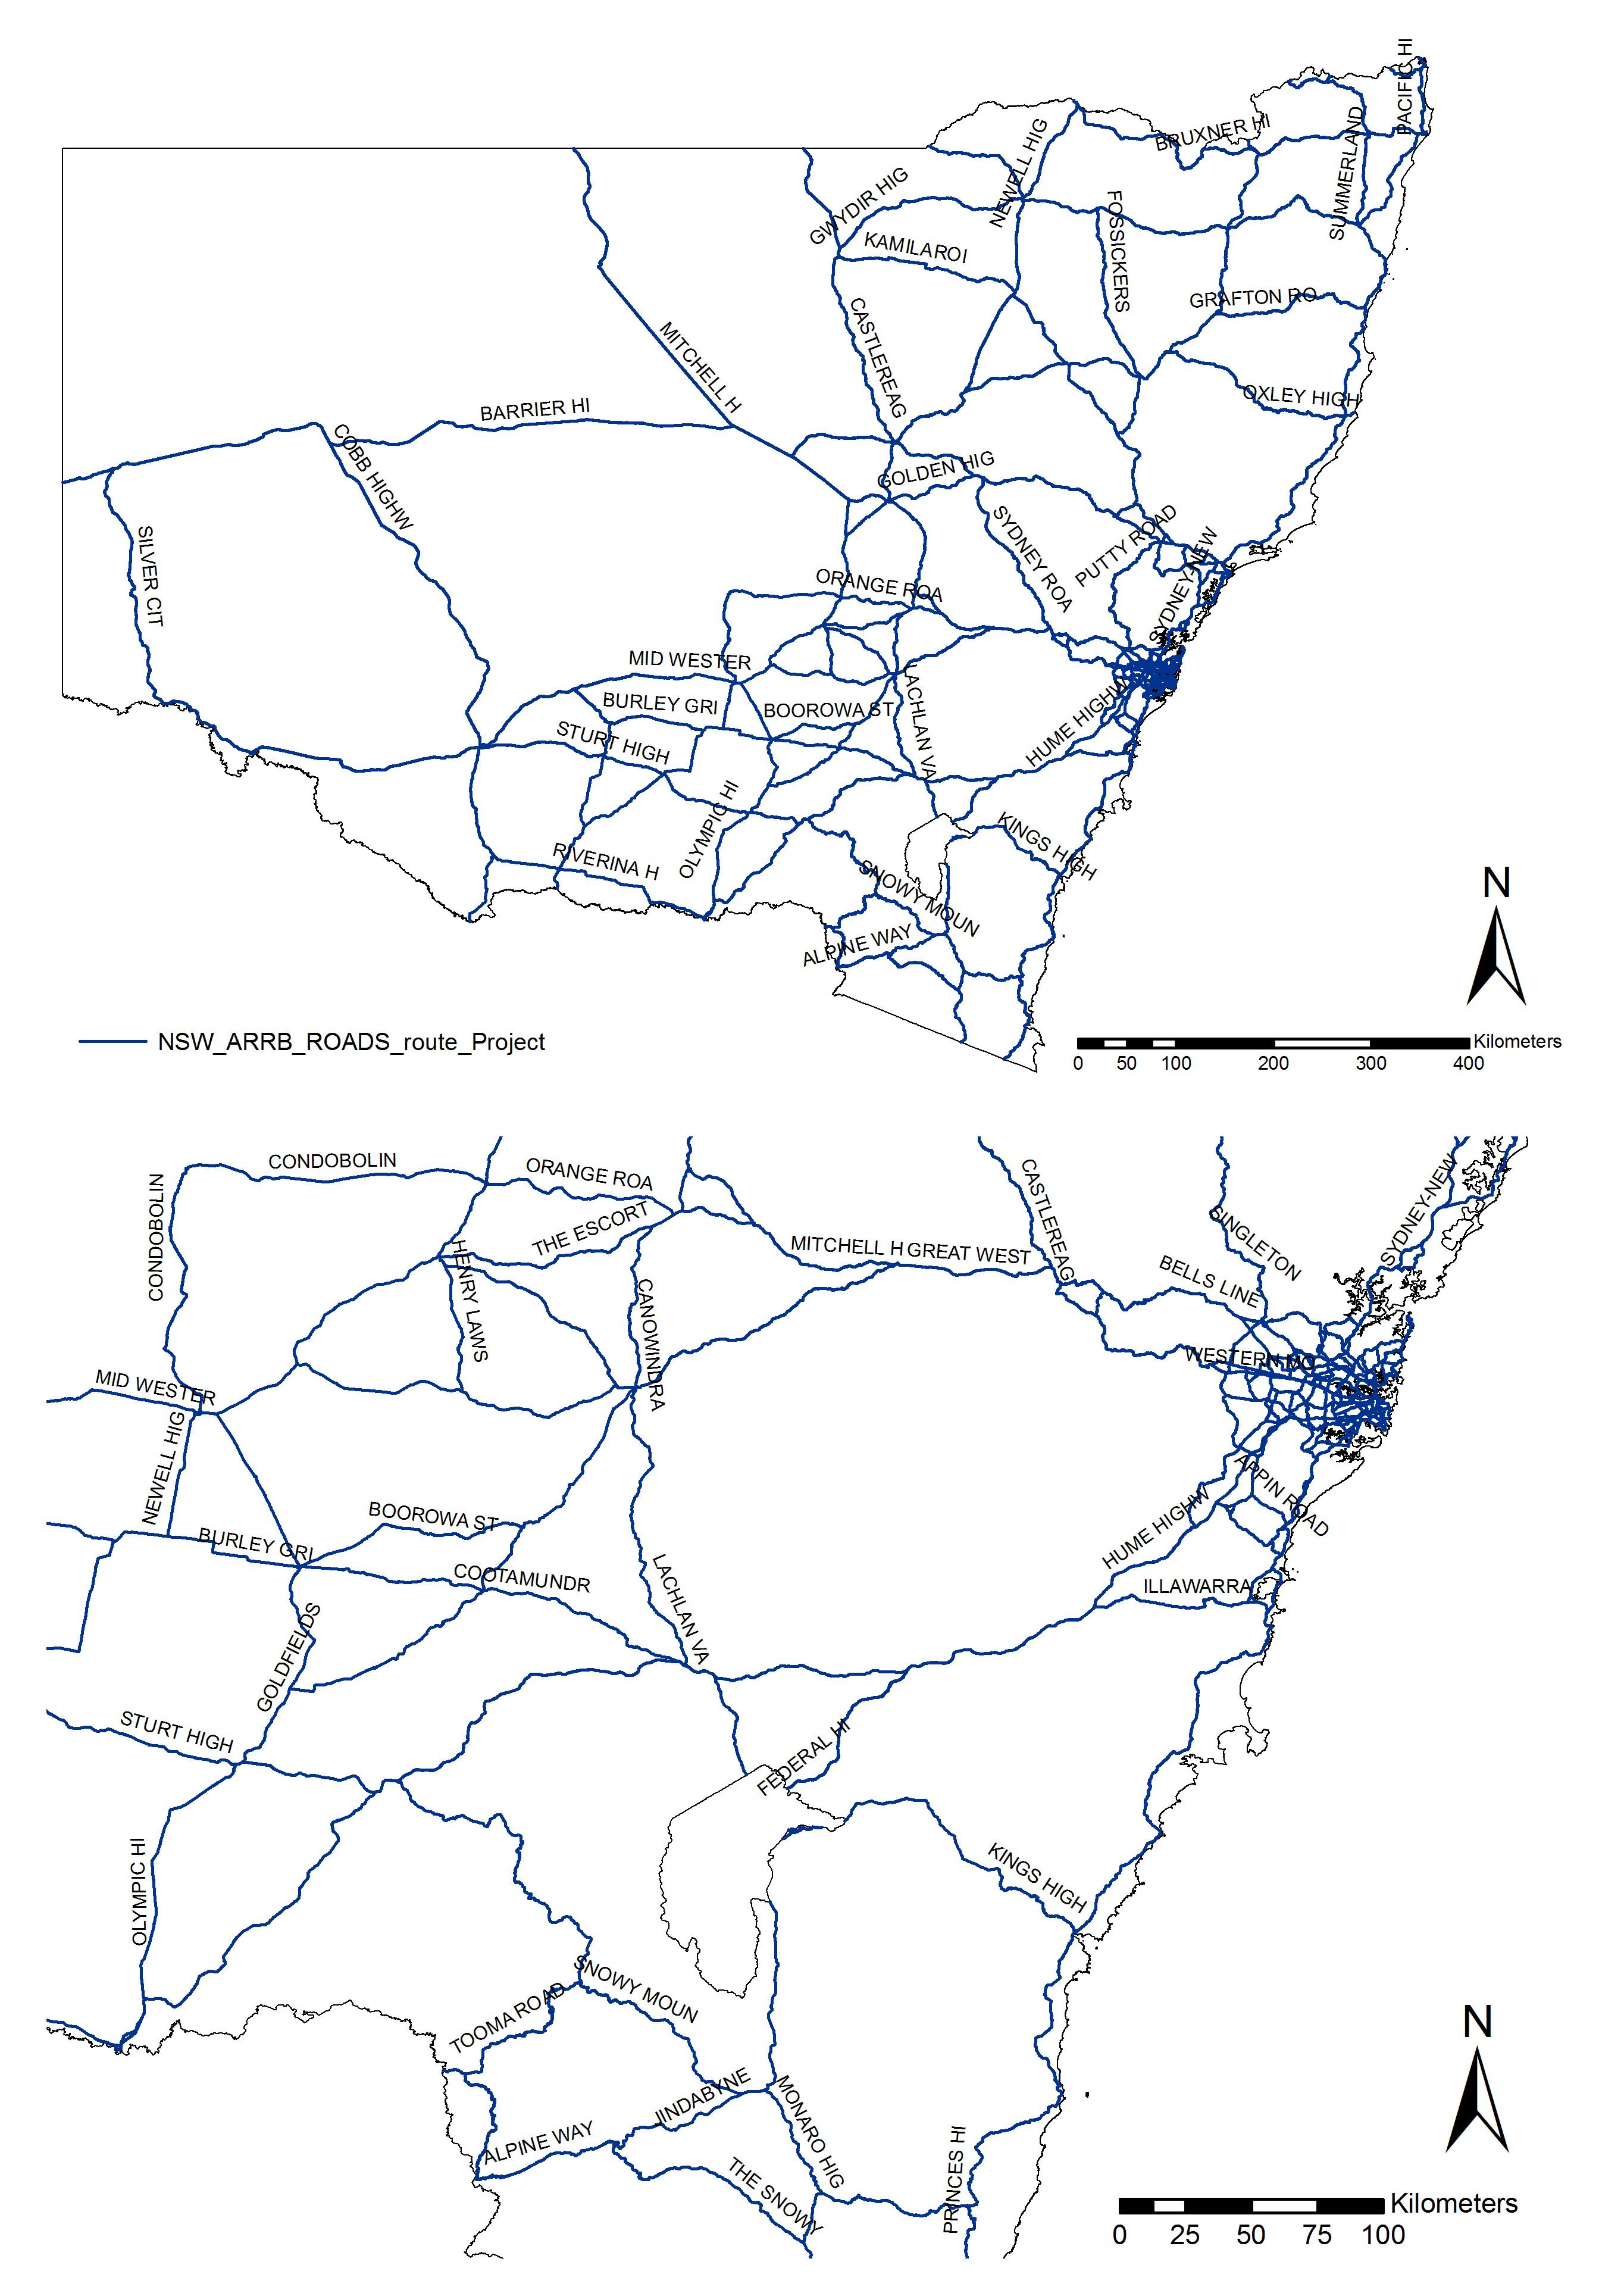
Map A 1: Major roads in NSW (with focus around ACT)
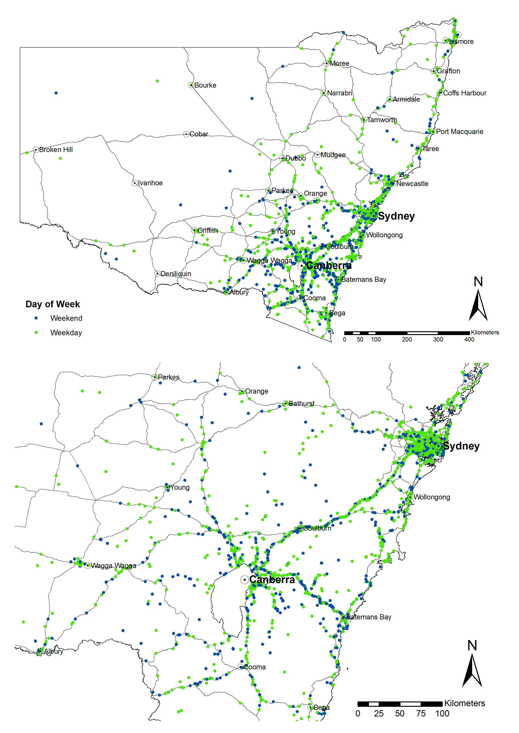
Map A 2: Crashes in NSW involving ACT controllers by day of week (weekday or weekend)
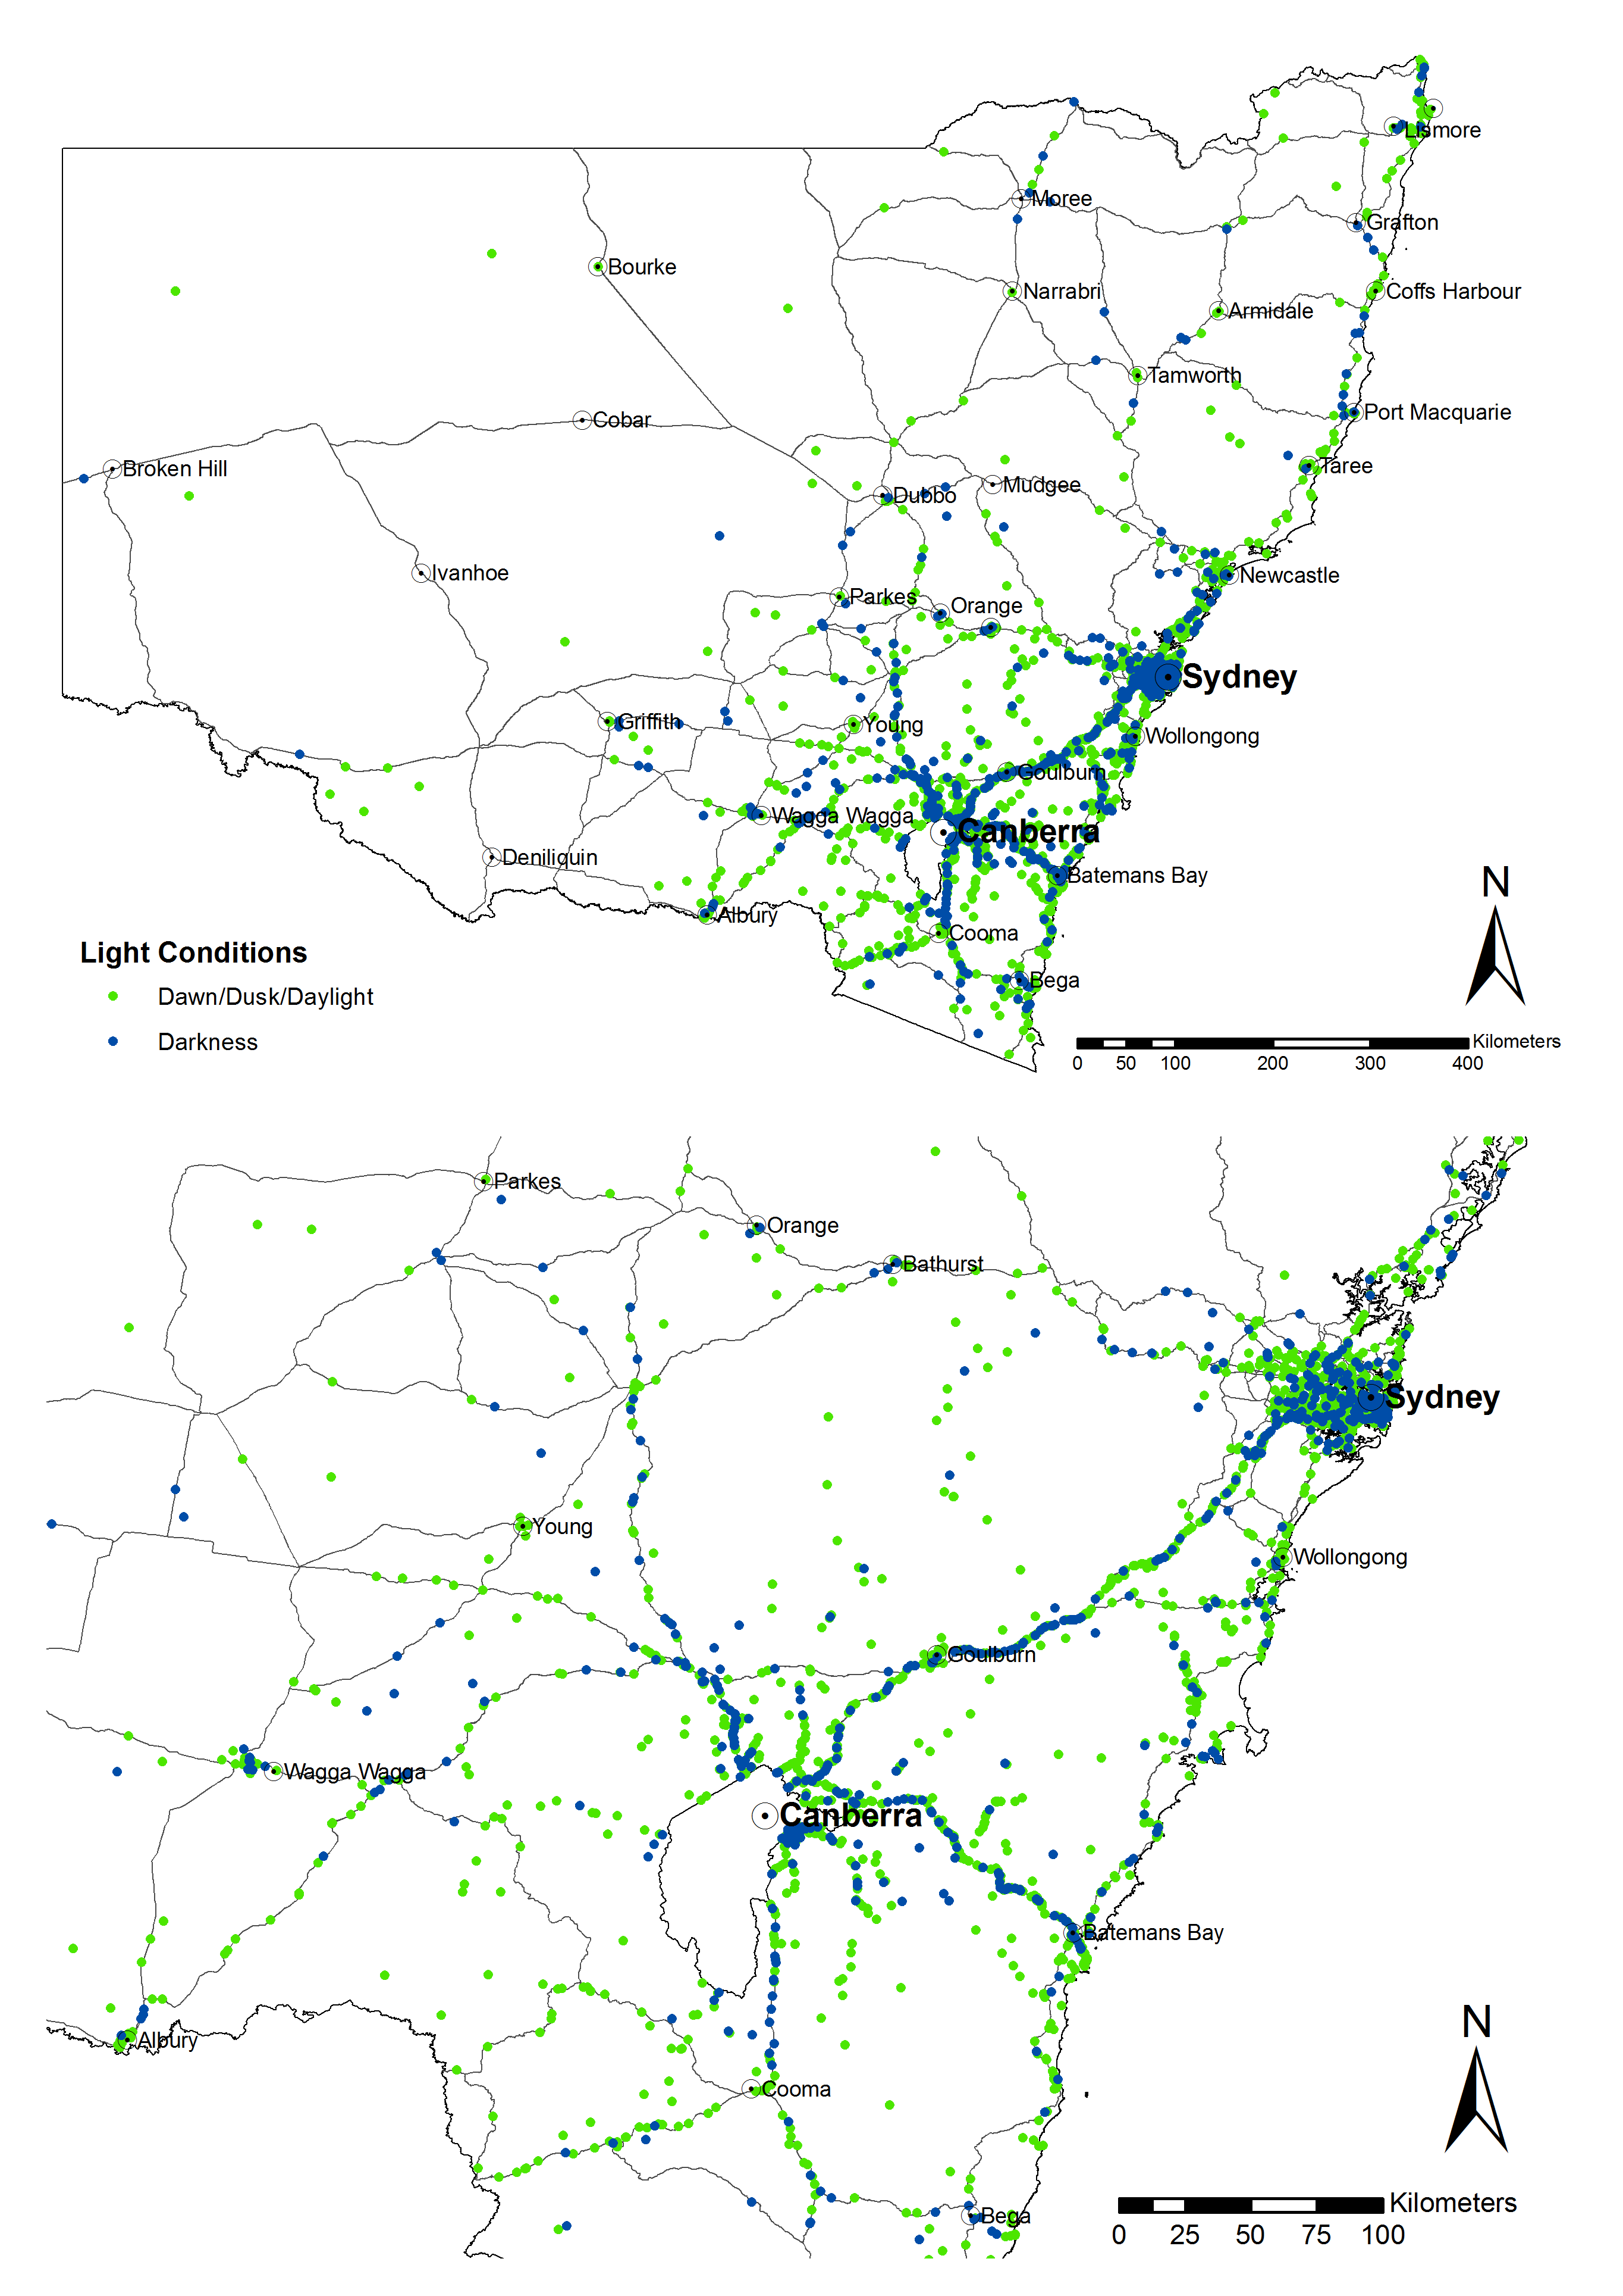
Map A 3: Crashes in NSW involving ACT controllers by light conditions
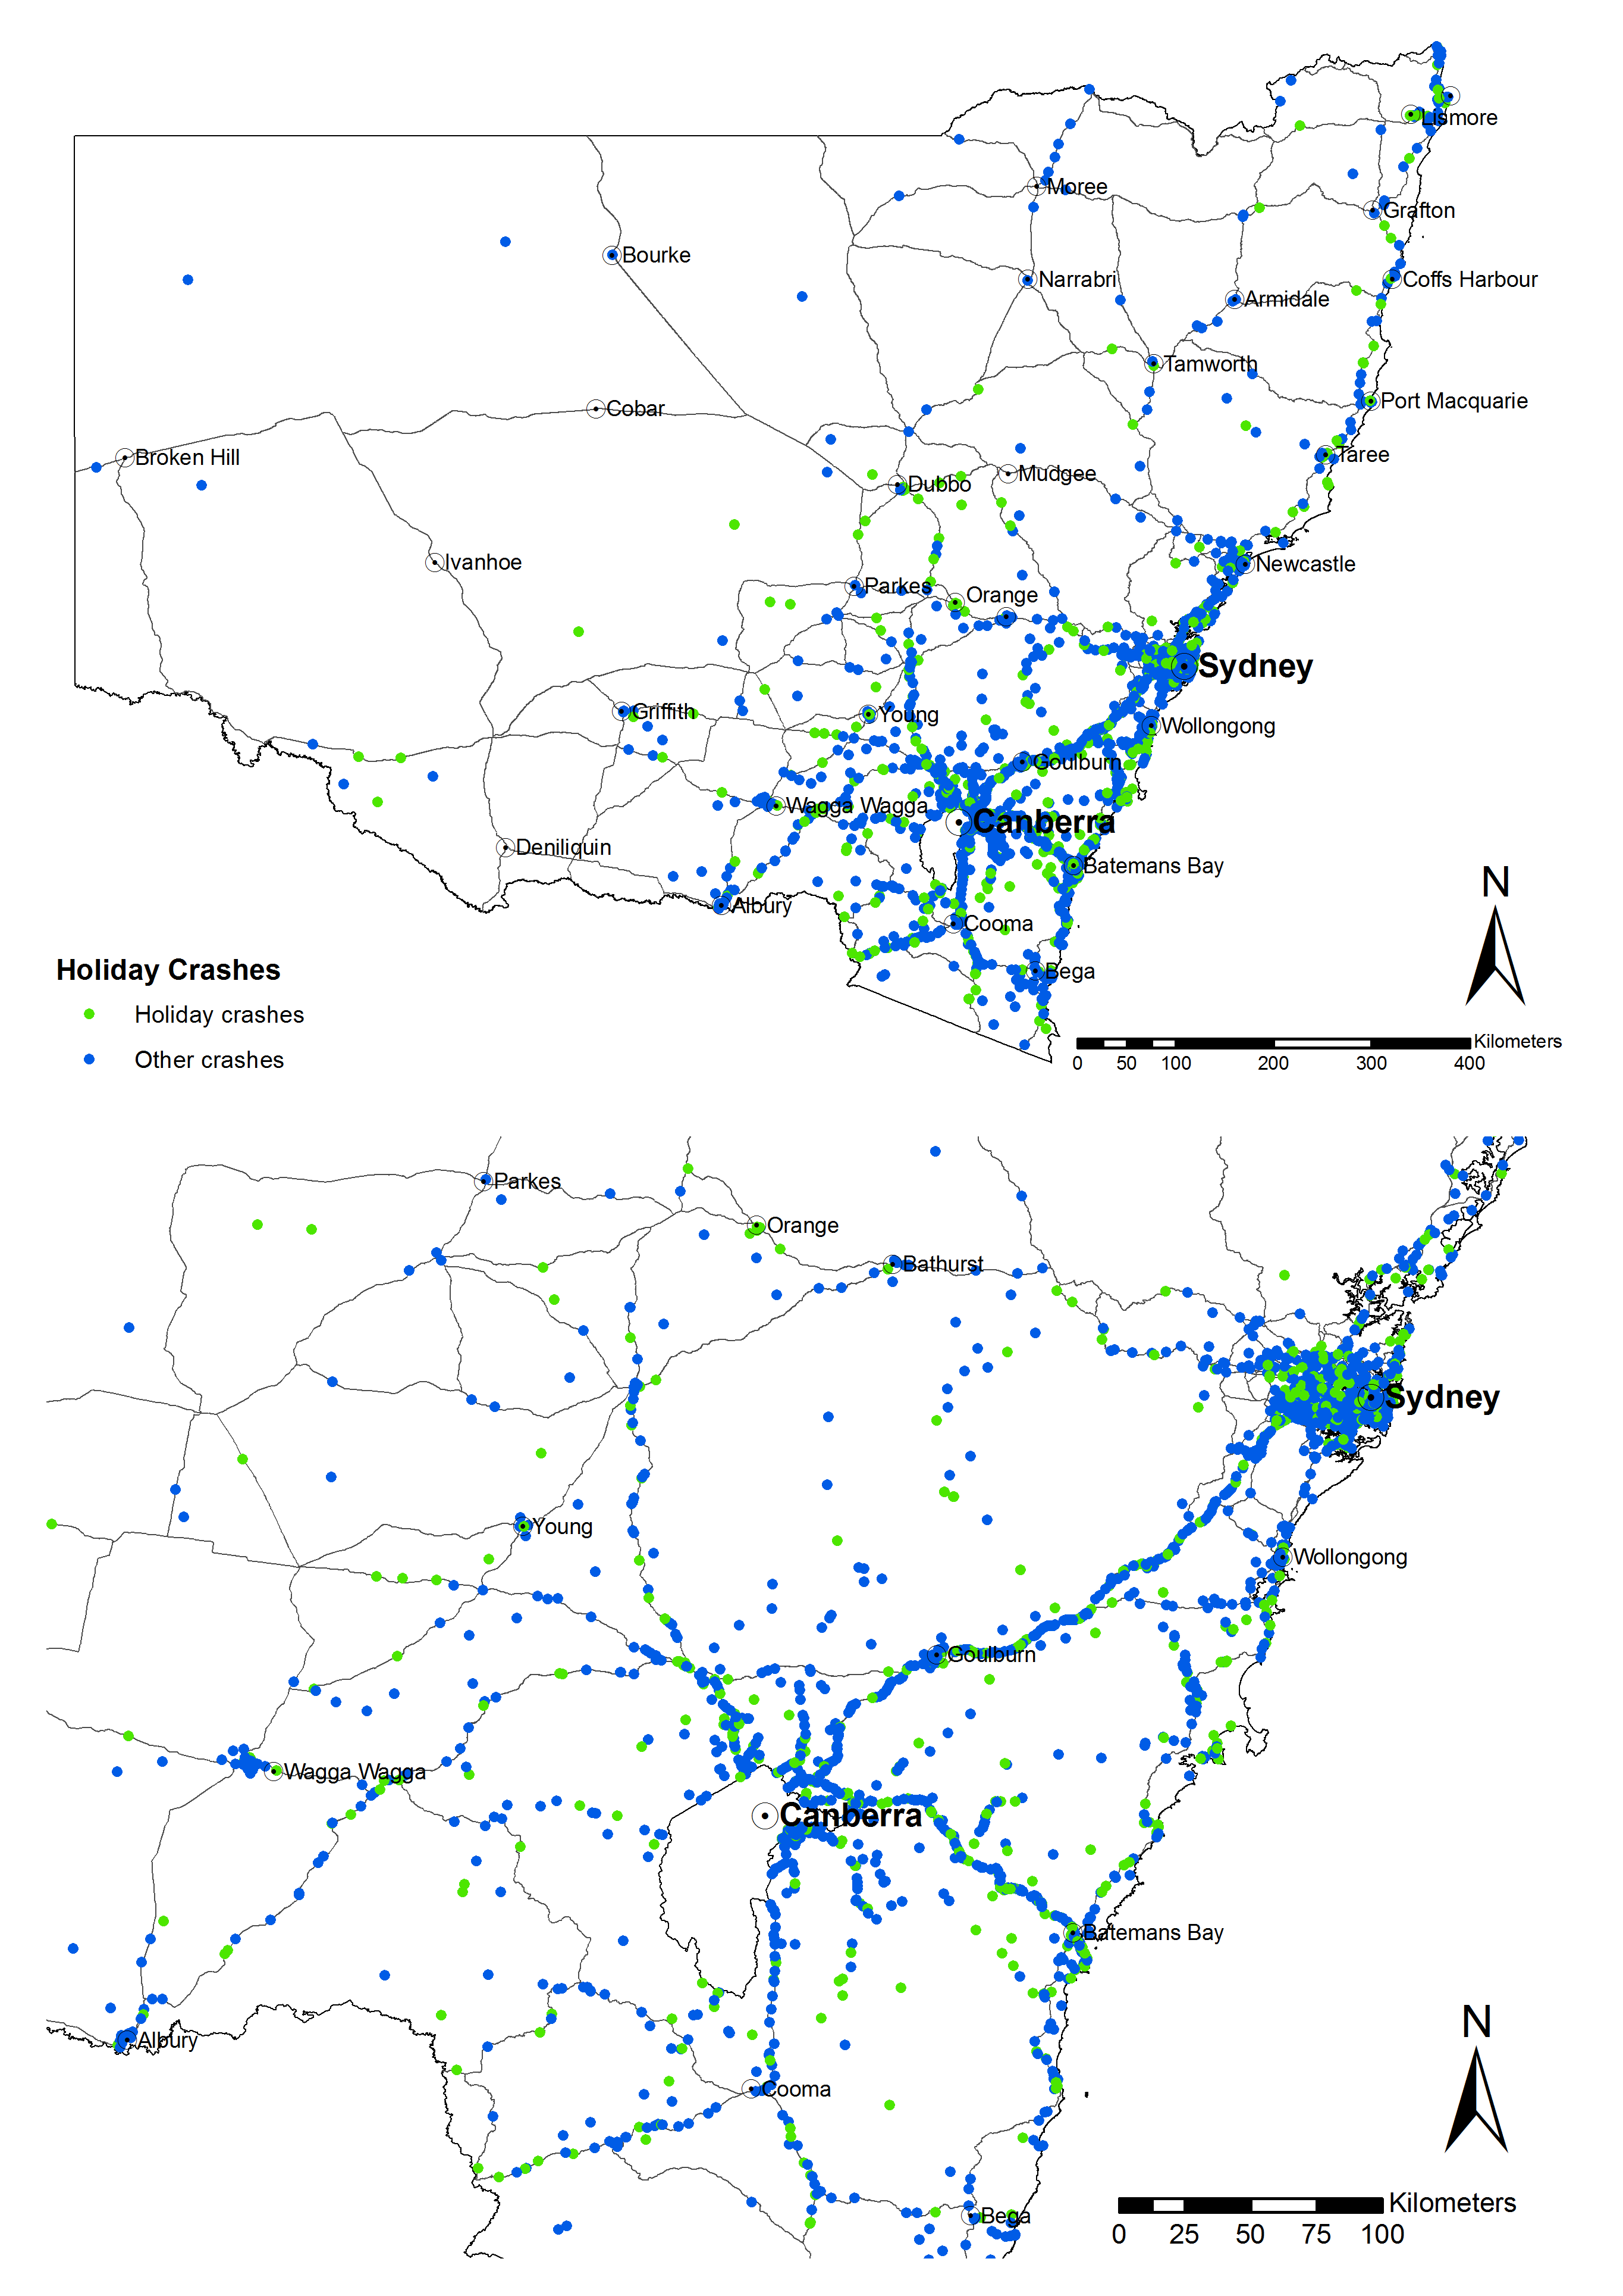
Map A 4: Crashes in NSW involving ACT controllers during holidays
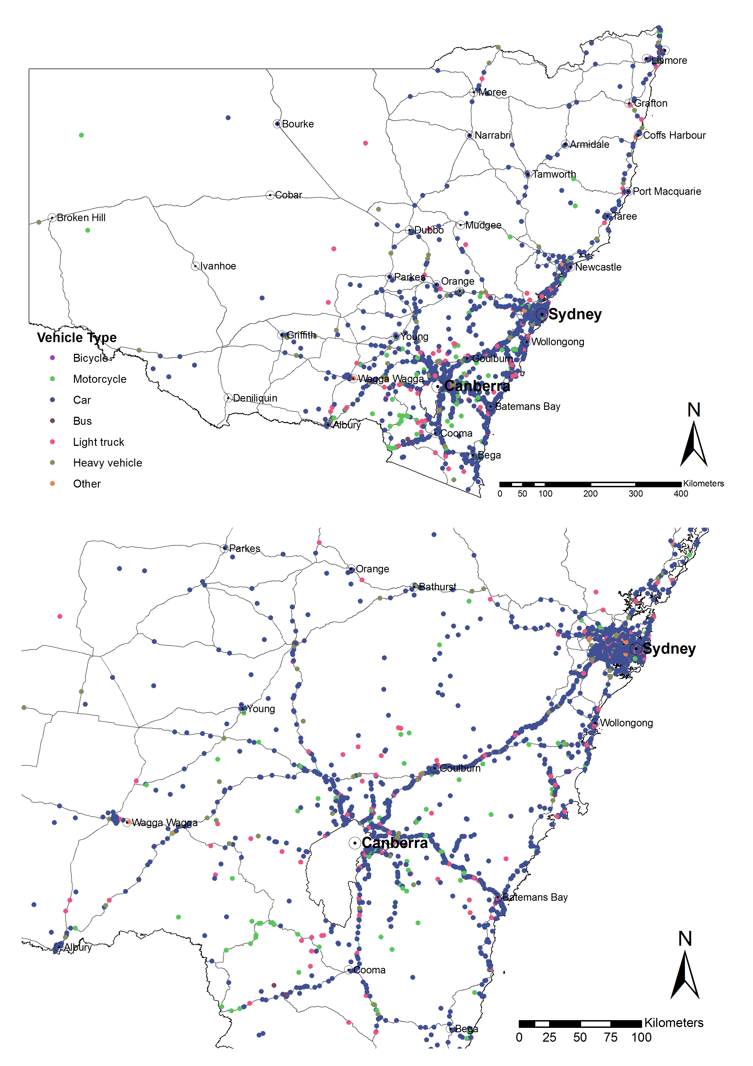
Map A 5: Crashes in NSW involving ACT controllers by vehicle type
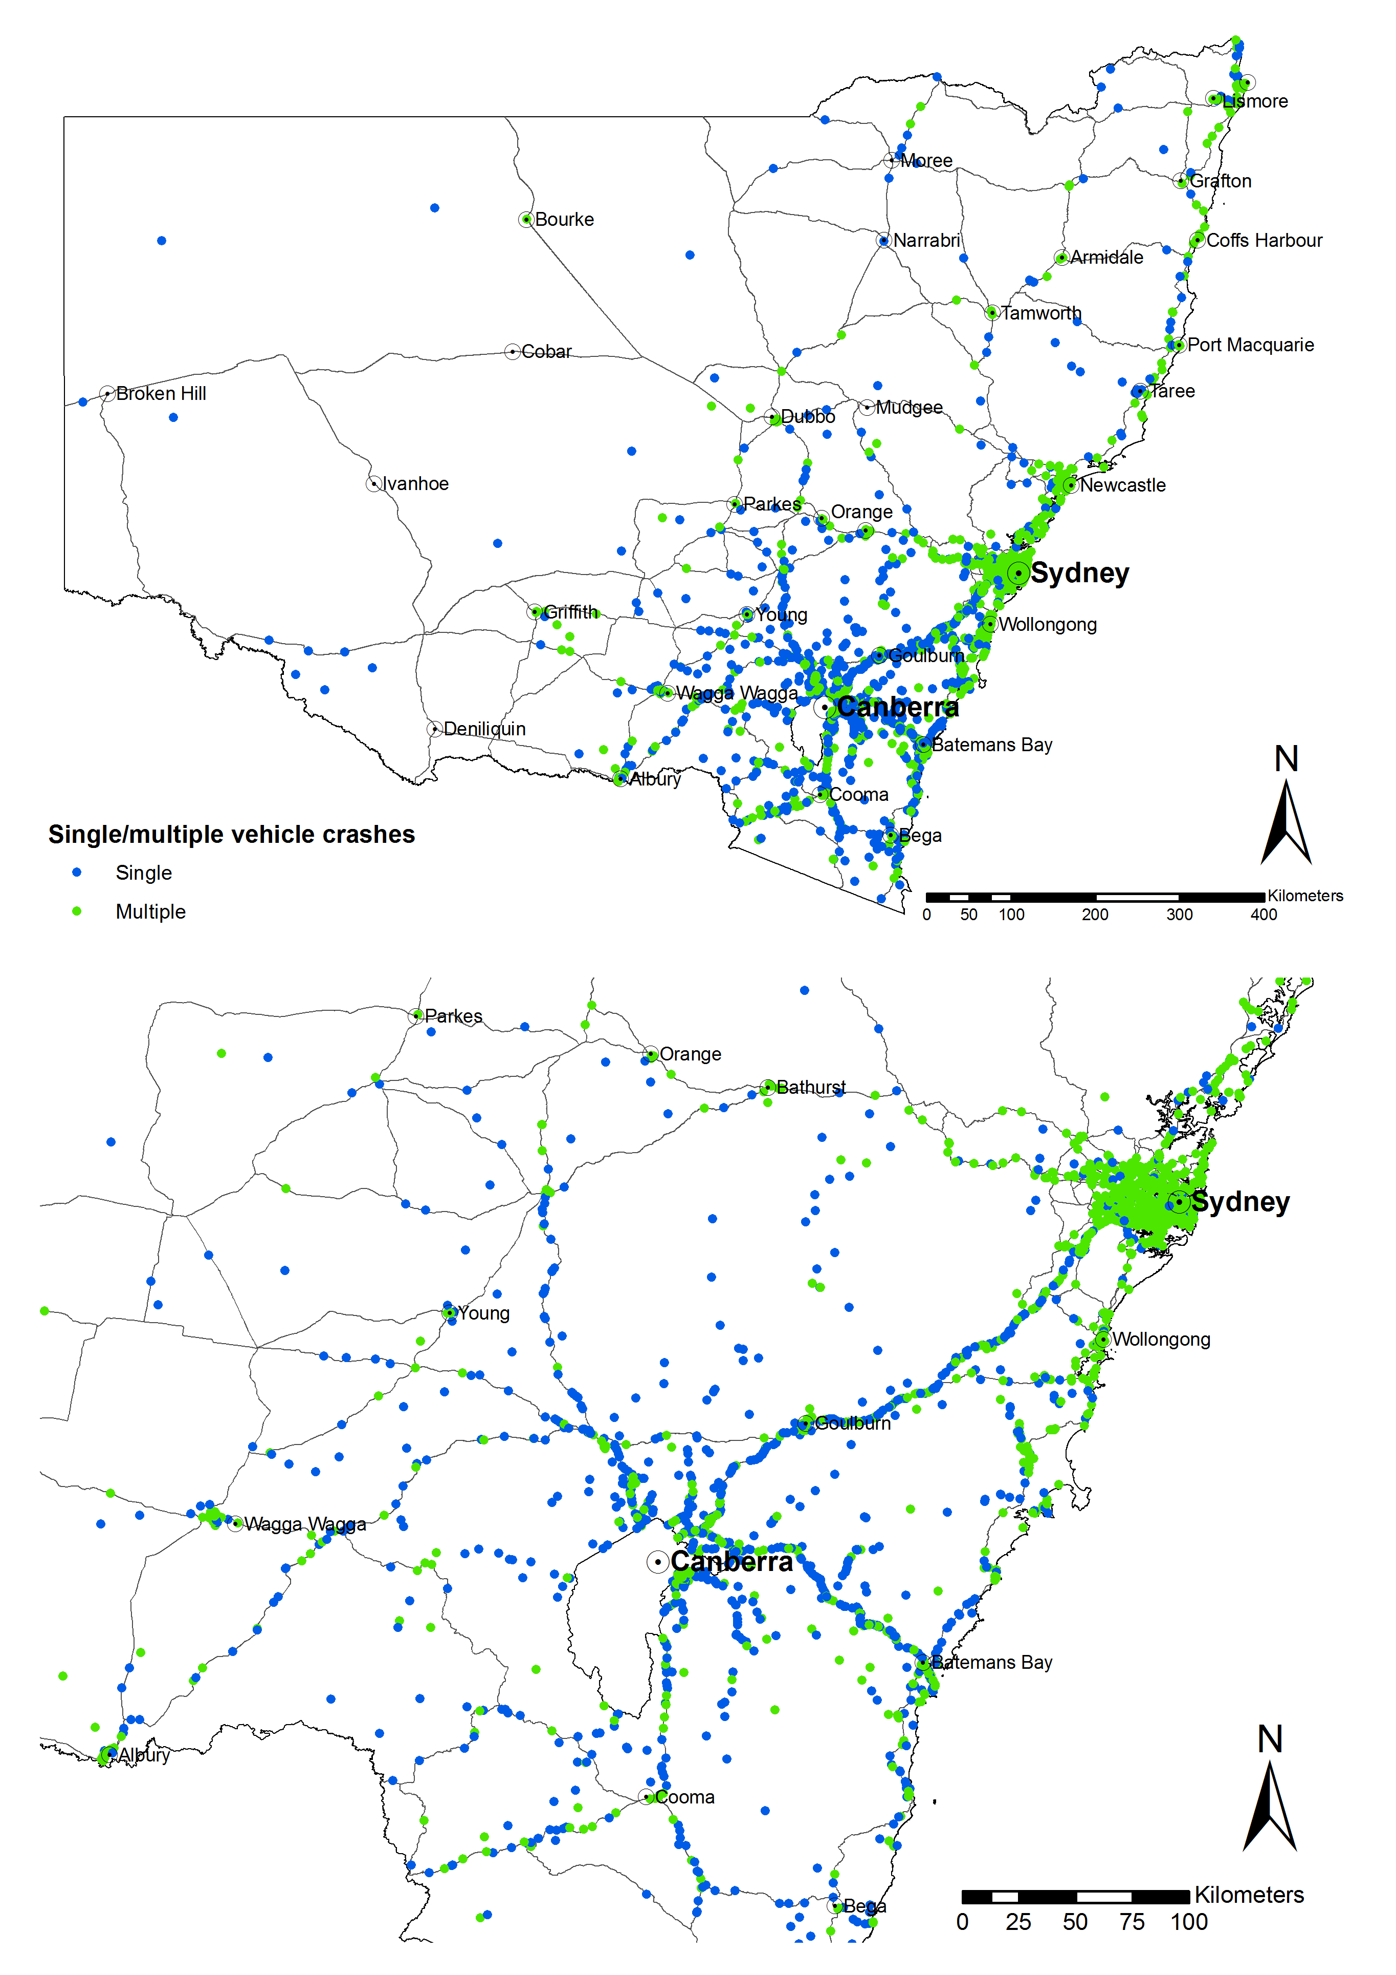
Map A 6: Single and multiple vehicle crashes in NSW involving ACT controllers
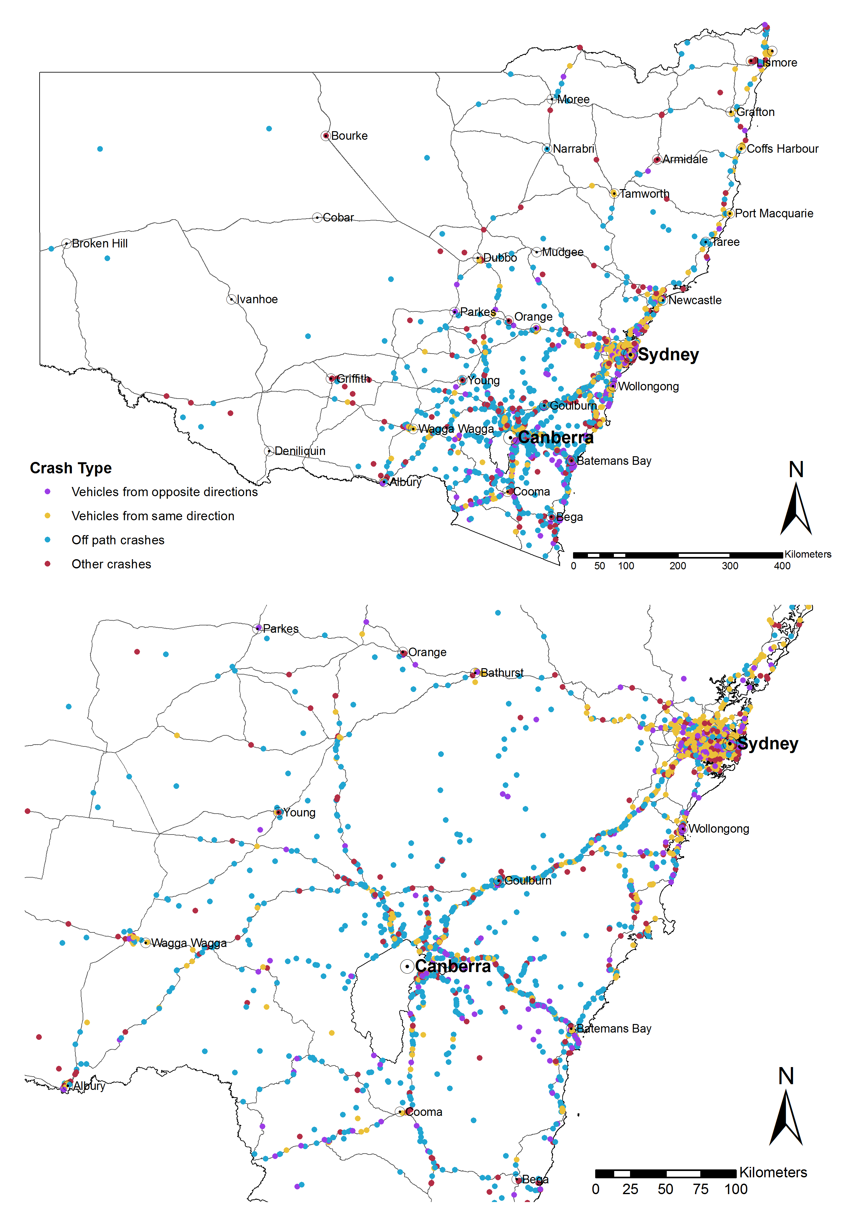
Map A 7: Crashes in NSW involving ACT controllers by major crash types
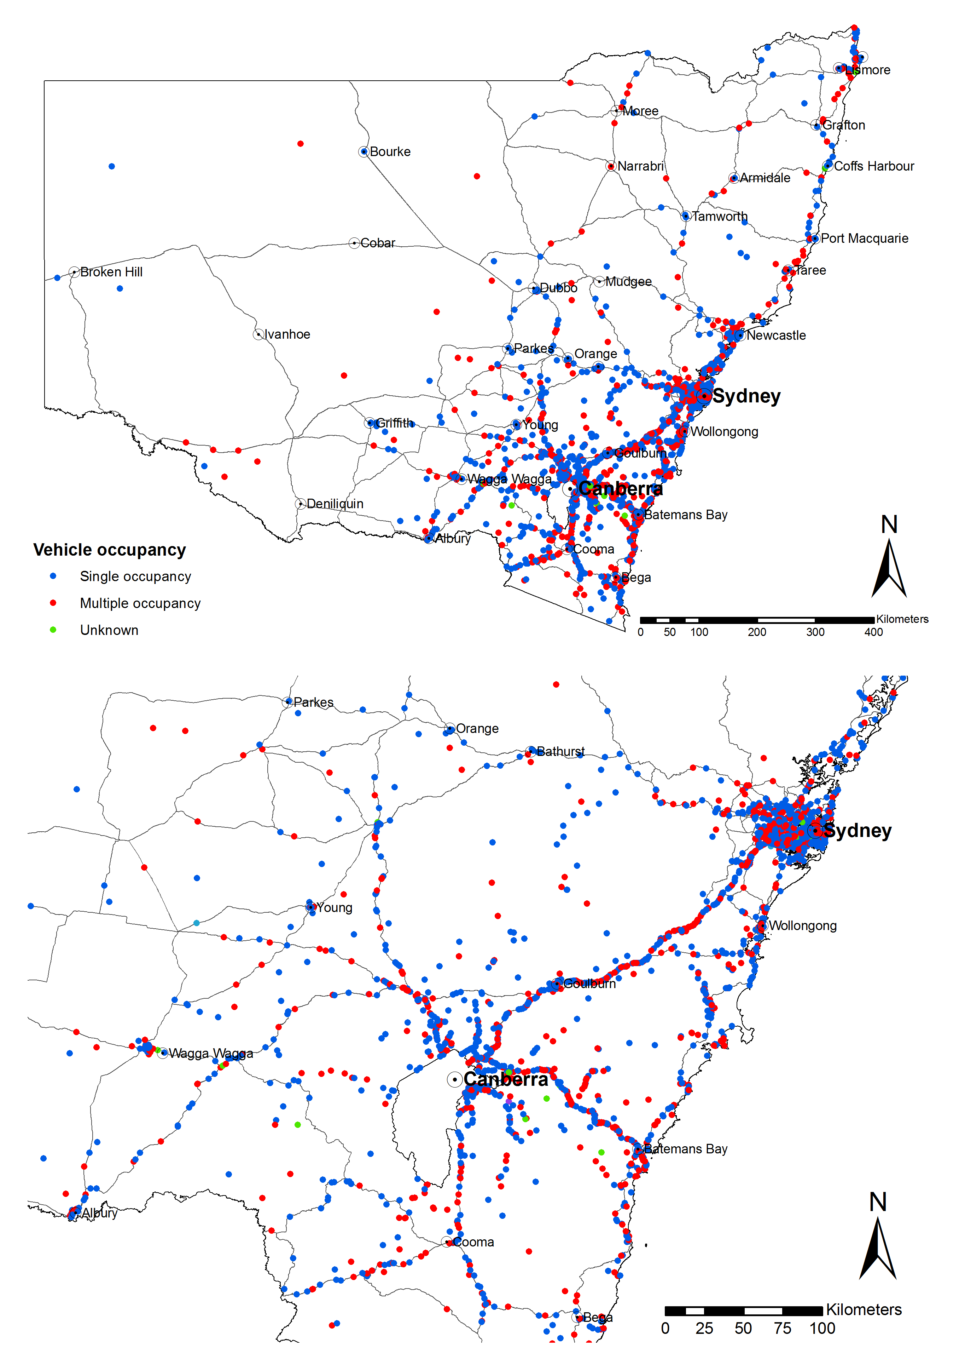
Map A 8: Crashes involving ACT controllers in NSW by vehicle occupancy
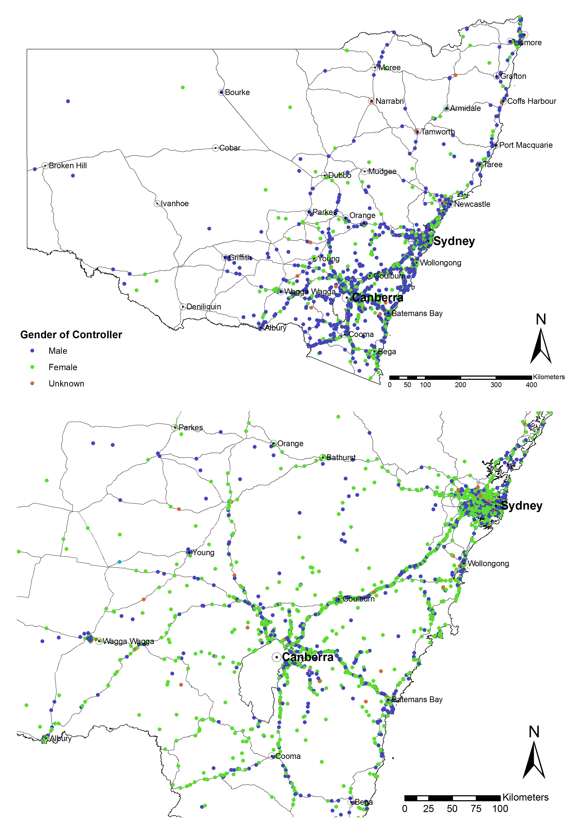
Map A 9: ACT controllers involved in crashes in NSW by gender
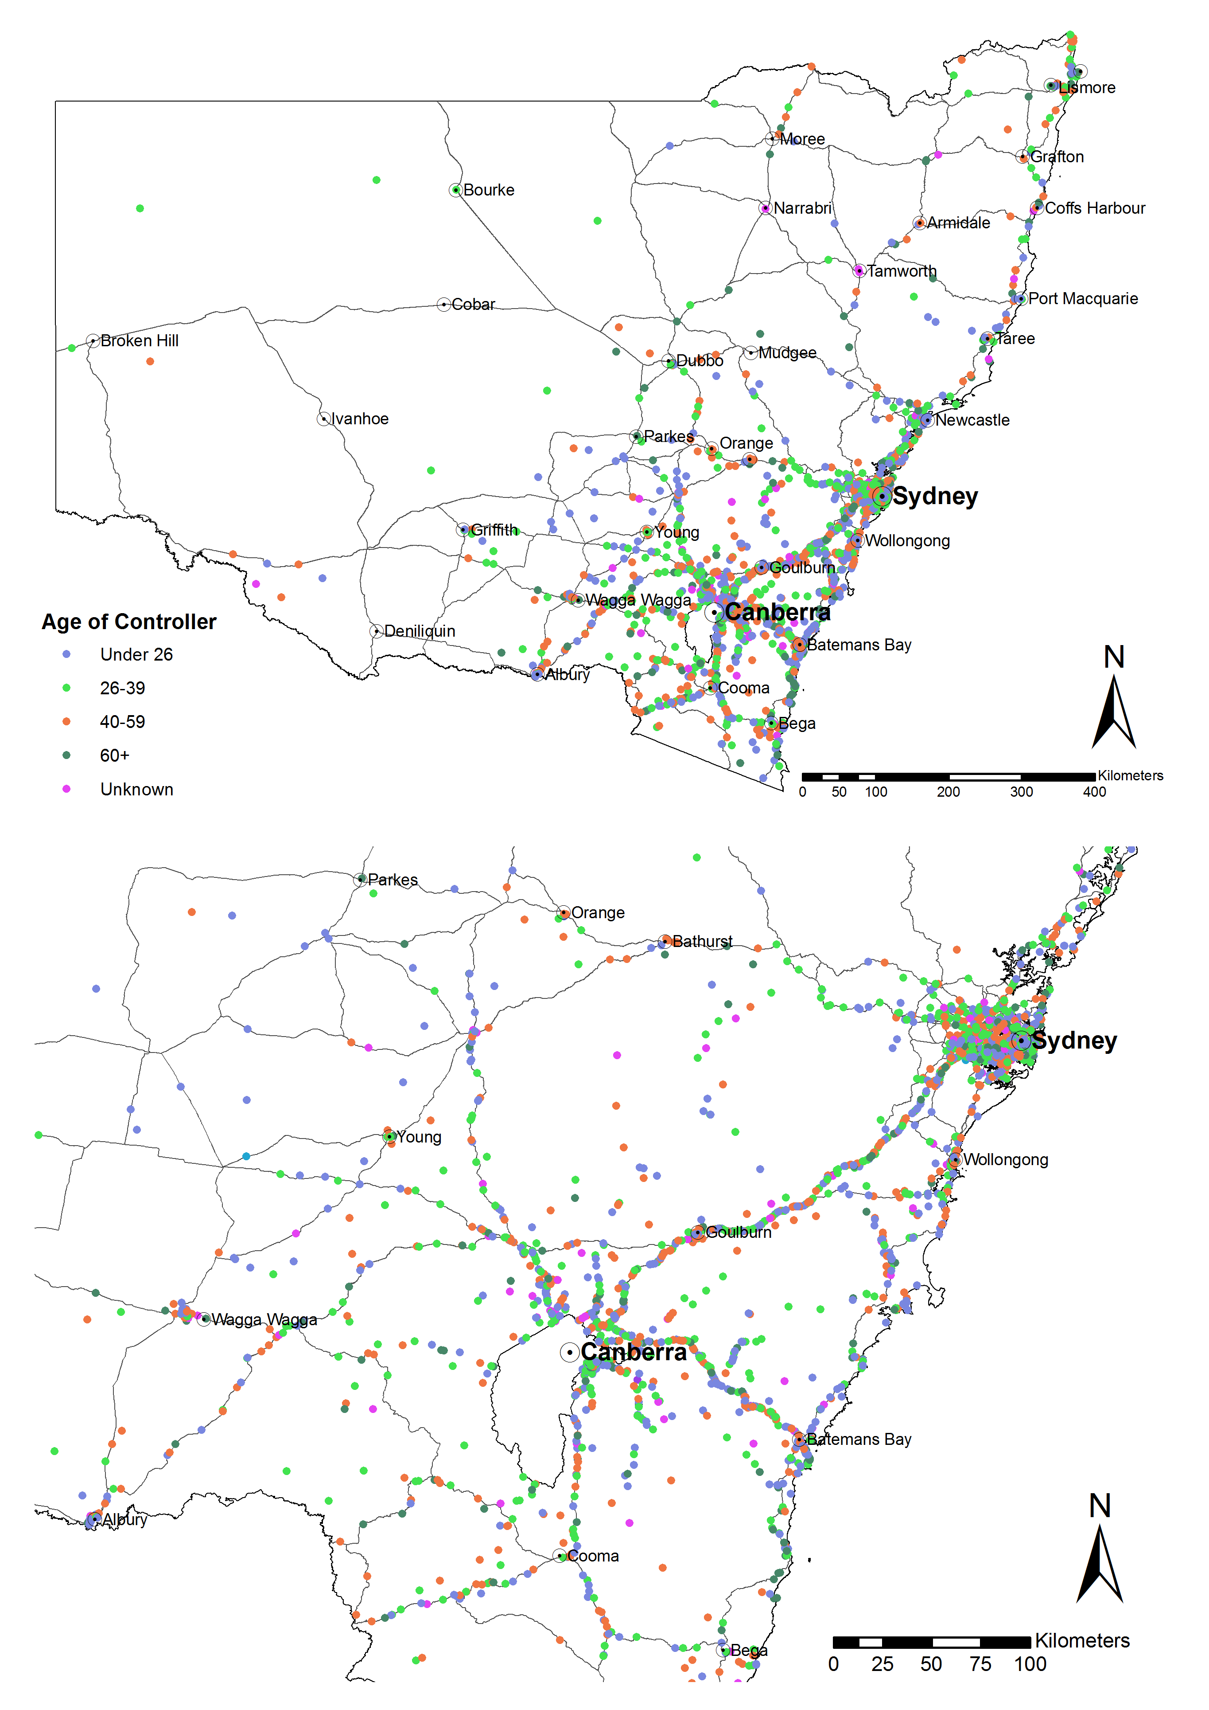
Map A 10: ACT controllers involved in crashes in NSW by age group
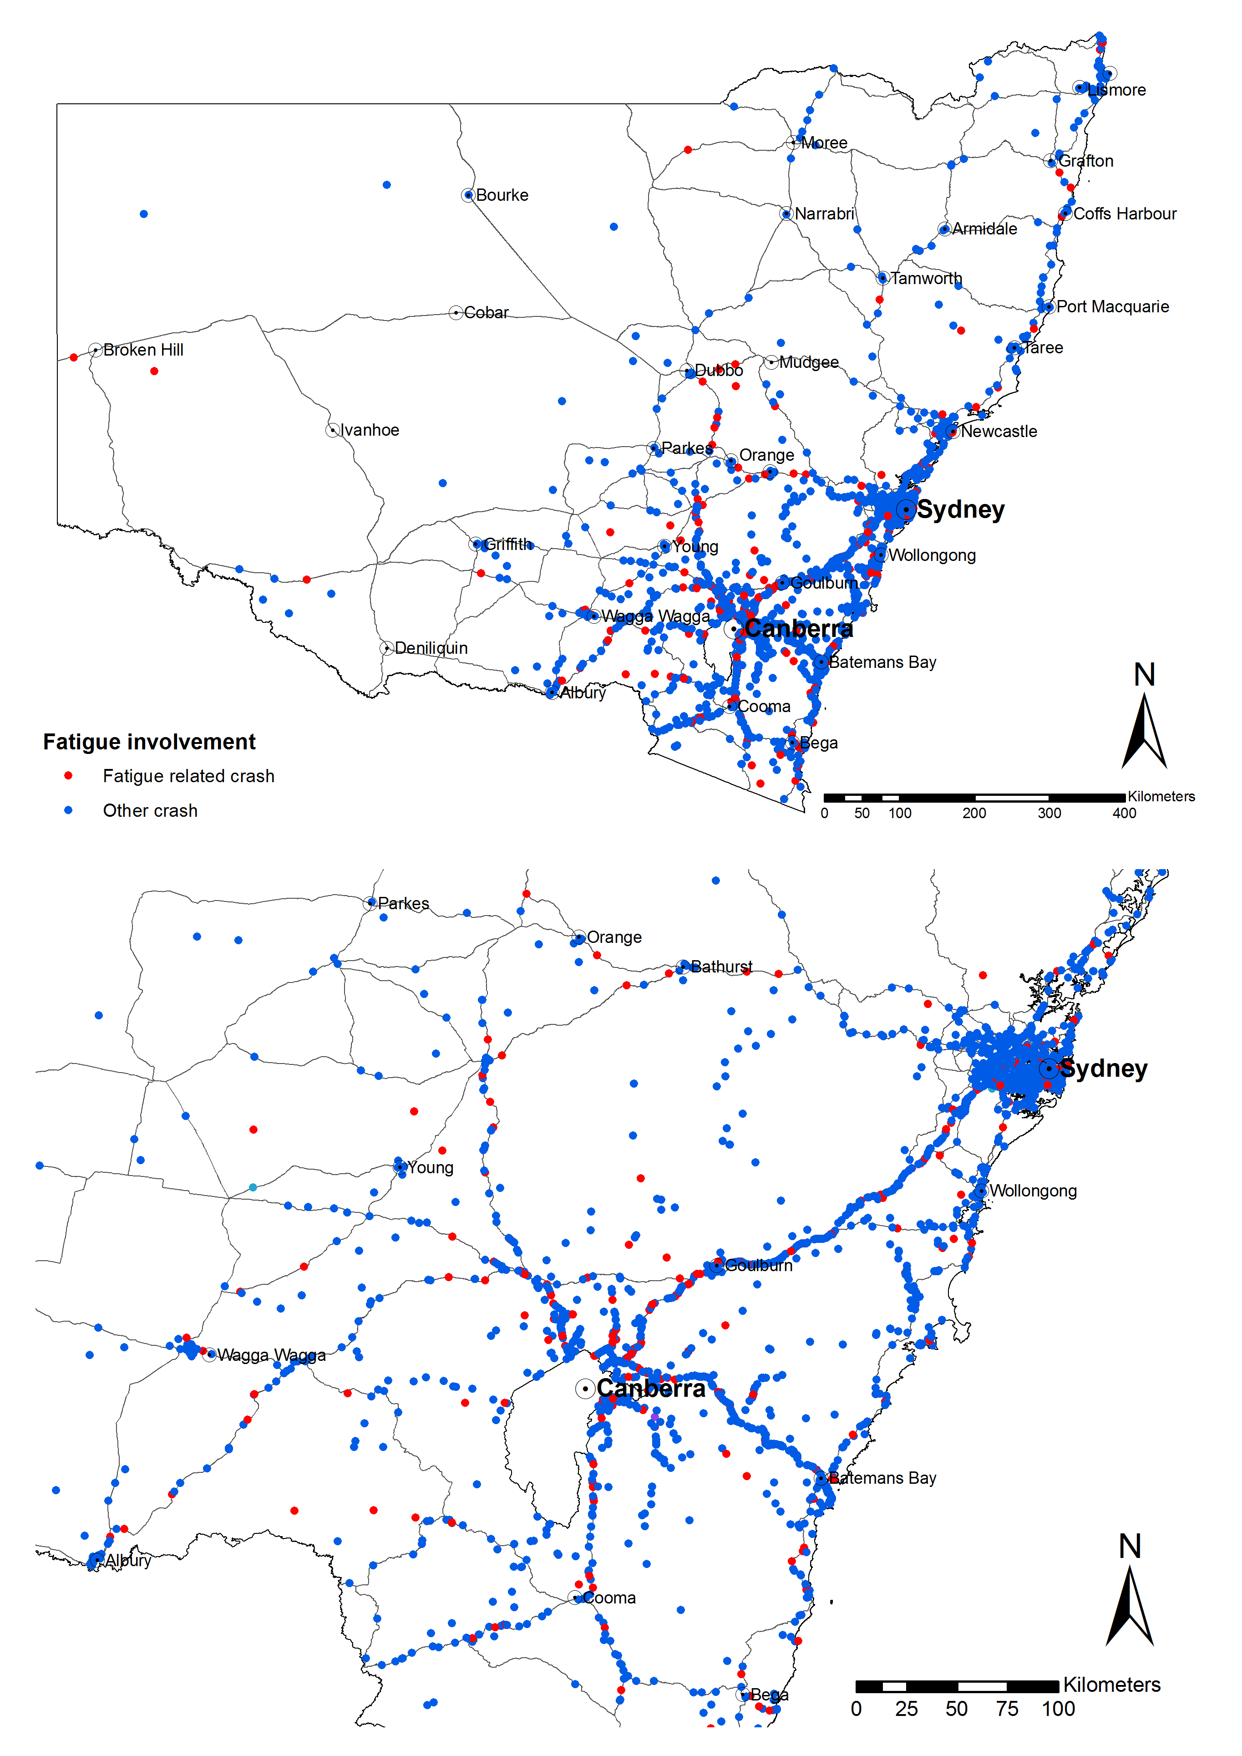
Map A 11: Fatigued ACT controllers involved in crashes in NSW
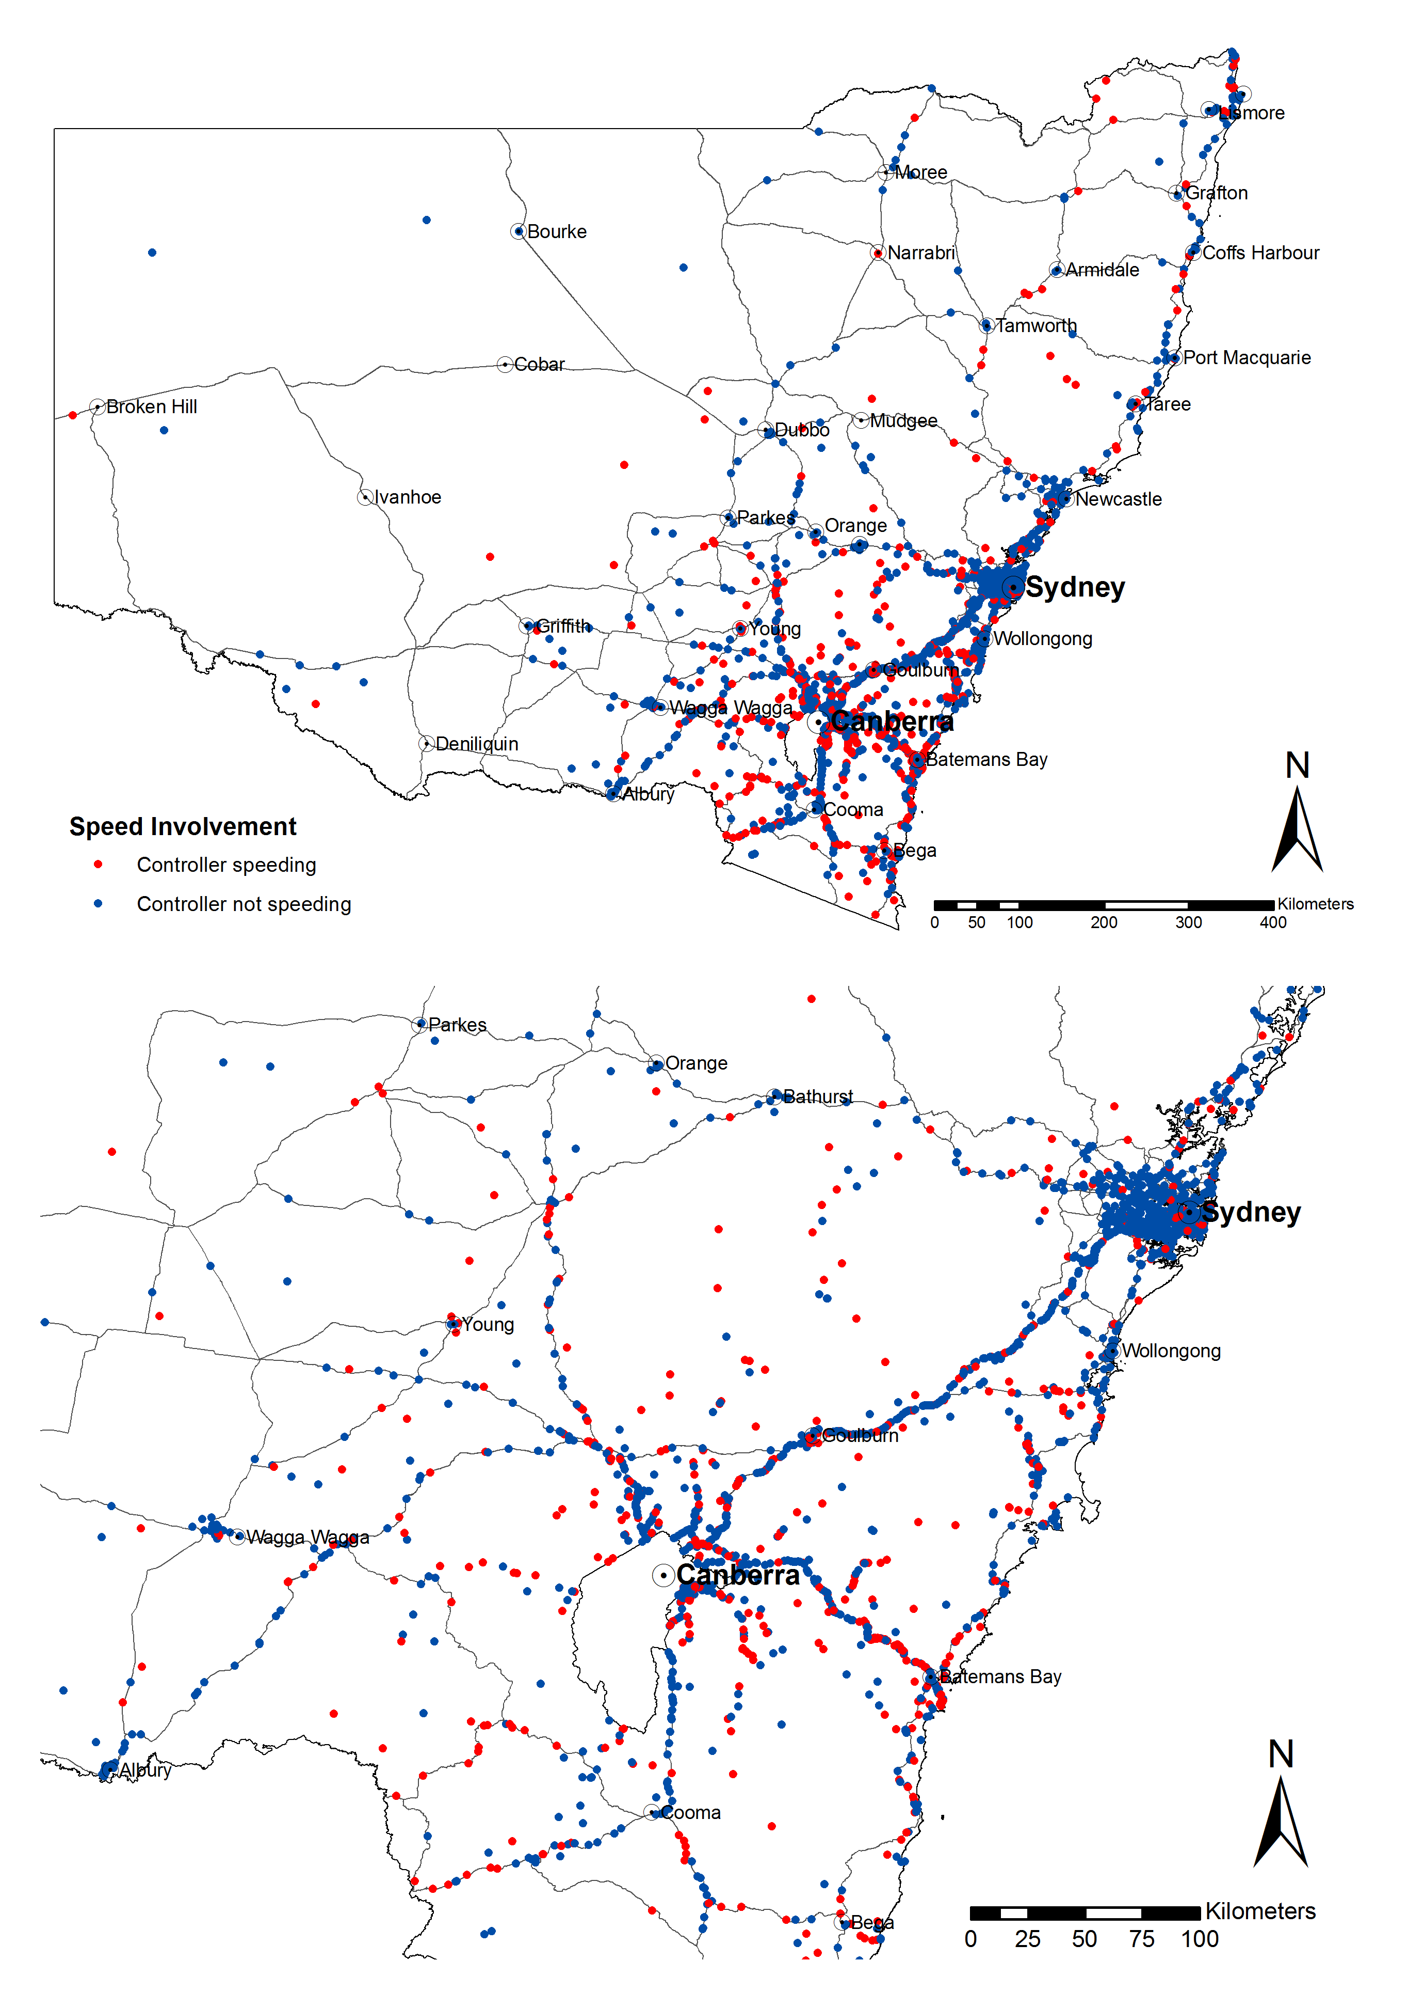
Map A 12: ACT controllers involved in crashes in NSW who were exceeding the speed limit
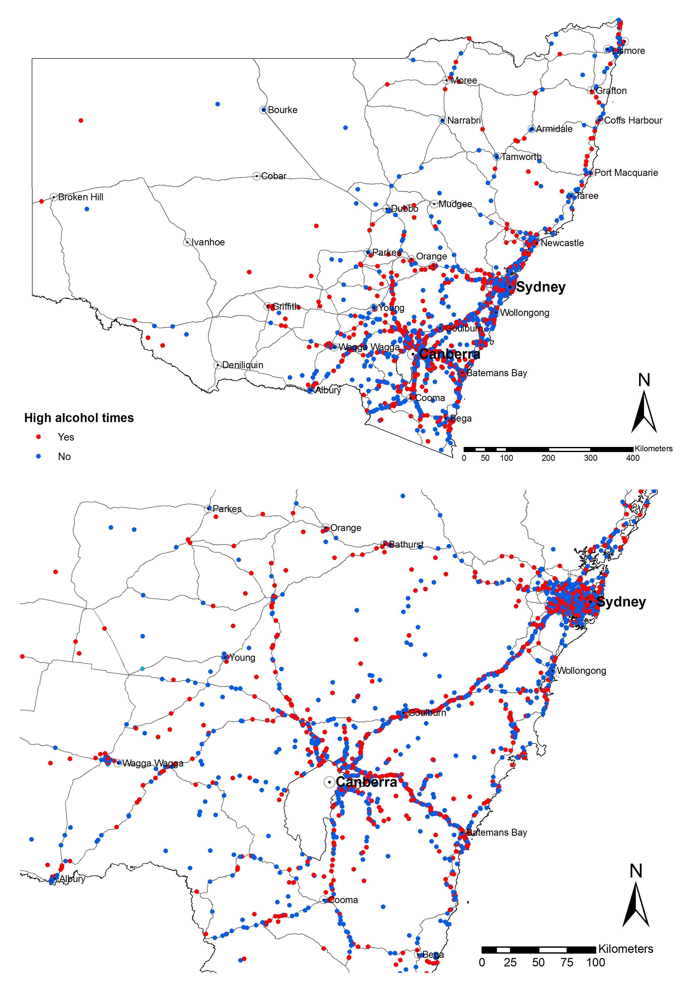
Map A 13: Crashes in NSW involving ACT controllers that occurred during high alcohol times
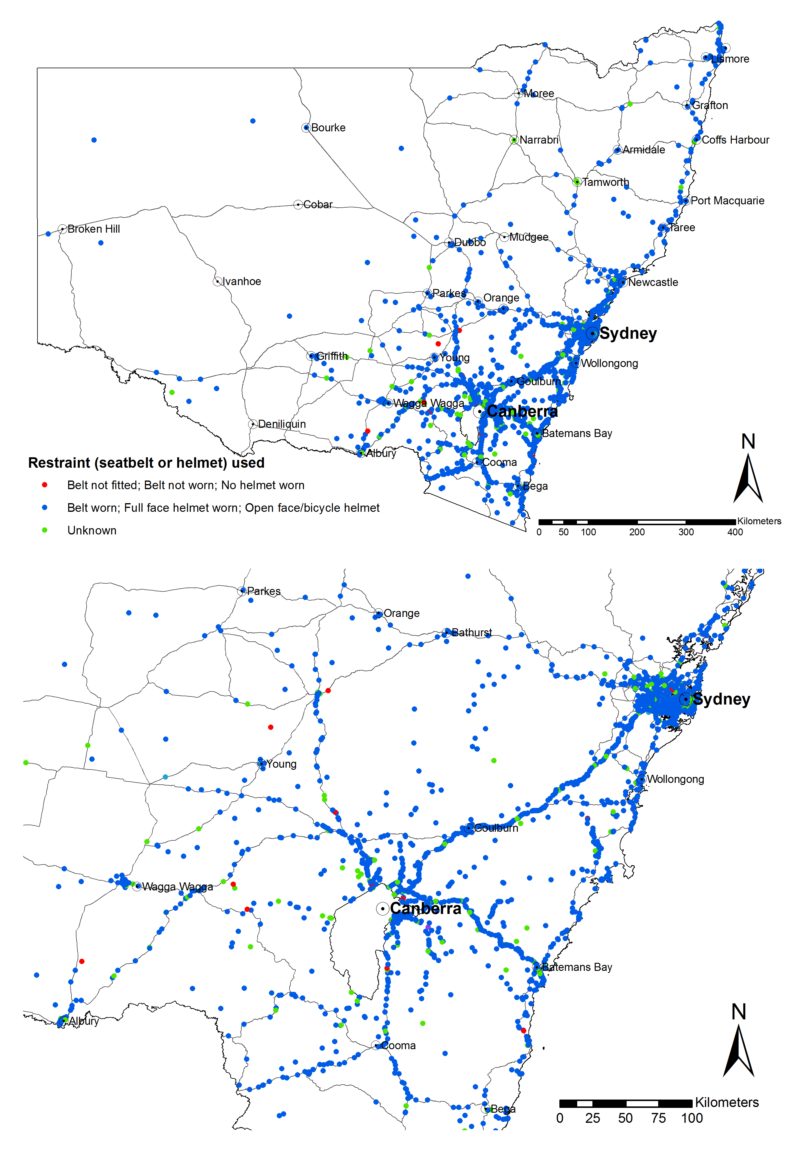
Map A 14: ACT controllers involved in crashes in NSW by restraint use
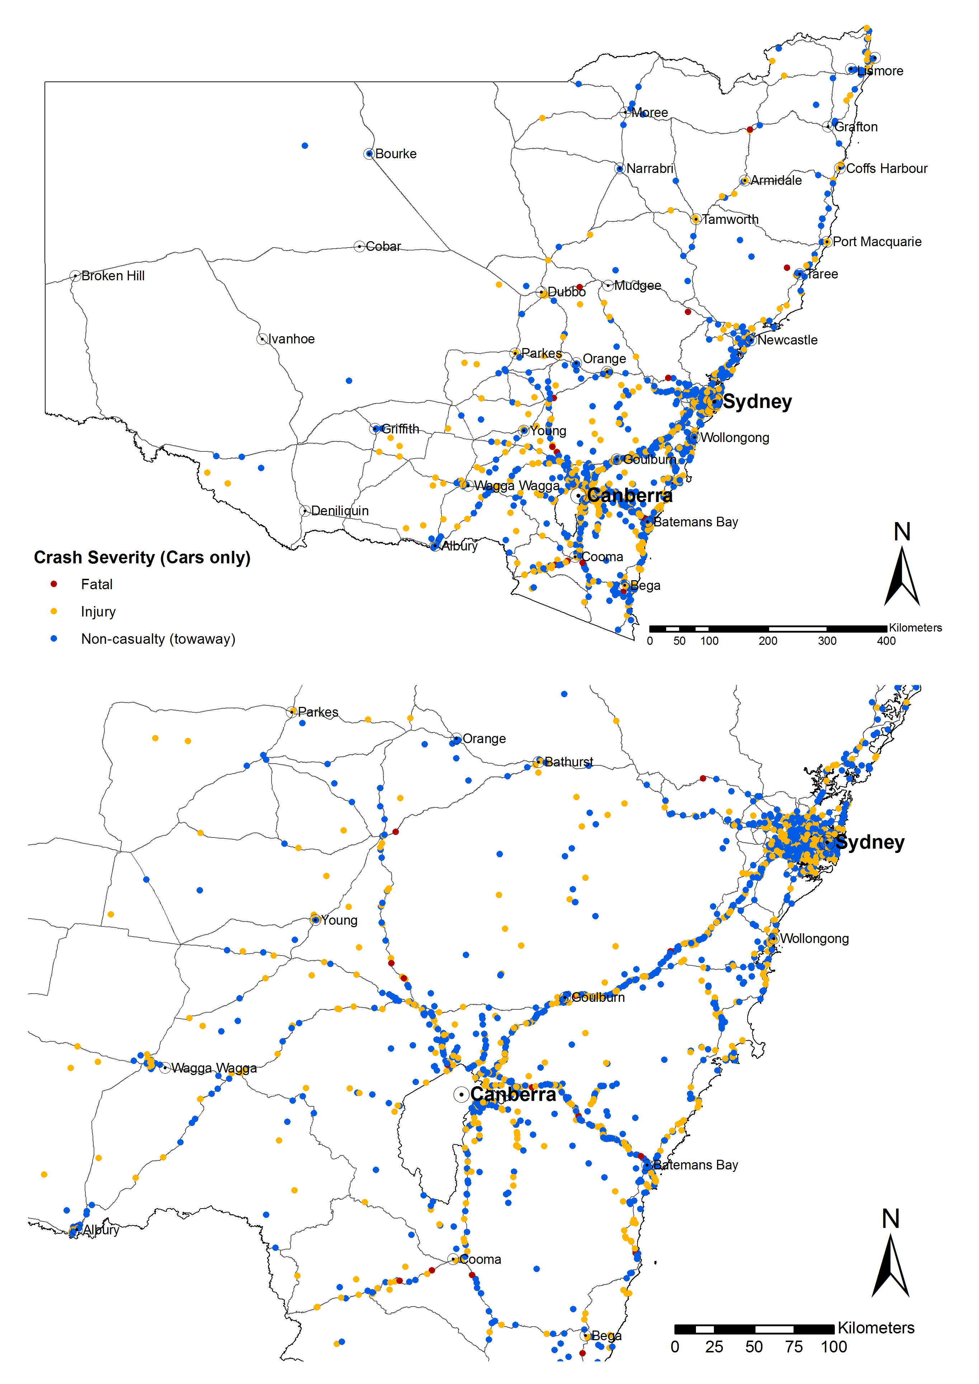
Map A 15: Crashes involving ACT controllers by crash severity (cars only)
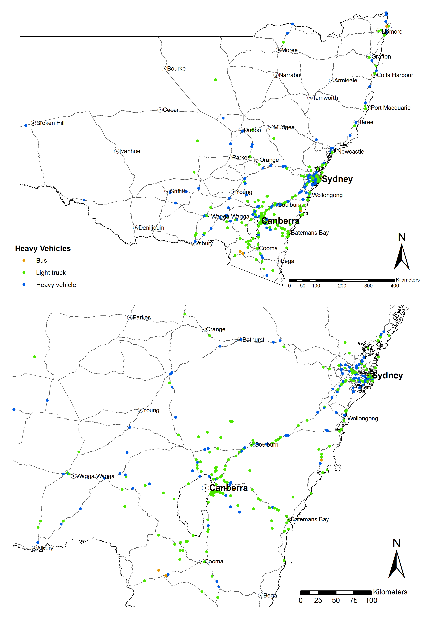
Map A 16: Heavy vehicle crashes in NSW involving ACT controllers
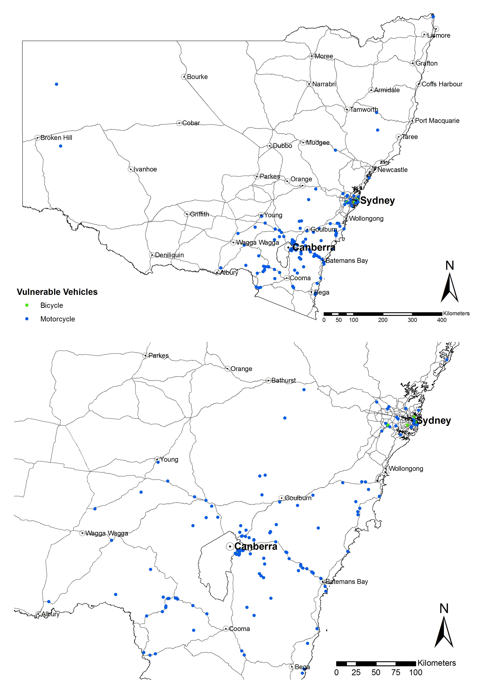
Map A 17: Motorcycle and bicycle crashes in NSW involving ACT controllers
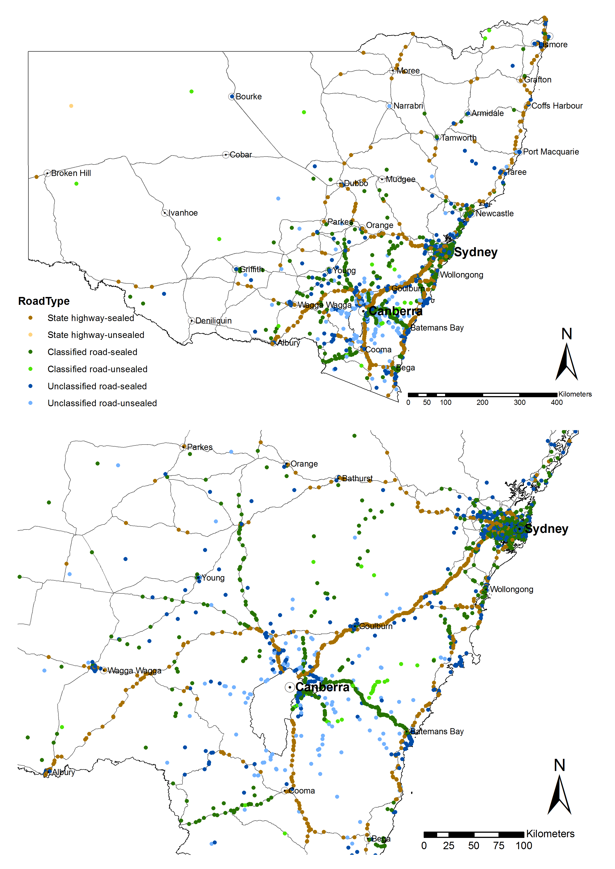
Map A 18: Crashes in NSW involving ACT controllers by road type
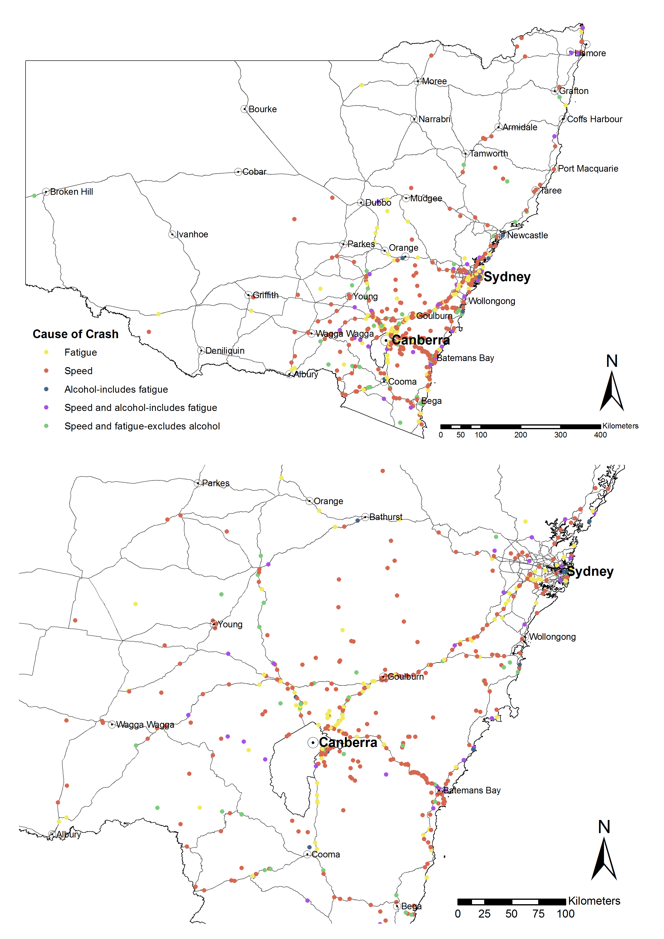
Map A 19: Crashes in NSW involving ACT controllers by crash cause
- Holidays
  - School holidays
2000 | 2001 | 2002
17 April to 28 April | 13 April to 27 April | 15 April to 26 April
3 July to 14 July | 9 July to 20 July | 8 July to 19 July
11 September to 2 October | 1 October to 12 October | 30 September to 11 October
20 December to 2 February | 24 December to 1 February | 20 December to 31 January
2003 | 2004 | 2005
14 April to 25 April | 9 April to 26 April | 11 April to 25 April
7 July to 18 July | 5 July to 16 July | 4 July to 15 July
29 September to 10 October | 27 September to 8 October | 26 September to 7 October
19 December to 29 January | 20 December to 26 January | 19 December to 2 February
2006 | 2007 | 2008
14 April to 28 April | 16 April to 27 April | 14 April to 25 April
10 July to 21 July | 9 July to 20 July | 7 July to 18 July
2 October to 13 October | 1 October to 12 October | 29 September to 10 October
22 December to 1 February | 24 December to 31 January | 22 December to 29 January
2009 | 2010 | 2011
10 April to 27 April | 12 April to 26 April | 18 April to 29 April
6 July to 17 July | 5 July to 16 July | 11 July to 22 July
28 September to 9 October | 27 September to 8 October | 3 October to 14 October
21 December to 27 January | 20 December to 3 February | 22 December
  - Public holidays
Holidays
2000 | 2001 | 2002
Easter - 21 April to 24 April | Easter - 13 April to 16 April | Easter – 29 March to 1 April
Canberra Day- 13 March | Canberra Day- 12 March | Canberra Day- 11 March
Queen’s Birthday- 12 June | Queen’s Birthday- 11 June | Queen’s Birthday- 10 June
Banks Holiday- 7 August | Banks Holiday- 6 August | Banks Holiday- 5 August
Labour Day-2 October | Labour Day-1 October | Labour Day-7 October
2003 | 2004 | 2005
Easter - 18 April to 21 April | Easter - 9 April to 12 April | Easter – 25 March to 28 April
Canberra Day- 10 March | Canberra Day- 8 March | Canberra Day- 14 March
Queen’s Birthday- 9 June | Queen’s Birthday- 14 June | Queen’s Birthday-13 June
Banks Holiday- 4 August | Banks Holiday- 2 August | Banks Holiday- 1 August
Labour Day- 6 October | Labour Day- 4 October | Labour Day- 3 October
2006 | 2007 | 2008
Easter - 10 April to 27 April | Easter – 6 April to 9 April | Easter – 21 March to 24 March
Canberra Day- 13 March | Canberra Day- 12 March | Canberra Day- 10 March
Queen’s Birthday- 12 June | Queen’s Birthday- 11 June | Queen’s Birthday- 9 June
Banks Holiday- 7 August | Banks Holiday- 6 August | Banks Holiday- 4 August
Labour Day- 2 October | Labour Day- 1 October | Labour Day-6 October
 | Family & Community Day- 7 November | Family & Community Day- 4 November
2009 | 2010 | 2011
Easter - 10 April to 13 April | Easter - 2 April to 5 April | Easter - 22 April to 25 April
Canberra Day- 9 March | Canberra Day- 8 March | Canberra Day- March 14
Queen’s Birthday- 8 June | Queen’s Birthday- 14 June | Queen’s Birthday- 13 June
Banks Holiday- 3 August | Banks Holiday- 2 August | Banks Holiday- 1 1 August
Labour Day- 5 October | Labour Day- 4 October | Labour Day- 3 October
Family and Community Day-3 November | Family and Community Day- 27 September | Family and Community Day-10 October
- data
Table C 1: Fatal, injury and all casualty crashes in NSW involving ACT controllers 1992-2011
Year | Fatal | Injury | All casualty crashes | %Change (Fatal) | %Change (Injury) | %Change (All casualty crashes)
1992 | 22 | 306 | 328
1993 | 11 | 312 | 323 | 50% | -2% | 2%
1994 | 17 | 283 | 300 | -55% | 9% | 7%
1995 | 12 | 261 | 273 | 29% | 8% | 9%
1996 | 13 | 241 | 254 | -8% | 8% | 7%
1997 | 8 | 226 | 234 | 38% | 6% | 8%
1998 | 12 | 271 | 283 | -50% | -20% | -21%
1999 | 12 | 274 | 286 | 0% | -1% | -1%
2000 | 10 | 284 | 294 | 17% | -4% | -3%
2001 | 3 | 290 | 293 | 70% | -2% | 0%
2002 | 11 | 268 | 279 | -267% | 8% | 5%
2003 | 16 | 258 | 274 | -45% | 4% | 2%
2004 | 14 | 263 | 277 | 13% | -2% | -1%
2005 | 8 | 251 | 259 | 43% | 5% | 6%
2006 | 13 | 245 | 258 | -63% | 2% | 0%
2007 | 11 | 219 | 230 | 15% | 11% | 11%
2008 | 6 | 254 | 260 | 45% | -16% | -13%
2009 | 11 | 223 | 234 | -83% | 12% | 10%
2010 | 14 | 247 | 261 | -27% | -11% | -12%
2011 | 9 | 249 | 258 | 36% | -1% | 1%
Table C 2: Fatal crashes and fatalities by jurisdiction
State/territory | 2006 | 2007 | 2008 | 2009 | 2010 | Total
Fatalities
New South Wales | 496 | 435 | 374 | 453 | 405 | 2163
Victoria | 337 | 332 | 303 | 290 | 288 | 1550
Queensland | 335 | 360 | 328 | 331 | 249 | 1603
South Australia | 117 | 124 | 99 | 119 | 118 | 577
Western Australia | 200 | 235 | 205 | 190 | 193 | 1023
Tasmania | 55 | 45 | 39 | 63 | 31 | 233
Northern Territory | 45 | 58 | 75 | 30 | 49 | 257
Australian Capital Territory | 13 | 14 | 14 | 12 | 19 | 72
ACT in NSW | 13 | 14 | 6 | 13 | 18 | 64
Fatal crashes
New South Wales | 449 | 405 | 353 | 408 | 365 | 1980
Victoria | 309 | 289 | 278 | 268 | 260 | 1404
Queensland | 313 | 338 | 294 | 296 | 236 | 1477
South Australia | 104 | 107 | 87 | 104 | 105 | 507
Western Australia | 181 | 214 | 185 | 176 | 176 | 932
Tasmania | 43 | 39 | 37 | 52 | 29 | 200
Northern Territory | 41 | 47 | 67 | 30 | 46 | 231
Australian Capital Territory | 12 | 14 | 14 | 11 | 16 | 67
NSW excluding ACT in NSW | 436 | 394 | 347 | 397 | 351 | 1925
ACT in NSW | 13 | 11 | 6 | 11 | 14 | 55
Source: Australian Road Deaths Database
Table C 3: Australian population by jurisdiction
State/territory | 2006 | 2007 | 2008 | 2009 | 2010 | Total
New South Wales | 6,816,087 | 6,888,014 | 6,984,172 | 7,238,819 | 7,133,398 | 35,060,490
Victoria | 5,126,540 | 5,204,826 | 5,313,823 | 5,547,527 | 5,448,207 | 26,640,923
Queensland | 4,090,908 | 4,181,431 | 4,293,915 | 4,516,361 | 4,427,278 | 21,509,893
South Australia | 1,567,888 | 1,584,197 | 1,603,361 | 1,644,642 | 1,624,572 | 8,024,660
Western Australia | 2,059,381 | 2,106,119 | 2,171,197 | 2,296,411 | 2,247,337 | 10,880,445
Tasmania | 489,951 | 493,371 | 497,529 | 507,626 | 503,275 | 2,491,752
Northern Territory | 210,627 | 214,929 | 219,818 | 229,675 | 226,171 | 1,101,220
Australian Capital Territory | 334,119 | 339,761 | 345,551 | 358,894 | 352,608 | 1,730,933
Total | 20,695,501 | 21,012,648 | 21,429,366 | 22,339,955 | 21,962,846 | 107,440,316
Source: ABS
Table C 4: Total kilometres travelled for ACT registered vehicles in ACT and NSW 2000-2007 and 2010
Year | Type of Vehicle | No. Vehicles | No. Vehicles – RSE* (%) | ACT KMS (‘000) | ACT – RSE (%) | NSW KMS (‘000) | NSW – RSE (%)
2000 | All vehicles | 194,948 | 1.7 | 2441 | 4.6 | 648 | 8.8
2001 | All vehicles | 203,859 | 1.5 | 2496 | 4.0 | 491 | 9.4
2002 | All vehicles | 206,444 | 1.5 | 2366 | 3.8 | 641 | 11.8
2003 | All vehicles | 212,072 | 1.4 | 2537 | 4.1 | 581 | 8.8
2004 | All vehicles | 215,581 | 1.2 | 2464 | 3.9 | 653 | 8.3
2005 | All vehicles | 217,036 | 1.9 | 2444 | 3.9 | 611 | 8.7
2006 | All vehicles | 220,827 | 2.7 | 2437 | 5.0 | 506 | 13.7
2007 | All vehicles | 227,031 | 1.6 | 2569 | 4.7 | 496 | 11.1
2008 | Survey not conducted in these years
2009
2010 | All vehicles | 252,771 | 2.4 | 2644 | 5.6 | 746 | 12.4
Note: *RSE- relative standard error
Source: ABS

- Workshop Notes
Workshop: Crashes involving ACT drivers in NSW

OUTCOMES

Date | Wednesday, 30 January 2013
Time | 10:00 am to 12:00 pm
Location | Country Heir Interiors & Café, 54 Monaro Street, Queanbeyan NSW 2620
Attendees | - Rod Anderson & Craig McPherson (ACT Police)  - Geoff Davidson (Justice and Community Safety Directorate, ACT Government)  - Ron Collins (NRMA Motoring & Services)  - David Quinlan, Jayanthy Vikneson & Pawel Potapowicz (Traffic Management and Safety, Roads ACT)  - Alison Beresford, Yass Valley  - Robert Reynolds (NSW RMS, Southern Region)  - Linda Cooke (NRMA-ACT Road Safety Trust)  - Karen Sydenham (Eurobodalla Shire)  - Keith Wheatley (ACRS)
Unable to attend | - Gary McDonald (Justice and Community Safety Directorate, ACT Government)  - Angus Duncan (NSW Police, Batemans Bay)  - Dominic Goodyer (NSW Police, Queanbeyan)  - Clay Anderson (Queanbeyan Road Safety Group)

Item No. | Item
1. | Topic – ACT has lowest annual average road fatalities among Australian states/territories, but residents roughly as likely to be involved in a fatal crash in NSW as they are in ACT.
1. | Discussion  - The ACT is unique in that it is essentially an urban environment and thus the appropriate comparison is with similar size urban areas, e.g. Perth Metro.  - Would like to see rates per population.
1. | Actions  - Fatalities per 100,000 population by state/territory will be reported  - Fatalities per vkt will be reported  Further thoughts  - It would be valuable to investigate whether any of the regional cities in NSW have similar population / area that could make for better benchmarking, but this is outside of the scope of the current project.
2. | Topic – Impact of population growth
2. | Discussion  - Between 2006 and 2011, population growth within the ACT was 1.5% to 2.1% per annum. This rate was consistently greater than the national average, approximately 1.5 times the rate in NSW, and similar to the LGAs on the north and north-east borders of the ACT. Therefore, it would be natural to expect an increase in crashes and/or a change in the pattern, hence the need for a review of the statistics.  - Many people who live in neighbouring LGAs work, study, use health, sporting and entertainment facilities in the ACT. It is the major urban hub in the region.
2. | Actions  - Review crash patterns of ACT residents.  Further thoughts  - It would be worthwhile comparing the crash patterns of residents of Yass, Queanbeyan and Palerang, but this is outside of the scope of the current project.  - ACT population is relatively young – median age is 35 years compared with approx. 37 years for whole of Australia and 38 years for NSW.
3. | Topic – Crash patterns
3. | Discussion  - The major highways are roughly similar to previous years.  - There has been a lot of road duplication that may account for some of the relative sparseness of crashes on, for example, the Hume Highway west of Goulburn and Princes Highway.  - There are also a number of more minor routes that stand out which may warrant further investigation.  - Cluster of crashes in Lismore?
3. | Actions  - Examine clusters on specific routes and localities.  - Close up of the regions around the ACT.  - Analysis by road classification and surface type.  - Analysis of fatigue / speed / alcohol involvement (problem with under-reporting)  - Obtain dates of significant duplications.
3. | Topic – Young drivers / provisional licence holders
3. | Discussion  - There is a perception that young ACT drivers are more over-represented than NSW young drivers in crashes on NSW roads.
3. | Actions  - Calculate average crash rates by population in age group.  - Identification of ‘high risk routes’ (not just major highways) where the % of young drivers (17-25) involved in crashes is higher than average.  - Profile times / days of week / times of year / conditions for high risk routes.  Further thoughts  - It would be worthwhile examining the incidence of crashes involving ACT young drivers in ACT and in NSW based on number of ACT p-licences held, even better if we knew how much driving they do, but this is outside the scope of the current project.
3. | Topic – Motorcycles and bicycles
3. | Discussion  - Motorcycling and cycling appear to be very popular among ACT residents. There are also a number of motorcycle ‘runs’ and cycling events that are thought to be associated with higher incidence of crashes. The potential over-involvement of these groups in crashes and identification of locations where these groups are over-involved is of interest.
3. | Actions  - Identification of ‘high risk routes’ (not just major highways) where the % of motorcyclists involved in crashes is higher than average.  - Identification of rider profiles on high risk routes (i.e. age, gender, speed, alcohol and fatigue implicated).  - Identification of route profiles for high risk routes (road classification / surface type / frequency of run-off-road on bend etc.).
3. | Topic – Reduction of crashes in Sydney and Liverpool
3. | Discussion  - Possibly due to construction of bypasses.
3. | Actions  - Obtain dates of bypass openings for use in time series modelling.
3. | Topic – Sources of background and contextual information
3. | Discussion  - Alison Beresford (Yass) – Working Group Survey?  - It is possibly tougher to get a licence in NSW due to the GLS regulations, and there is anecdotal evidence that young drivers in bordering municipalities may hold ACT driver licences. This means that these drivers will be picked up in our statistics.  - Kings Highway – major review.  - RMS reports for ideas on presentation of statistics.  - 31% of Eurobodalla rate payers live in ACT (i.e. holiday-house owners).  - ACT has surveyed residents on awareness of road safety campaigns.
3. | Actions  - Obtain reports and survey results.  - Acknowledge possible ‘contamination’ of driver licence data and vehicle registrations from non-ACT residents.
3. | Topic – Other influences on crash rates
3. | Discussion  - There are many influences on travel patterns and crashes. These include weather patterns, employment, fuel prices, average income, population growth, location of trip generators (particularly in relation to user’s home residences), availability of alcohol and other drugs, driver age and gender, perceptions of police enforcement, self-perceptions, expectations regarding the perceptions of other drivers, peer group and significant others.
3. | Actions  - Where possible, take these factors into account in modelling either directly (e.g. fuel price) or indirectly (e.g. population demographics). Acknowledge that there may be other influences unaccounted for.  Further thoughts  - Travel patterns of ACT residents is out of scope but would provide much greater insights. Do Australia’s privacy laws prevent geo-referenced mobile telecommunications data from being used to map travel? How would you distinguish between ACT residents and non-ACT residents? Would it matter if you couldn’t? You couldn’t distinguish between different vehicle types. Might be better to do targeted vehicle counts in this context.
3. | Topic – Next steps
3. | Actions  - Further mapping and descriptive statistics.  - Time series modelling.

- NSW DCA codes
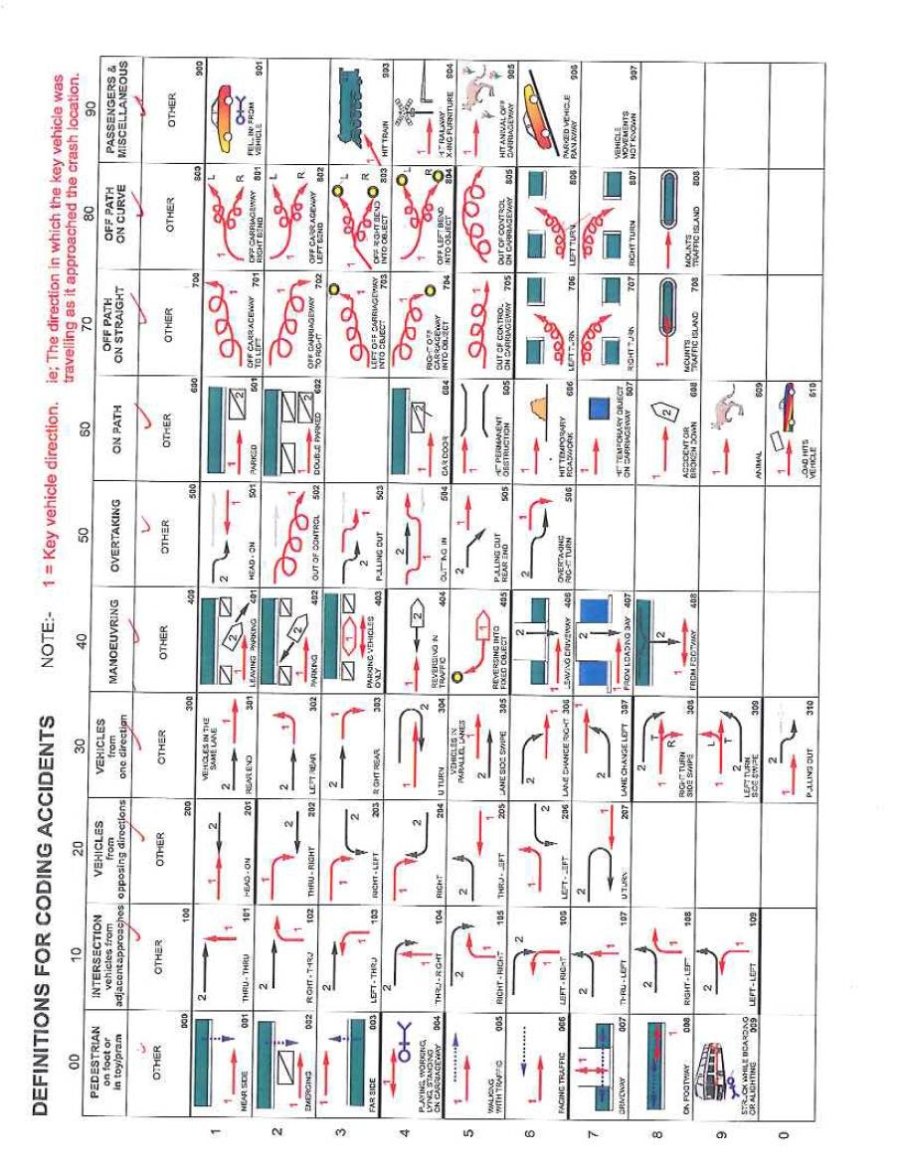
Figure E 1: NSW DCA codes
- Time Series Analysis Diagnostics
P-P plots depict the correlation between the frequency distribution of the observed data series and the expected frequency distribution under the normal probability density function.

Figure F 1: Normal probability plots

Fatal crashes – ACT controllers | Fatal crashes – Non-ACT controllers
Injury crashes – ACT controllers | Injury crashes – Non-ACT controllers
Figure F 2: Frequency distributions and scatterplots of year, crashes per 100,000 population and vehicle kilometres travelled by crash severity and controller type
Table F 1: Collinearity and autocorrelation diagnostics
Severity | Controllers | Variables | Correlations Zero-order | Durbin-Watson
Fatal | ACT | (Constant)
Fatal | ACT | Year | -.359 | 2.030
Fatal | Non-ACT | (Constant)
Fatal | Non-ACT | Year | -.969 | 1.687
Injury | ACT | (Constant)
Injury | ACT | Year | -.908 | 2.138
Injury | Non-ACT | (Constant)
Injury | Non-ACT | Year | -.838 | 0.854

Note: Residuals for injury crashes involving non-ACT controllers obtained using AR(1) model
Figure F 3: Residuals plots

Controller refers to a vehicle driver or rider.
As described in Section 2.1, references to ACT controllers in this report refer to drivers or riders who held an ACT licence or whose vehicle was registered in the ACT.
Although there may be a case for including crashes on Fridays after 6 pm as occurring during ‘weekend’ time, Saturdays and Sundays are used here for consistency with earlier studies.
Autocorrelation is correlation of the time series with itself at different time periods. This occurs in time series because observations close together in time tend to be more similar than points further apart in time. Autocorrelation in the residuals indicates that some pattern in the time series has not been explained by the model. It results in under-estimates of the standard error and over-confidence in the parameter estimates. The Durbin-Watson statistic tests the hypothesis that there is no autocorrelation of one time lag in the residuals. Residuals are the difference between each observation and the regression line.

